Excel Get Started

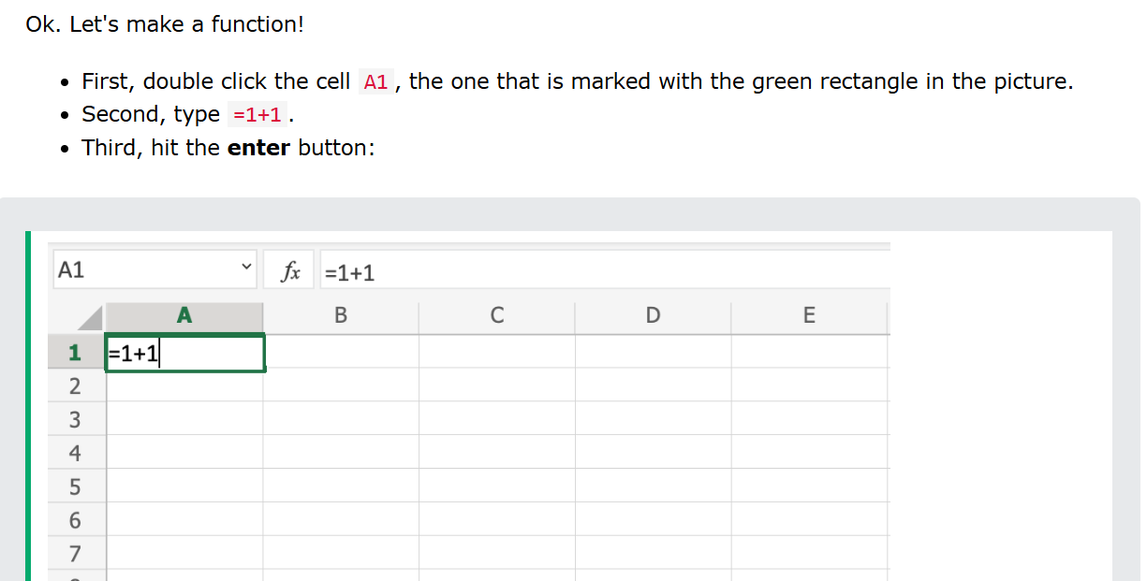

# Excel Overview

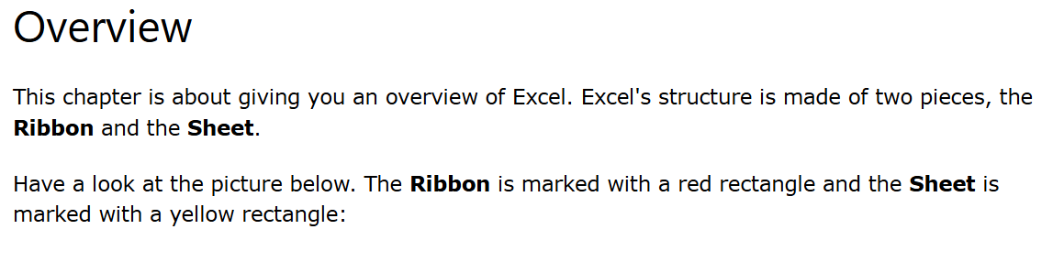

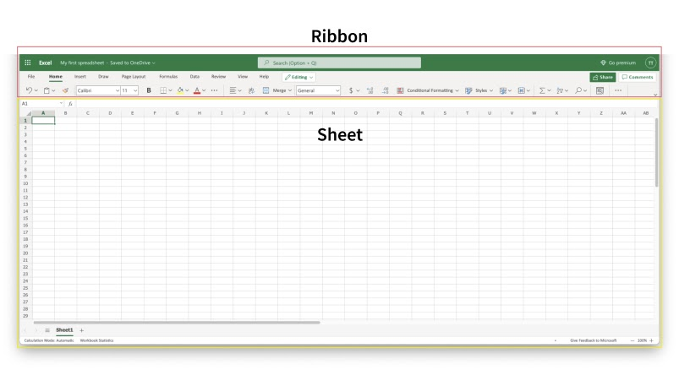

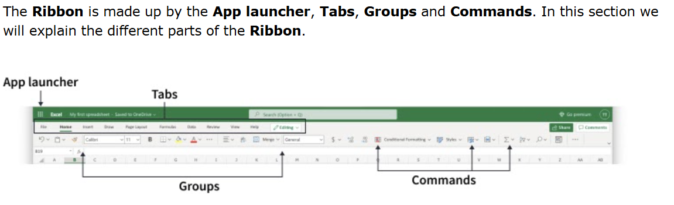

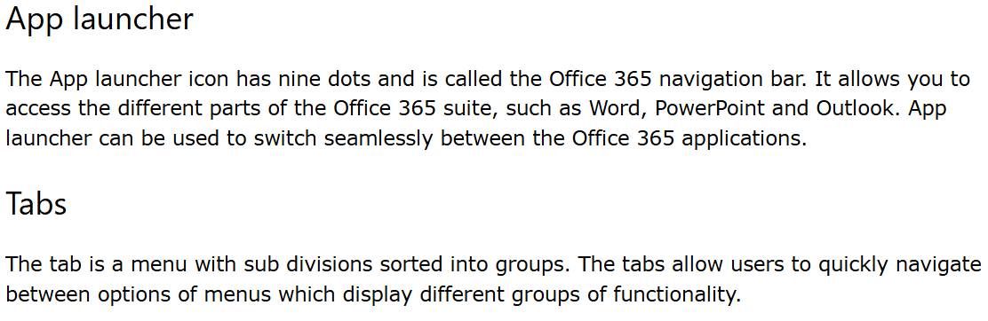

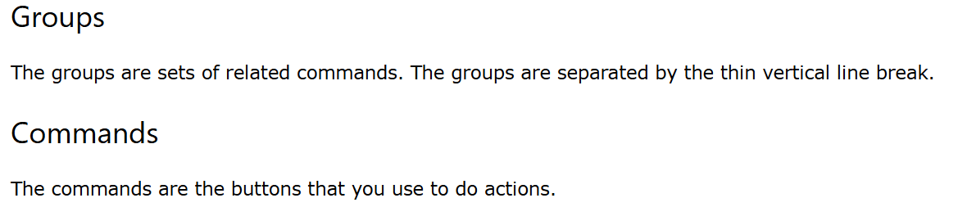

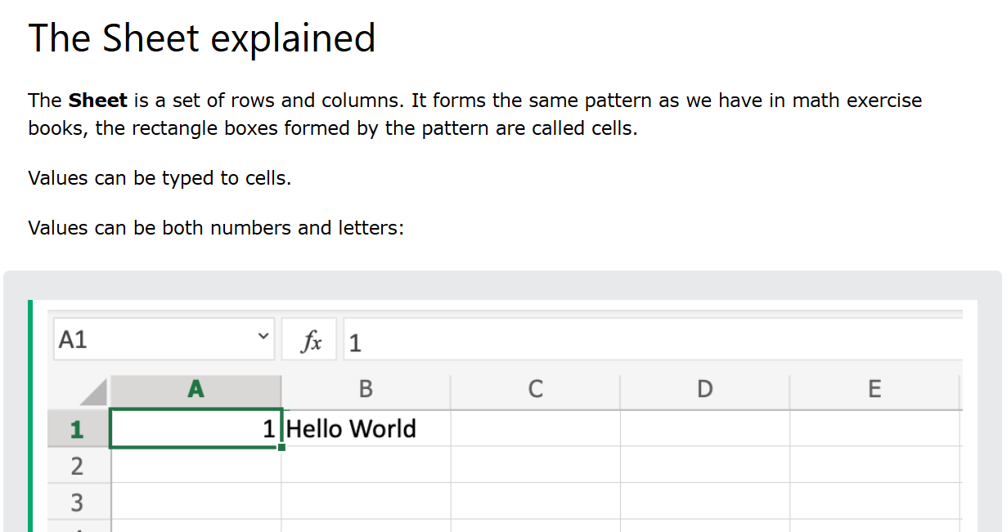

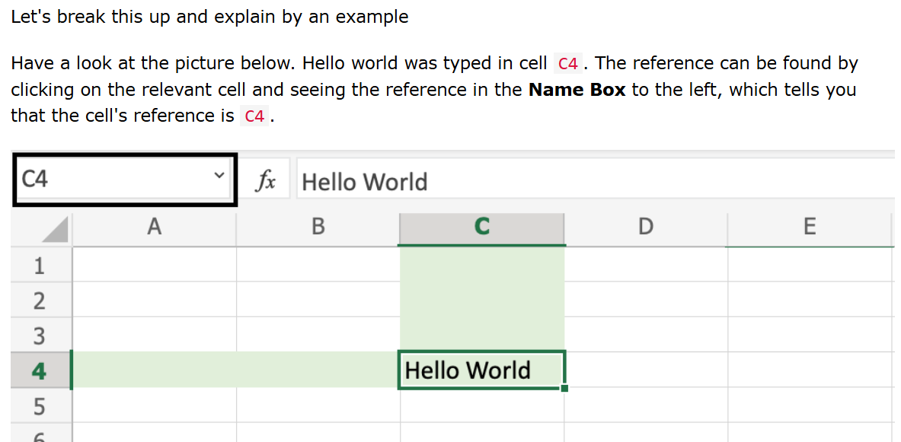

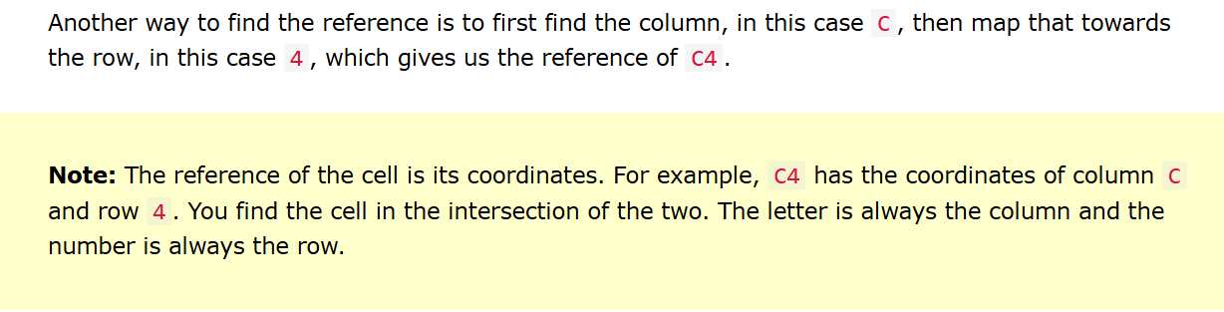

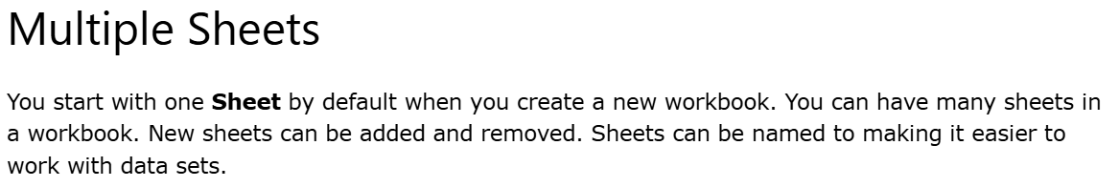



# Excel Syntax

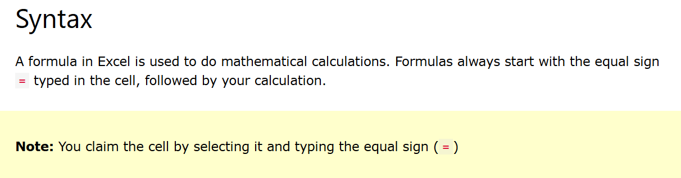

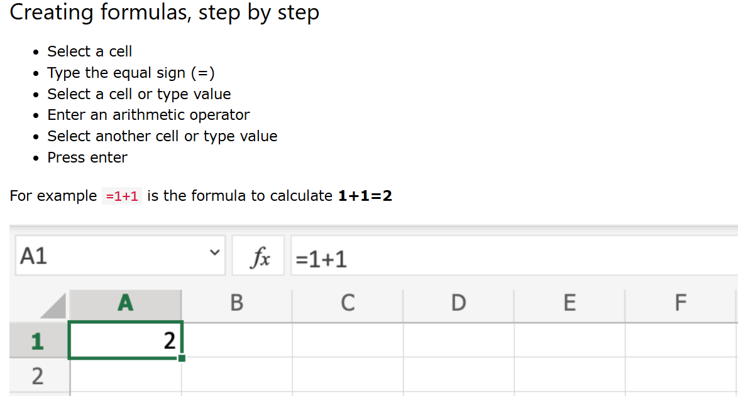



## **Using Formulas with Cells**

You can type values to cells and use them in your formulas.

Lets type some dummy values to get started. Double click the cells to type values into them. Go ahead and type:

* A1(309)
* A2(320)
* B1(39)
* B2(35)

Compare with the picture shown below:

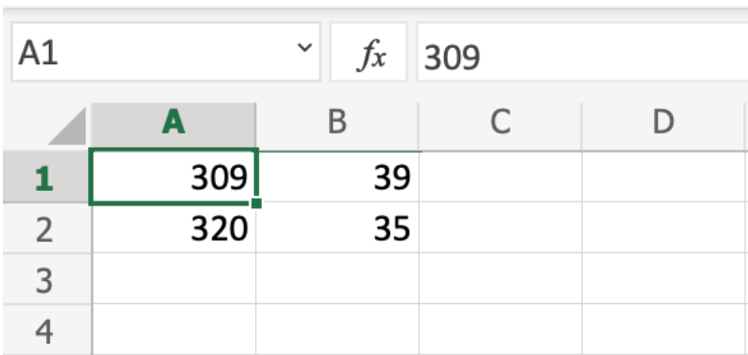

Here is how to do it, step by step.

1. Select the cell C1
2. Type the equal sign (=)
3. Left click on A1, the cell that has the (309) value
4. Type the minus sign (-)
5. Left click on B2, the cell that has the (35) value
6. Hit enter

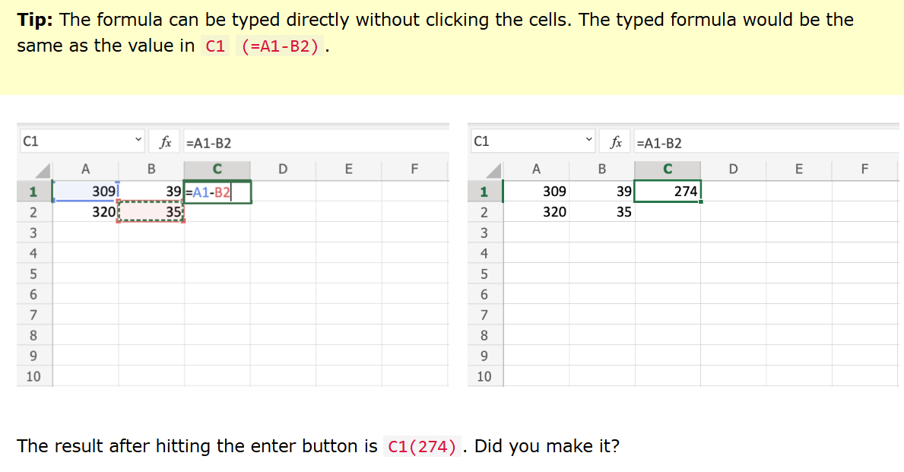

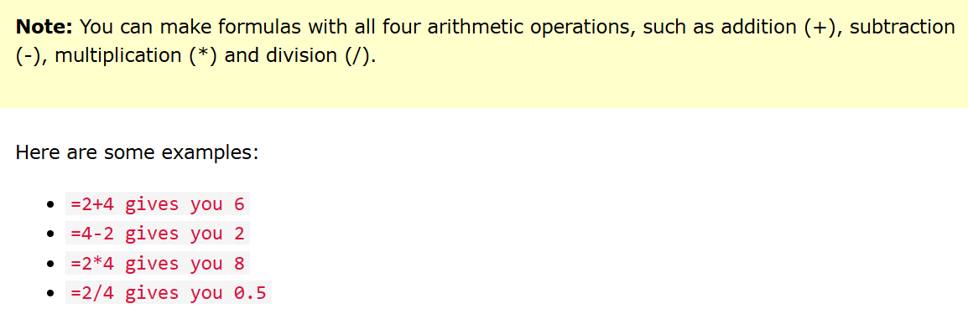

# Excel Ranges

## **The Name Box**

The Name Box shows you the reference of which cell or range you have selected. It can also be used to select cells or ranges by typing their values.

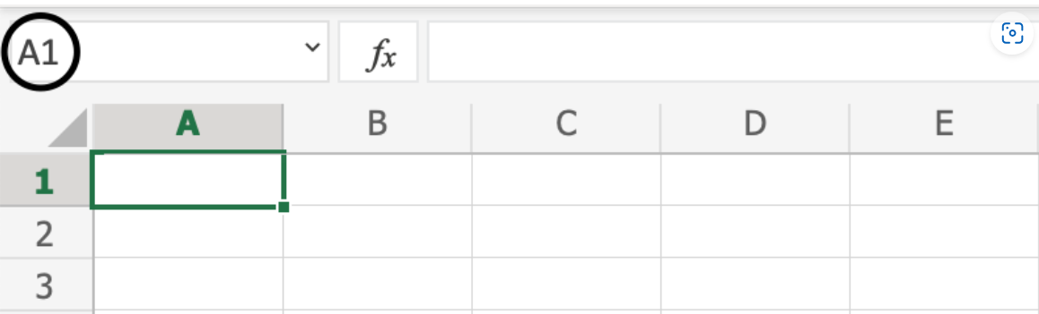

You will learn more about the Name Box later in this chapter.

## **Selecting a Cell**

Cells are selected by clicking them with the left mouse button or by navigating to them with the keyboard arrows.

It is easiest to use the mouse to select cells.

To select cell A1, click on it:

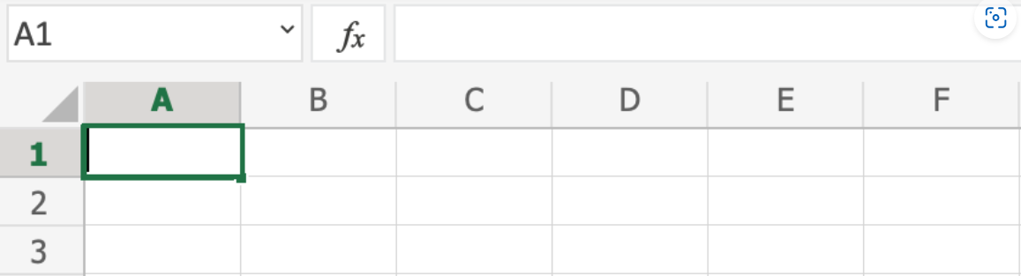

## **Selecting Multiple Cells**

More than one cell can be selected by pressing and holding down **CTRL**or **Command**and left clicking the cells. Once finished with selecting, you can let go of **CTRL**or **Command**.

Lets try an example: Select the cells A1, A7, C1, C7 and B4.

Did it look like the picture below?

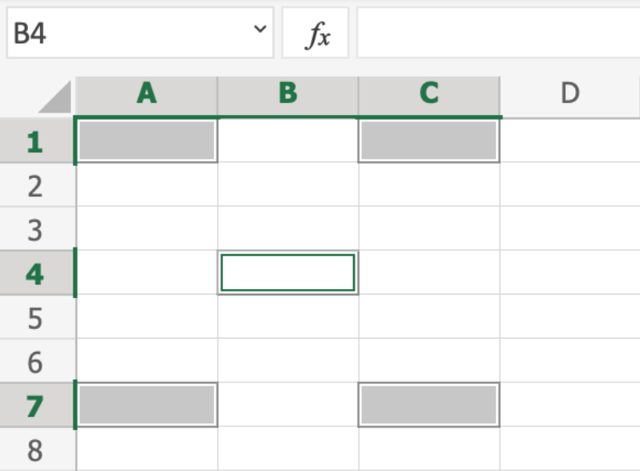

## **Selecting a Column**

Columns are selected by left clicking it. This will select all cells in the sheet related to the column.

To select **column A**, click on the letter A in the column bar:

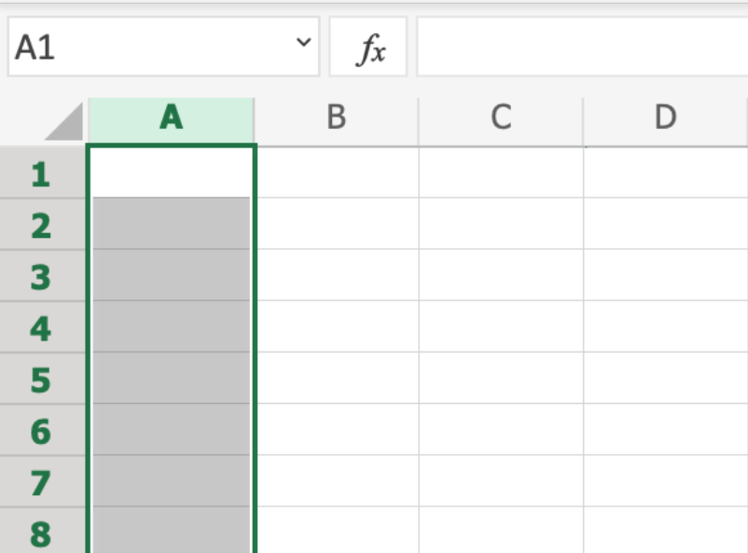

## **Selecting a Row**

Rows are selected by left clicking it. This will select all the cells in the sheet related to that row.

To select **row 1**, click on its number in the row bar:

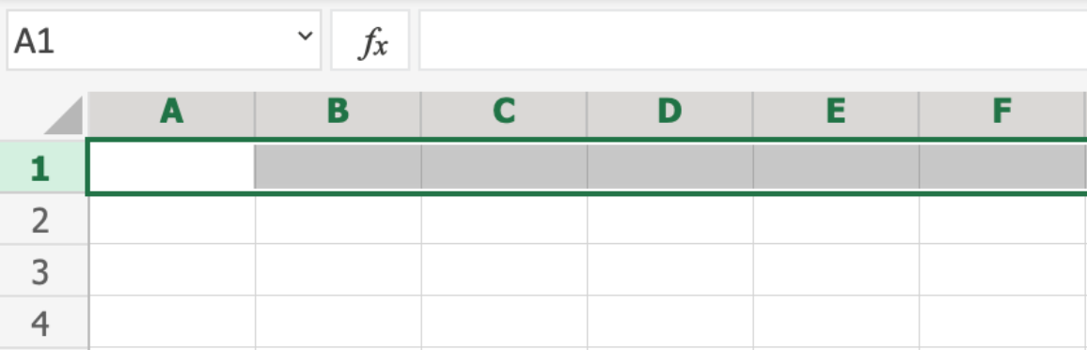

## **Selecting the Entire Sheet**

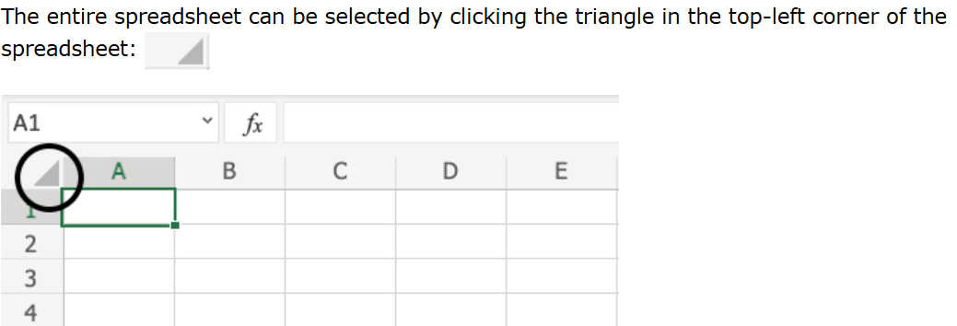

Now, the whole spreadsheet is selected:

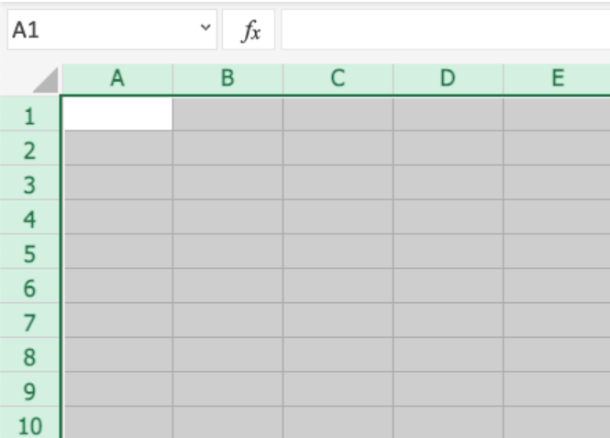

**Note:** You can also select the entire spreadsheet by pressing Ctrl+A for Windows, or Cmd+A for MacOS.

## **Selection of Ranges**

There are two ways to select a range of cells

1. Name Box
2. Drag to mark a range.

The easiest way is drag and mark. Let's keep it simple and start there.

How to drag and mark a range, step-by-step:

1. Select a cell
2. Left click it and hold the mouse button down
3. Move your mouse pointer over the range that you want selected. The range that is marked will turn grey.
4. Let go of the mouse button when you have marked the range

Let's have a look at an example for how to mark the range A1:E10.

**Note:** You will learn about why the range is called A1:E10 after this example.

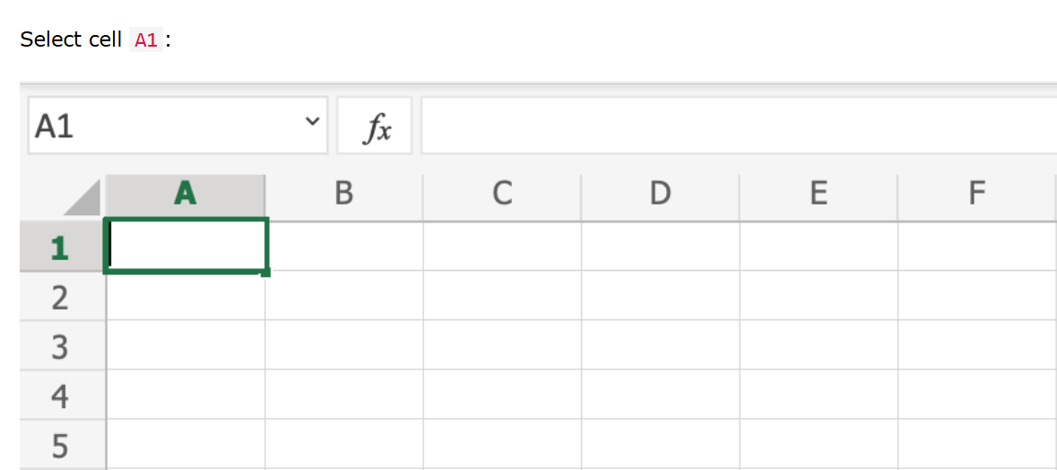

Press and hold A1 with the left mouse button. Move to the mouse pointer to mark the selection range. The grey area helps us to see the covered range.

Let go of the left mouse button when you have marked the range A1:E10:

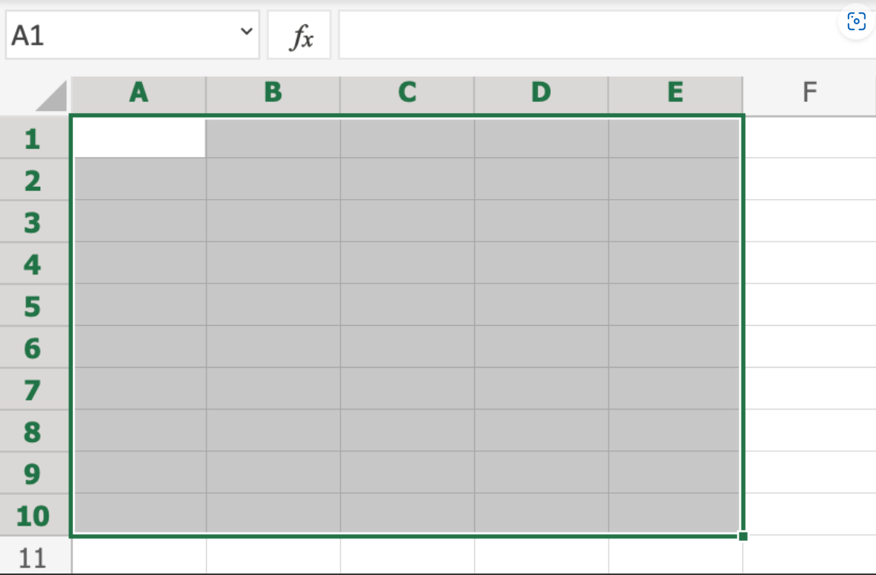

You have successfully selected the range A1:E10. **Well done!**

The second way to select a range is to enter the range values in the Name Box. The range is set by first entering the cell reference for the top left corner, then the bottom right corner. The range is made using those two as coordinates. That is why the cell range has the reference of two cells and the **:** in between.

**Top left corner reference : Right bottom corner reference**

The range shown in the picture has the value of A1:E10:

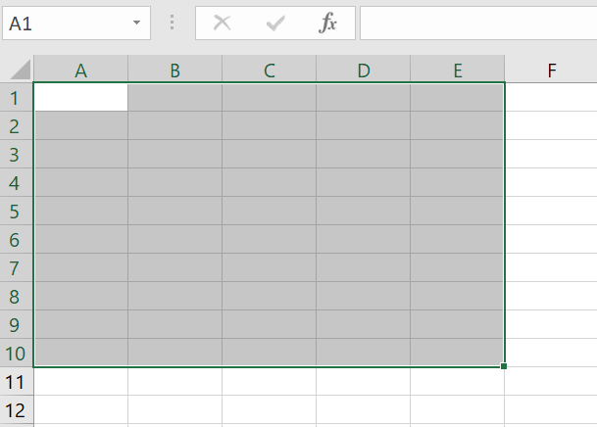

The best way for now is to use the drag and mark method as it is easier and more visual.

# Excel Fill

## **Filling**

Filling makes your life easier and is used to fill ranges with values, so that you do not have to type manual entries.

Filling can be used for:

* Copying
* Sequences
* Dates
* Functions (*)

For now, do not think of functions. We will cover that in a later chapter.

## **How To Fill**

Filling is done by selecting a cell, clicking the fill icon and selecting the range using drag and mark while holding the left mouse button down.

The fill icon is found in the bottom right corner of the cell and has the icon of a small square. Once you hover over it your mouse pointer will change its icon to a thin cross.

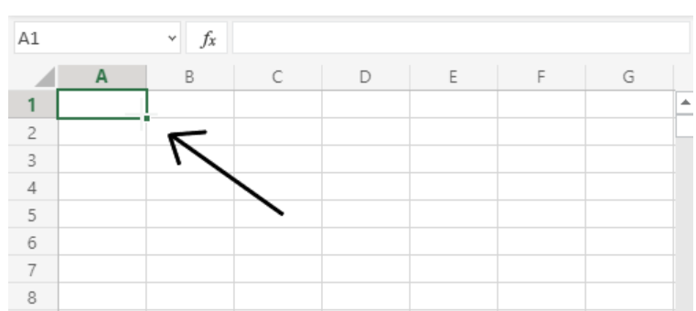

Click the fill icon and hold down the left mouse button, drag and mark the range that you want to cover.

In this example, cell A1 was selected and the range A1:A10 was marked.

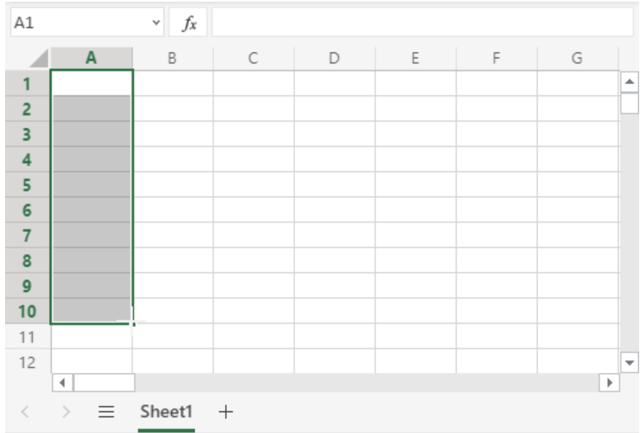

Now that we have learned how to fill. Let's look into how to copy with the fill function.

## **Fill Copies**

Filling can be used for copying. It can be used for both numbers and words.

Let's have a look at numbers first.

In this example we have typed the value A1(1):

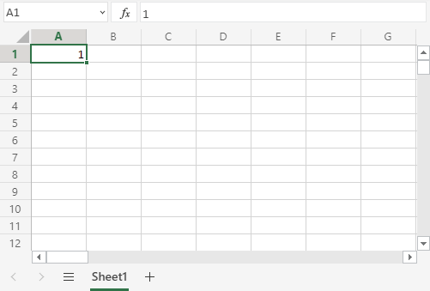

Filling the range A1:A10 creates **ten copies** of **1**:

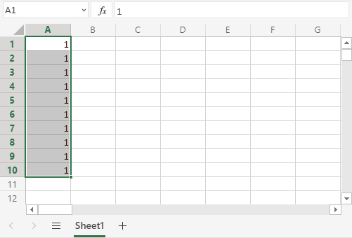

The same principle goes for text.

In this example we have typed A1(Hello World).

Filling the range A1:A10 creates ten copies of "Hello World":

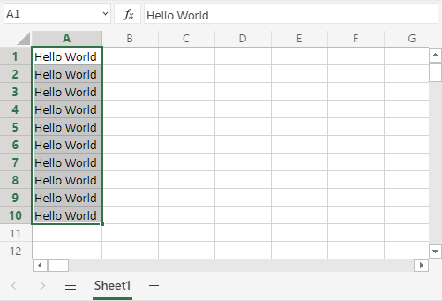

Now you have learned how to fill and to use it for copying both numbers and words. Let's have a look at sequences.

## **Fill Sequences**

Filling can be used to create sequences. A sequence is an order or a pattern. We can use the filling function to continue the order that has been set.

Sequences can for example be used on numbers and dates.

Let's start with learning how to count from 1 to 10.

This is different from the last example because this time we do not want to copy, but to count from 1 to 10.

Start with typing A1(1):

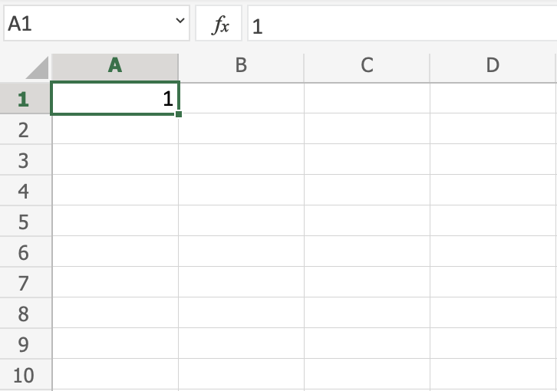

First we will show an example which does not work, then we will do a working one. Ready?

Lets type the value (1) into the cell A2, which is what we have in A1. Now we have the same values in both A1 and A2.

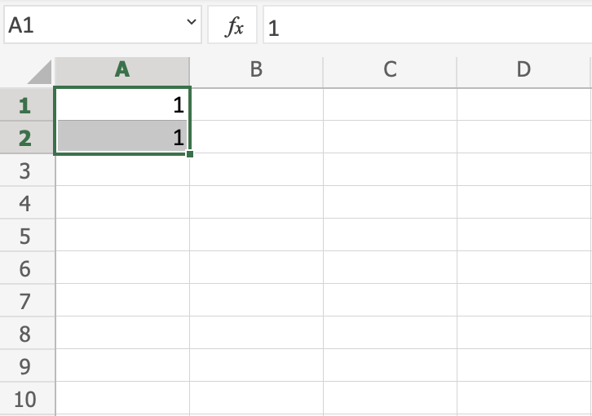

Let's use the fill **function**from A1:A10 to see what happens. Remember to mark both values before you fill the range.

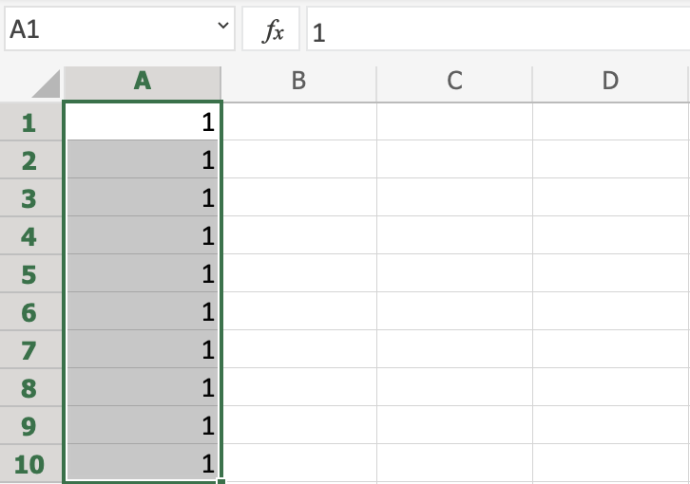

What happened is that we got the same values as we did with copying. This is because the fill function assumes that we want to create copies as we had two of the same values in both the cells A1(1) and A2(1).

Change the value of A2(1) to A2(2). We now have two different values in the cells A1(1) and A2(2). Now, fill A1:A10 again. Remember to mark both the values (holding down shift) before you fill the range:

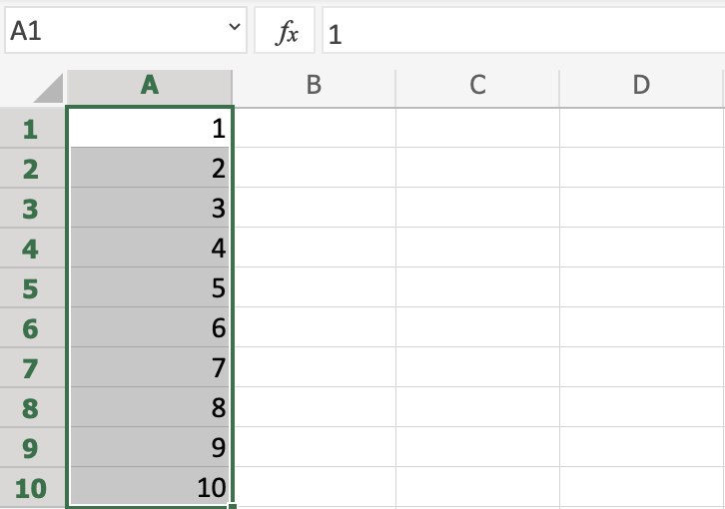

**Congratulations!** You have now counted from 1 to 10.

The fill function understands the pattern typed in the cells and continues it for us.

That is why it created copies when we had entered the value (1) in both cells, as it saw no pattern. When we entered (1) and (2) in the cells it was able to understand the pattern and that the next cell A3 should be (3).

Let's create another sequence. Type A1(2) and A2(4):

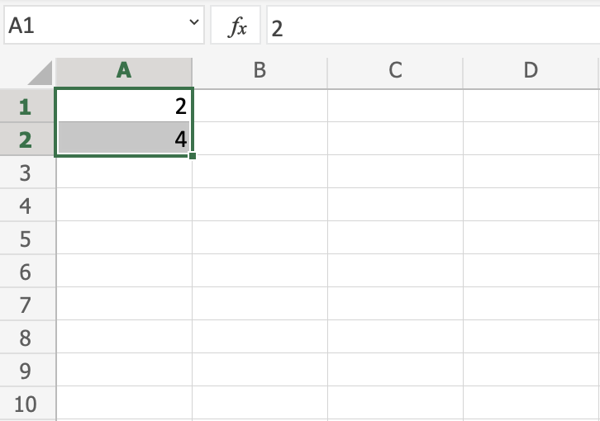

Now, fill A1:A10:

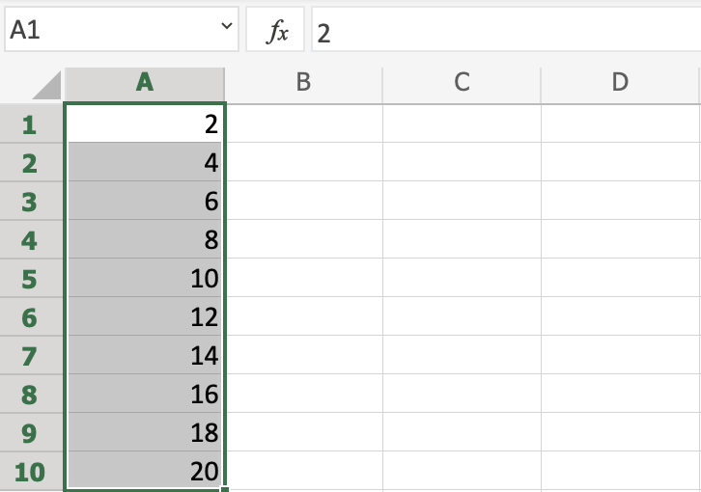

It counts from 2 to 20 in the range A1:A10.

This is because we created an order with A1(2) and A2(4).

Then it fills the next cells, A3(6), A4(8), A5(10) and so on. The fill function understands the pattern and helps us continue it.

## **Sequence of Dates**

The fill function can also be used to fill dates.

**Note:**The date format depends on you [regional language settings](https://www.w3schools.com/excel/excel_format_settings.php).

For example 14.03.2023 vs. 3/14/2023 VS 15/01/2021.

Test it by typing A1(20-07-2021):

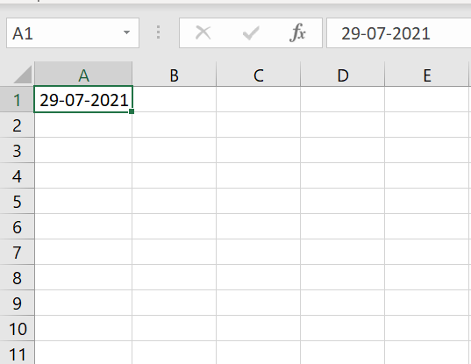

And fill the range A1:A10:

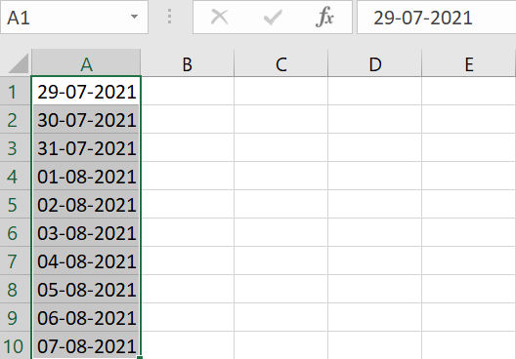

The fill function has filled 10 days from A1(29-07-2021) to A10(07-08-2021).

Note that it switched from July to August in cell A4. It knows the calendar and will count real dates.

## **Combining Words and Letters**

Words and letters can also be combined.

Type A1(Hello 1) and A2(Hello 2):

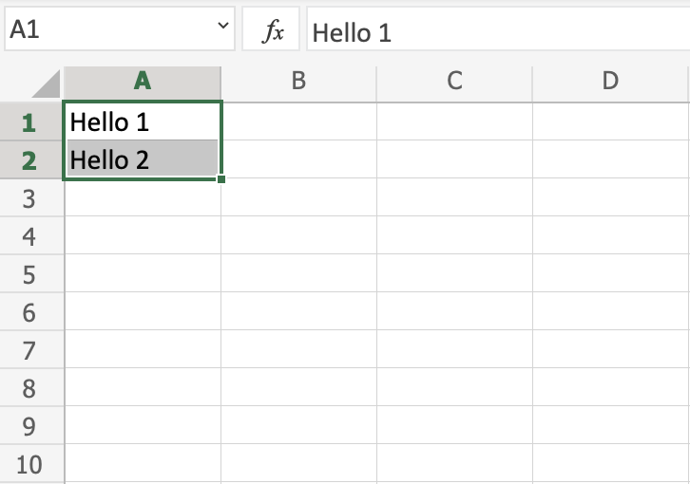

Next, fill A1:A10 to see what happens:

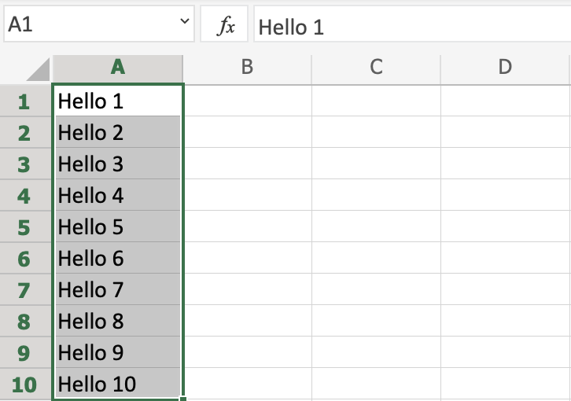

The result is that it counts from A1(Hello 1) to A10(Hello 10). Only the numbers have changed.

It recognised the pattern of the numbers and continued it for us. Words and numbers can be combined, as long as you use a recognizable pattern for the numbers.

# Excel Double Click to Fill

## **Double Click to Fill**

The **fill function** can be **double clicked** to complete formulas in a range:



**Note:** For the double click to work it has to see a recognizable pattern.

For example: by using headers, or with the formulas in the columns or rows next to the data.

### **Double Click to Fill Example**

Let's use the Double click fill function to calculate the AttackB2:B20 + Defense C2:C20 for the Pokemons in the range D2:D20.

1. Select D2
2. Type =

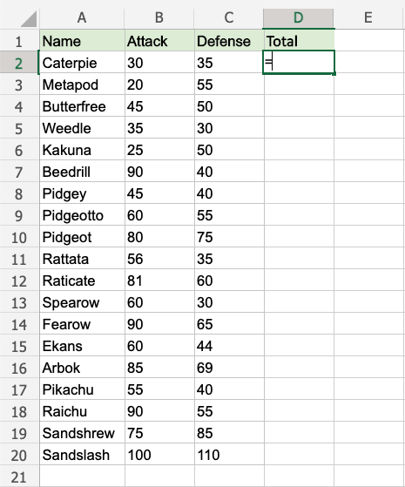

1. Select B2
2. Type +
3. Select C2

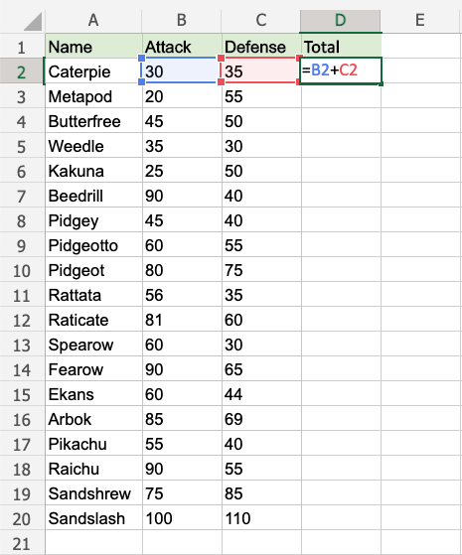

1. Hit enter

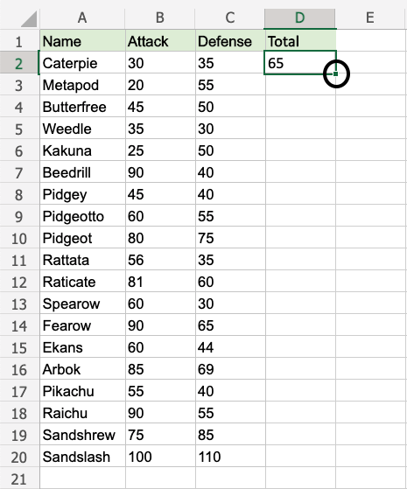

1. Double click the fill function

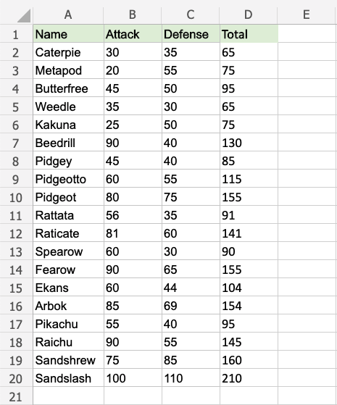

**Way to go!** The function understands the pattern and completes the calculation for D2:D20. Note that it stops when there is no more data to calculate, at row **20**.

## **A Non-Working Example**

Delete values in the range D1:D20

Enter the formula "=B2+C2" in E2

**Note:** There is no header for Columns **D** and **E**. There are blank cells in between.

Double click the fill function.

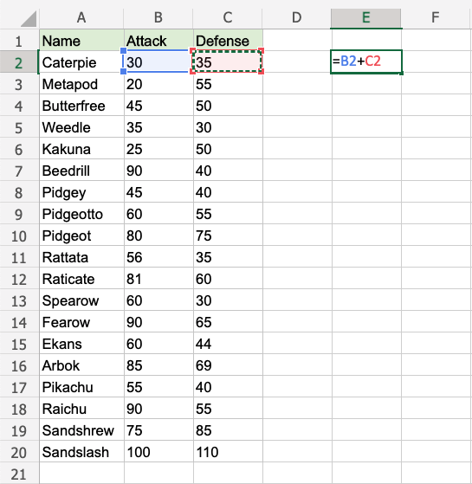

**Waiting...**

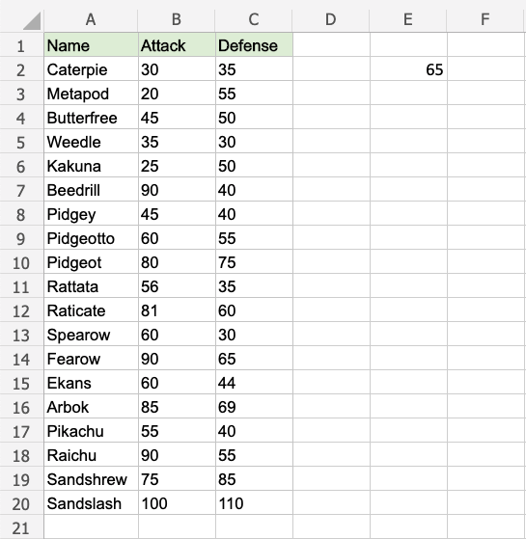

The fill function is just loading without filling the rows. It is not understanding the pattern.

**Give it more clues.**

Add a header to see what happens. Enter "Atk+def" in E1

Double click the fill function.

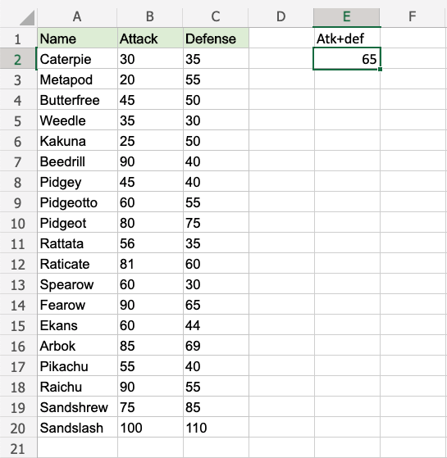

**Loading... Still nothing...**

One more header. Enter "Random" in D1

Double click the fill function.

**Is the gap closed?**

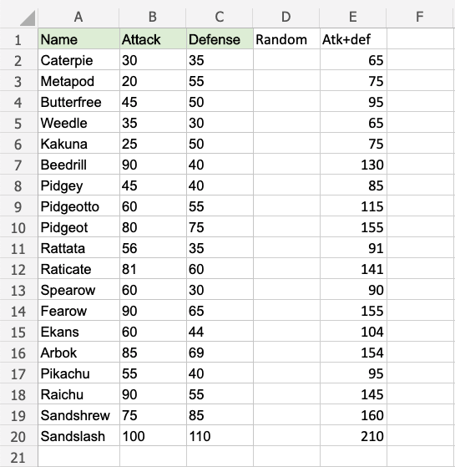

**There we go!** The function recognised the pattern and filled in the formulas for each row.

Adding headers helped the function to understand the relationship between the data.

# Excel Move Cells

## **Moving Cells**

There are two ways to move cells: **Drag and drop** or by **copy and paste**.

## **Drag and Drop**

Let's start by typing or copying some values that we can work with:

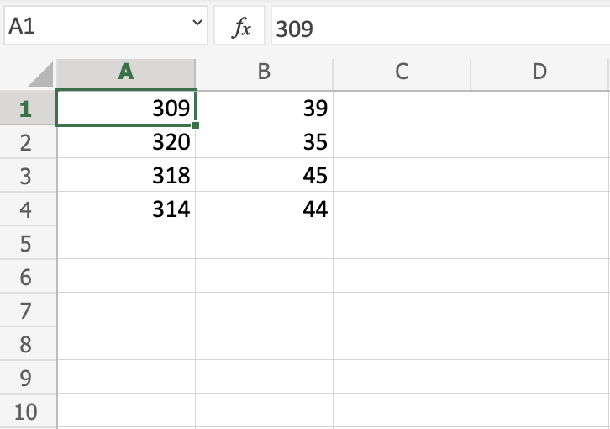

Next, start by marking the area A1:B4:

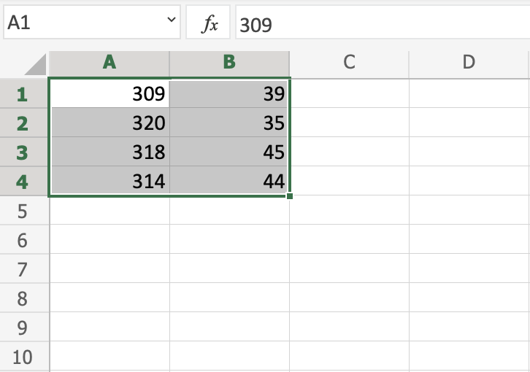

You can drag and drop the range by pressing and holding the left mouse button on the border. The mouse cursor will change to the move symbol when you hover over the border.

Drag and drop it when you see the symbol.

Move the range to B2:C5 as shown in the picture:

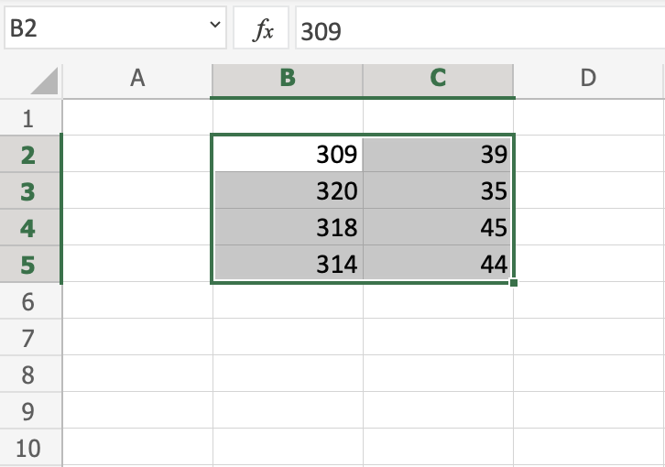

Next, lets see how we can move data by using cut and paste.

## **Cut and Paste**

Ranges can be moved by cutting and pasting values from one place to another.

**Tip:** You can cut using the hotkey CTRL+X and paste by CTRL+V. This saves you time.

Mark the range A1:C5

Right click the marked area, and click on the "Cut" command, which has scissors as its icon:

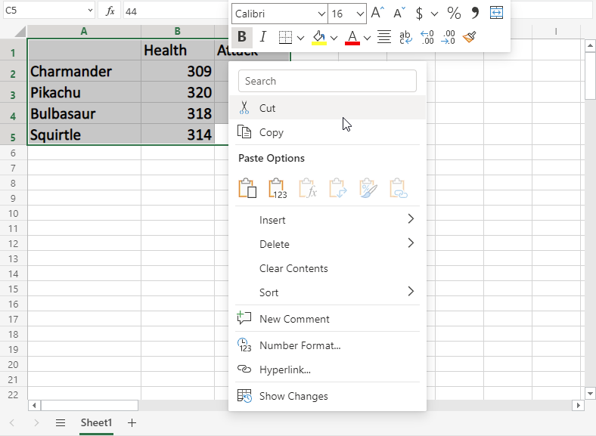

Cutting makes the range white-grey with dotted borders. This indicates that the range is cutted and ready for pasting.

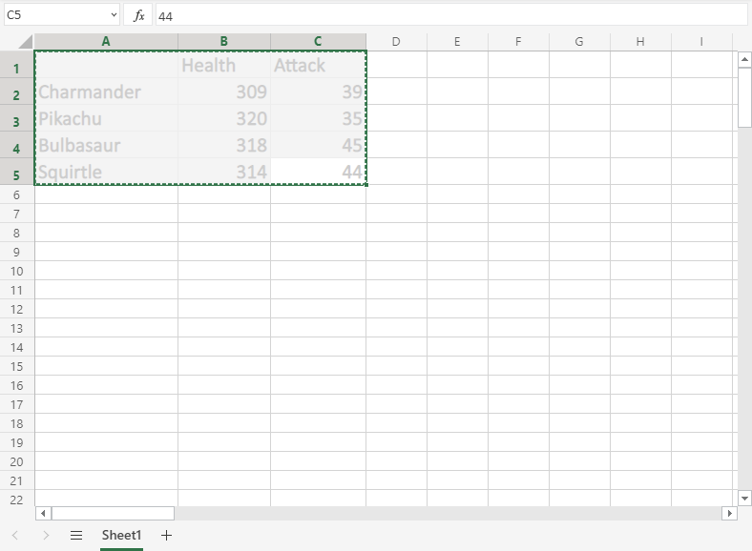

Right click the paste destination B6 and left click the paste icon.

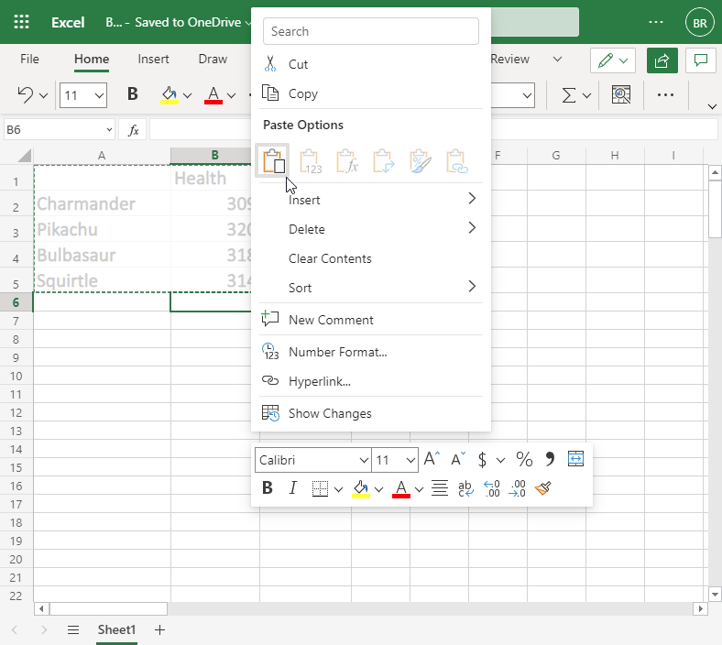

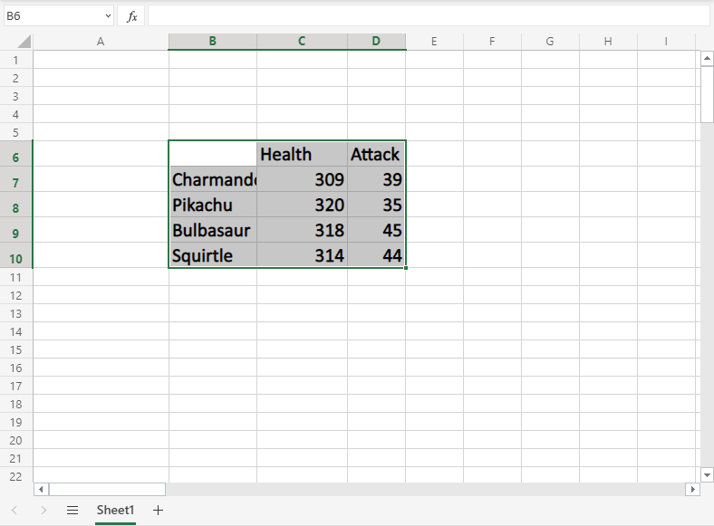

You have successfully cutted and pasted the range from A1:C5 to B6:D10.

## **Copy and paste**

Copy and paste works in the same way as cut and paste. The difference is that it does not remove the original cells.

Let's copy the cells back from B6:D10 to A1:C5.

**Tip:** You can copy using the hotkey CTRL+C and paste by CTRL+V. This saves you time. Try it!

Mark the range B6:D10.

Right click the marked area, and click on the "Copy" command which has two papers as its icon.

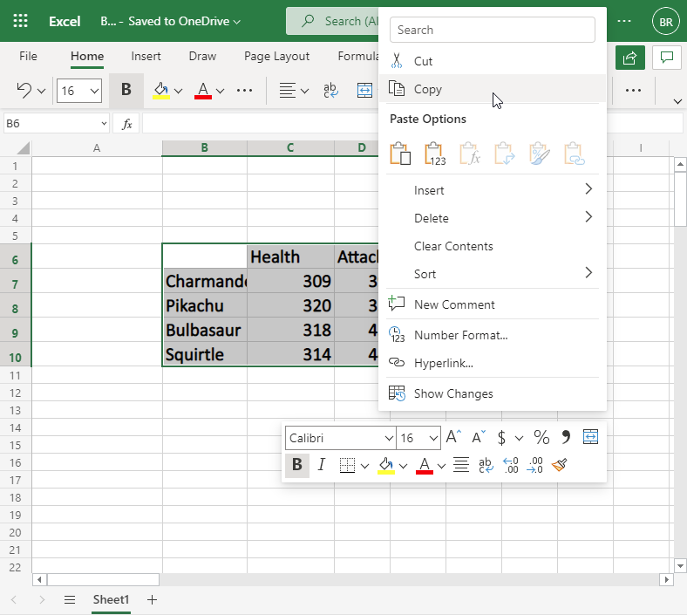

Copying gives the range a dotted green border. This indicates that the range is copied and ready for pasting.

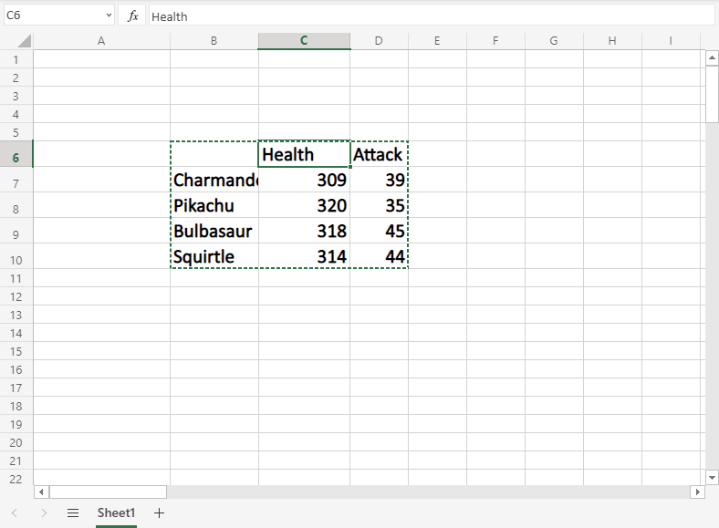

Right click the paste destination A1 and left click the paste icon:

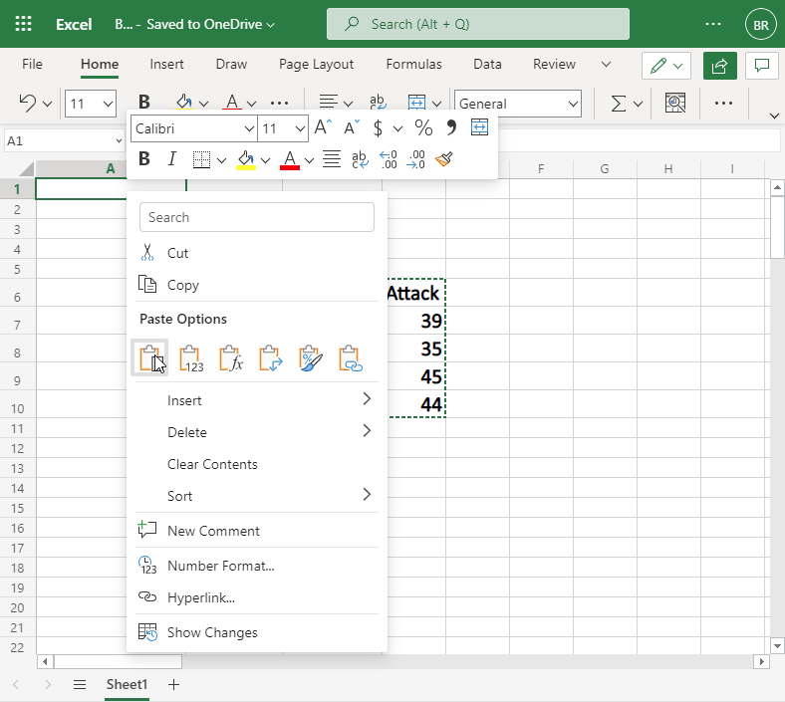

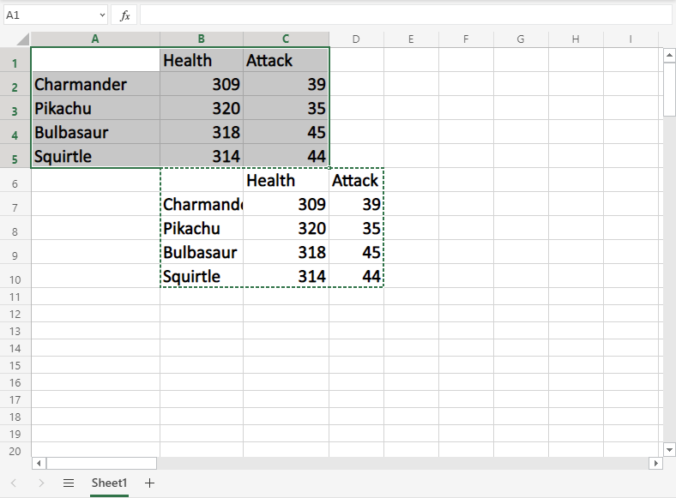

The difference between cutting and copying, is that cutting removes the originals, while copying leaves the originals.

Next, let's delete the original data and keep the data in the A1:C5 range.

## **Delete Data**

Select the original cells and remove them by pressing the "Delete" button on the keyboard:

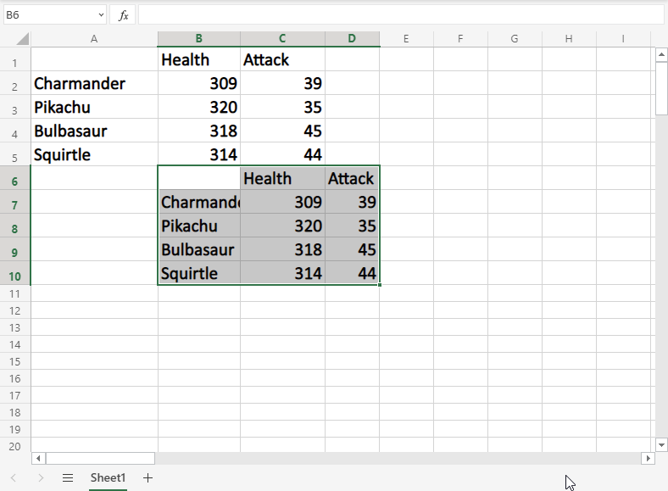

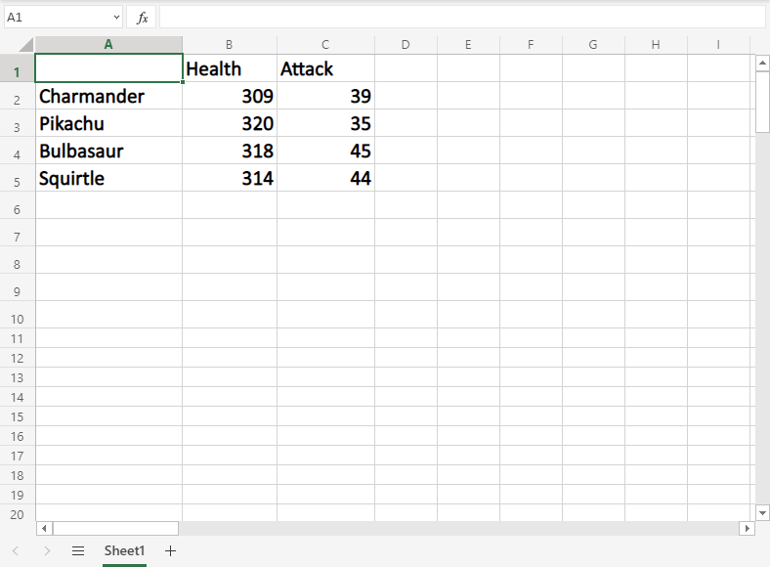

# Excel Add Cells

## **Adding New Columns**

Columns can be added and deleted. You access the menu by right clicking the column letter. New columns are added to the same place you clicked.

Let's try to create a new column B.

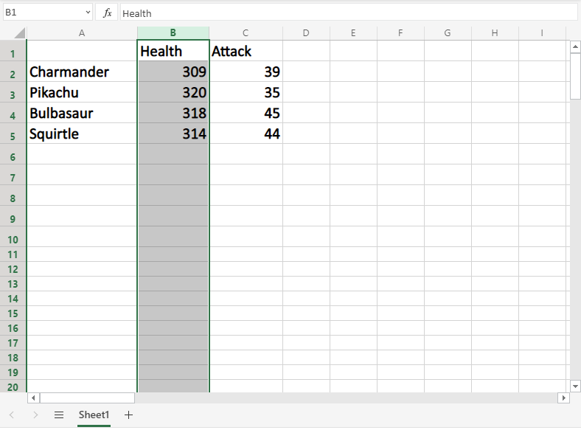

Right click on the column and select "Insert Columns":

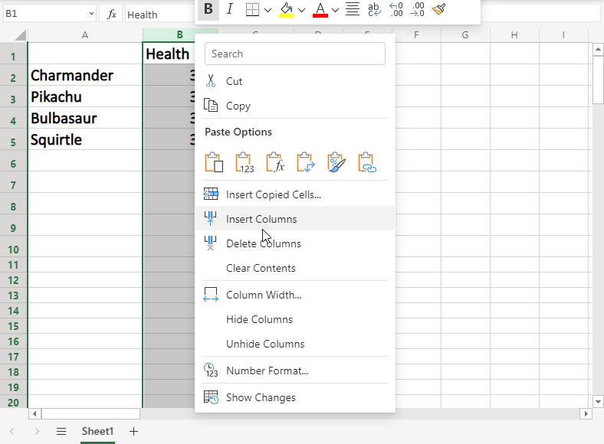

And a new column is created:

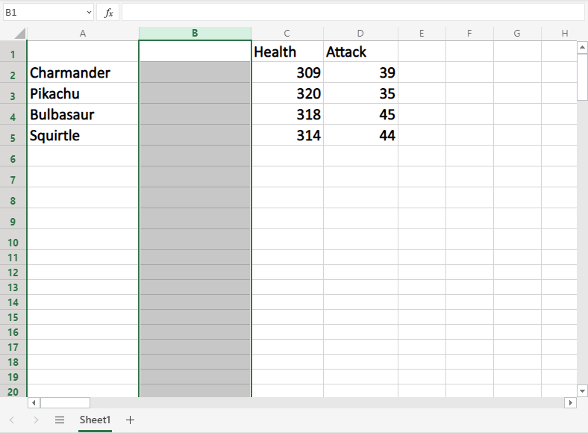

Next, we need to get some Pokemon trainers in there. Type or copy the following data in the new column B:

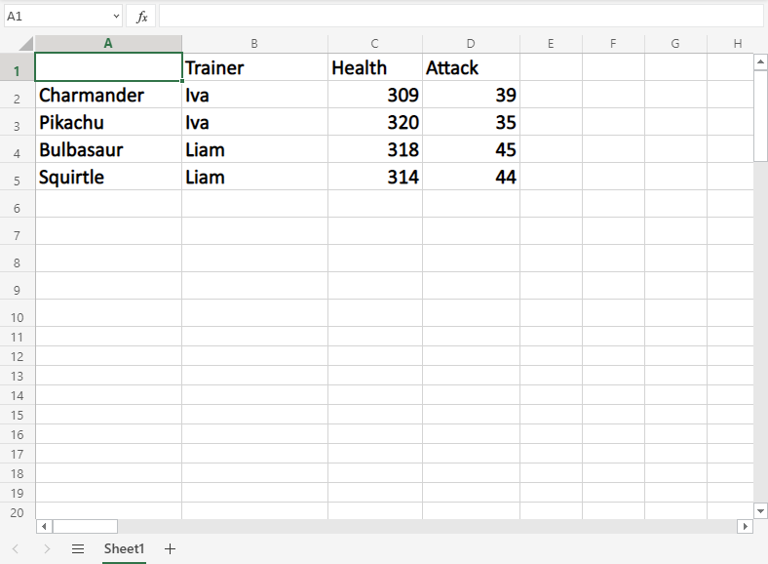

## **Adding New Rows**

Rows can also be added and deleted. You access the menu by right clicking the row number. New rows are added to the same place you clicked.

Let's try to create a new row 4.

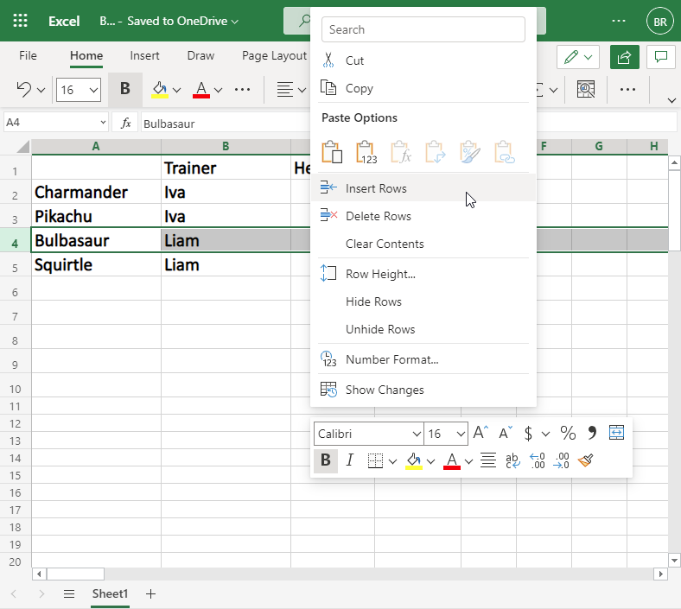

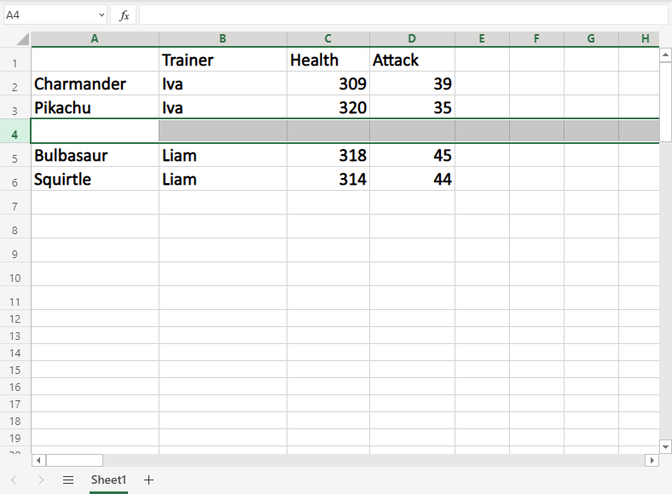

We forgot to add Iva's Pokemon, **Marowak**. Lets add his data to the new row 4, by typing or copying the following values:

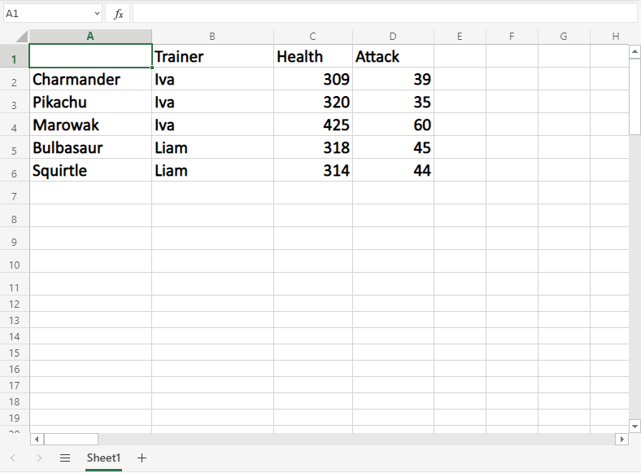

# Excel Delete Cells

## **Delete Cells**

Cells can be deleted by selecting them, and pressing the delete button.

**Note:** The delete function will not delete the formatting of the cell, just the value inside of it.

Let's have a look at three examples.

### **Example 1**

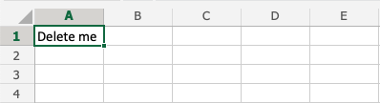

Pressing the delete button:

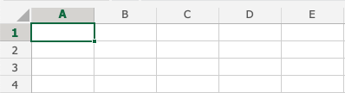

### **Example 2**

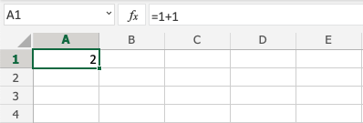

Pressing the delete button:

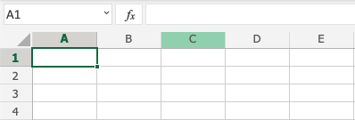

### **Example 3**

With formatting:

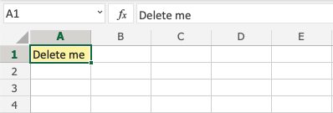

Pressing the delete button:

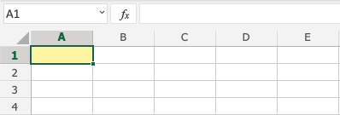

Note that it only deletes the value in the cells, and not the formatting (the color).

# Excel Undo and Redo

## **Undo**

The Undo function lets you reverse an action.

Undo is helpful if you regret an action and want to go back to how it was before.

**Note:** You cannot Undo things that you do in the File Menu, such as deleting a sheet, saving a spreadsheet or changing the options. The thumb rule is that you can Undo things you do in your sheet.

There are two ways to access the Undo command.

1) Pressing the Undo button in the Ribbon:

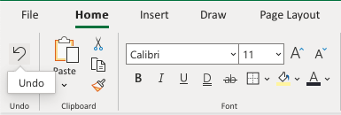

2) Using the keyboard shortcut CTRL + Z / Command + Z

Note: It is recommended to practice using the keyboard shortcut. It saves you time!

## **Redo**

The Redo function has the opposite effect as Undo, it reverses the Undo action.

Redo is helpful if you regret using Undo.

**Note:**The Redo command is only available if you have used Undo.

There are two ways to access the Redo command.

1) Pressing the Redo button in the Ribbon:

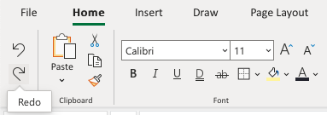

2) Using the keyboard shortcut CTRL + Y / Command + Y

# Excel Formulas

## **Formulas**

A formula in Excel is used to do mathematical calculations. Formulas always start with the equal sign (=) typed in the cell, followed by your calculation.

Formulas can be used for calculations such as:

* =1+1
* =2*2
* =4/2=2

It can also be used to calculate values using cells as input.

Let's have a look at an example.

Type or copy the following values:

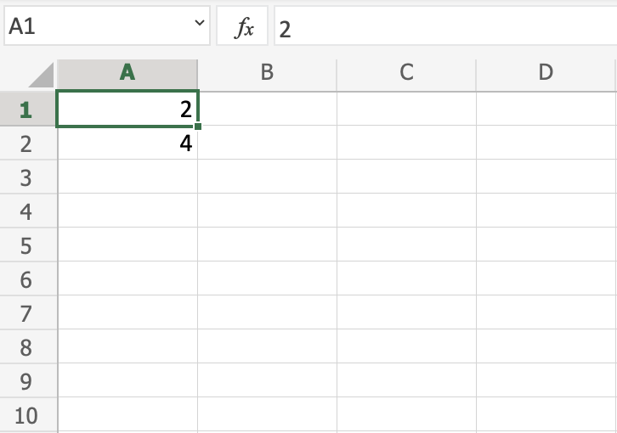

Now we want to do a calculation with those values.

Step by step:

1. Select C1 and type (=)
2. Left click A1
3. Type (+)
4. Left click A2
5. Press enter

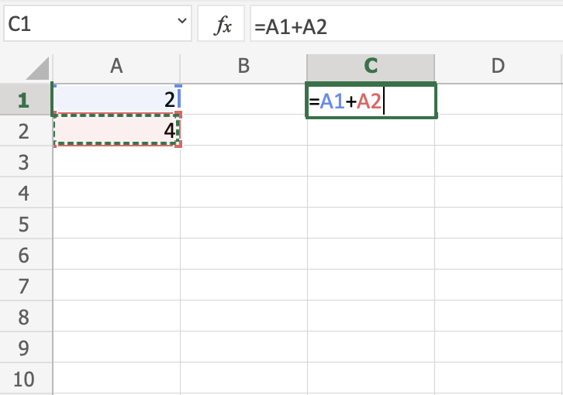

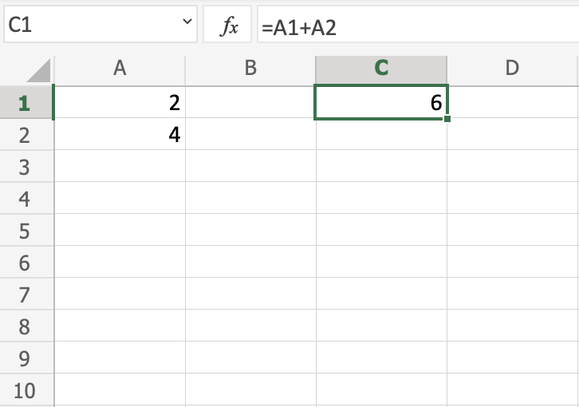

**You got it!** You have successfully calculated A1(2) + A2(4) = C1(6).

**Note:** Using cells to make calculations is an important part of Excel and you will use this alot as you learn.

Lets change from addition to multiplication, by replacing the (+) with a (*). It should now be =A1*A2, press enter to see what happens.

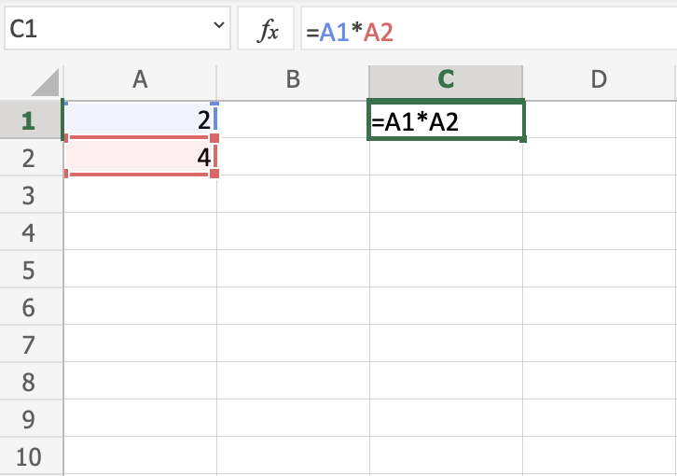

You got C1(8), right? **Well done!**

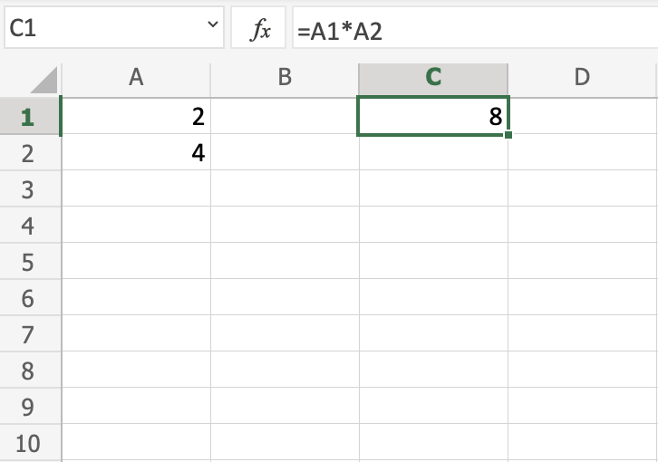

Now, try to change the multiplication (*) to subtraction (-) and dividing (/).

Let's add new data for the next example, where we will help the Pokemon trainers to count their Pokeballs.

Type or copy the following values:

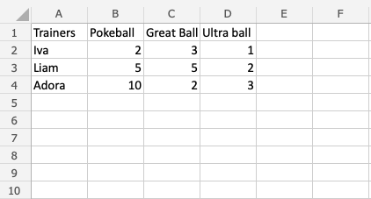

The data explained:

* Column A: Pokemon Trainers
* Row 1: Types of Pokeballs
* Range B2:D4: Amount of Pokeballs, Great balls and Ultra balls

**Note:** It is important to practice reading data to understand its context. In this example you should focus on the trainers and their Pokeballs, which have three different types: Pokeball, Great ball and Ultra ball.

Let's help Iva to count her Pokeballs. You find Iva in A2(Iva). The values in row 2 B2(2), C2(3), D2(1) belong to her.

Count the Pokeballs, step by step:

1. Select cell E2 and type (=)
2. Left click B2
3. Type (+)
4. Left click C2
5. Type (+)
6. Left click D2
7. Hit enter

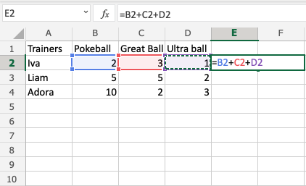

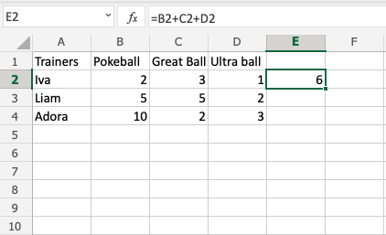

Did you get the value E2(6)? **Good job!** You have helped Iva to count her Pokeballs.

Now, let's help Liam and Adora with counting theirs.

Do you remember the [fill function](https://www.w3schools.com/excel/excel_filling.php) that we learned about earlier? It can be used to continue calculations sidewards, downwards and upwards. Let's try it!

Lets use the fill function to continue the formula, step by step:

1. Select E2
2. Fill E2:E4

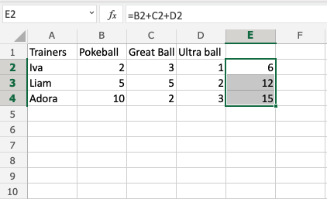

**That is cool, right?** The fill function continued the calculation that you used for Iva and was able to understand that you wanted to count the cells in the next rows as well.

Now we have counted the Pokeballs for all three; Iva(6), Liam(12) and Adora(15).

Let's see how many Pokeballs Iva, Liam and Adora have in total.

The total is called **SUM** in Excel.

There are two ways to calculate the **SUM**.

* Adding cells
* SUM function

Excel has many pre-made functions available for you to use. The **SUM**function is one of the most used ones. You will learn more about functions in a later chapter.

Let's try both approaches.

**Note:** You can navigate to the cells with your keyboard arrows instead of left clicking them. Try it!

Sum by adding cells, step by step:

1. Select cell E5, and type =
2. Left click E2
3. Type (+)
4. Left click E3
5. Type (+)
6. Left click E4
7. Hit enter

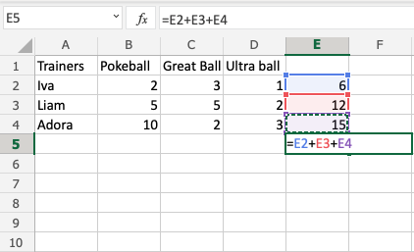

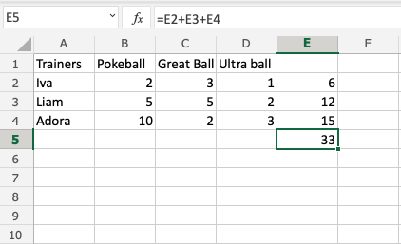

The result is E5(33).

Let's try the **SUM** function.

Remember to delete the values that you currently have in E5.

**SUM** function, step by step:

1. Type E5(=)
2. Write **SUM**
3. Double click **SUM** in the menu
4. Mark the range E2:E4
5. Hit enter

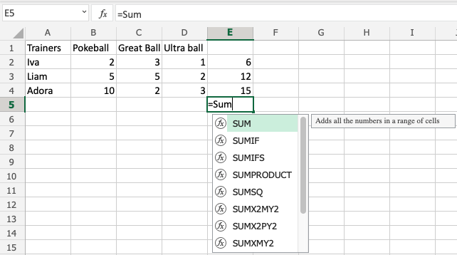

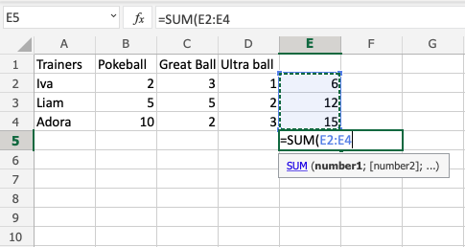

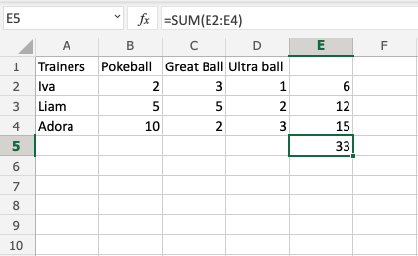

**Great job!** You have successfully calculated the **SUM** using the **SUM**function.

Iva, Liam and Adora have 33 Pokeballs in total.

Let's change a value to see what happens. Type B2(7):

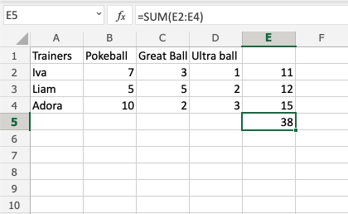

The value in cell B2 was changed from 2 to 7. Notice that the formulas are doing calculations when we change the value in the cells, and the **SUM**is updated from 33 to 38. It allows us to change values that are used by the formulas, and the calculations remain.

## **Chapter Summary**

Values used in formulas can be typed directly and by using cells. The formula updates the result if you change the value of cells, which is used in the formula. The fill function can be used to continue your formulas upwards, downwards and sidewards. Excel has pre-built functions, such as **SUM**.

In the next chapter you will learn about relative and absolute references.

# Excel Relative References

## Relative and Absolute References

Cells in Excel have unique references, which is its location.

References are used in formulas to do calculations, and the fill function can be used to continue formulas sidewards, downwards and upwards.

Excel has two types of references:

1. Relative references
2. Absolute references

Absolute reference is a choice we make. It is a command which tells Excel to lock a reference.

The dollar sign ($) is used to make references absolute.

Example of relative reference: A1

Example of absolute reference: $A$1

## **Relative reference**

References are relative by default, and are without dollar sign ($).

The relative reference makes the cells reference free. It gives the fill function freedom to continue the order without restrictions.

Let's have a look at a relative reference example, helping the Pokemon trainers to count their Pokeballs (B2:B7) and Great balls (C2:C7).

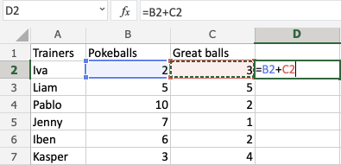

The result is: D2(5):

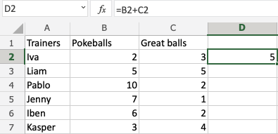

Next, fill the range D2:D7:

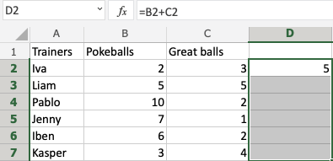

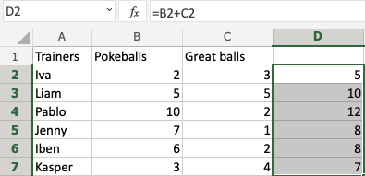

The references being relative allows the fill function to continue the formula for rows downwards.

Have a look at the formulas in D2:D7. Notice that it calculates the next row as you fill.

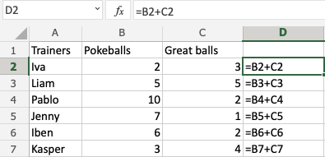

## **A Non-Working Example**

Let's try an example **that will not work**.

Fill D2:G2, filling to the **right**instead of downwards. Resulting in strange numbers:

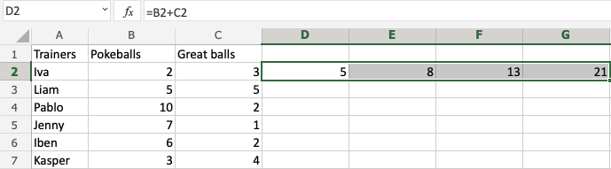

Have a look at the formulas.

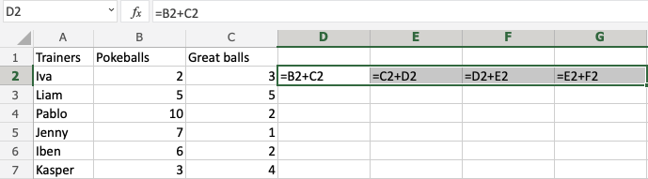

It assumes that we are calculating sidewards and not downwards.

The numbers that we want to calculate need to be in the same direction as we fill.

# Excel Absolute References

## **Absolute References**

Absolute reference is when a reference has the dollar sign ($).

It locks a reference in the formula.

Add $ to the formula to use absolute references.

The dollar sign has three different states:

* Absolute for column and row. The reference is absolutely locked.  
  Example =$A$1

* Absolute for the column. The reference is locked to that column. The row remains relative.  
  Example =$A1

* Absolute for the row. The reference is locked to that row. The column remains relative.  
  Example =A$1

Let's have a look at an example helping the Pokemon trainers to calculate prices for Pokeballs

Type or copy the following data:

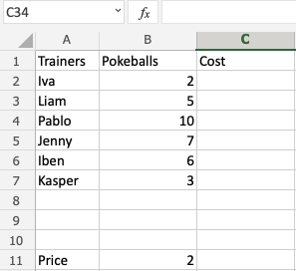

**Data explained**

* There are 6 trainers: Iva, Liam, Adora, Jenny, Iben and Kasper.
* They have different amount of Pokeballs each in their shop cart
* The price per Pokeball is 2 coins

**Help them to calculate the prices for the Pokeballs.**

The price's reference is B11, we do not want the fill function to change this, so we lock it.

The reference is absolutely locked by using the formula $B$11.

How to do it, step by step:

1. Type C2(=)
2. Select B11
3. Type ($) before the B and 11 ($B$11)
4. Type (*)
5. Select B2
6. Hit enter
7. Auto fill C2:C7

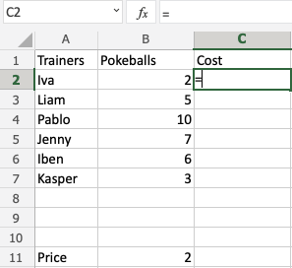

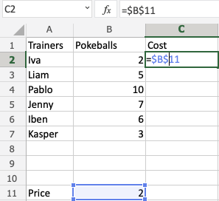

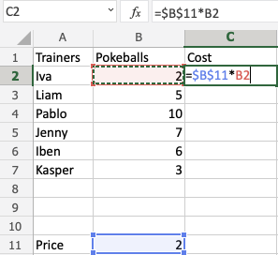

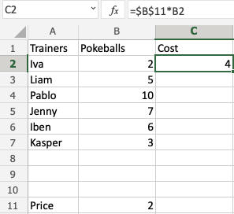

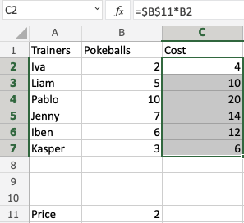

**Congratulations!** You successfully calculated the prices for the Pokeballs using an absolute reference.

# Excel Addition Operator

## **Addition Operator**

Addition uses the + symbol in Excel, and is also known as **plus**.

There are two ways to do addition in Excel. Either by using the + symbol in a formula or by using the**SUM** function.

How to add cells:

1. Select a cell and type (=)
2. Select a cell
3. Type (+)
4. Select another cell
5. Hit enter

You can add more cells to the formula by typing (+) between the cells.

Let's have a look at some examples.

## **Adding Two Manual Entries**

* Type A1(=)
* Type 5+5
* Hit enter

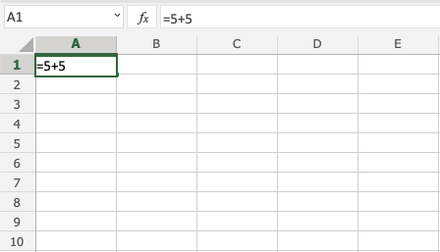

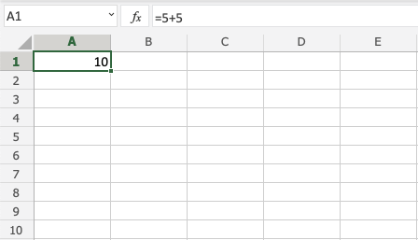

**Congratulations!** You have successfully added 5+5=10.

## **Adding Two Cells**

First let's add some numbers to work with. Type the following values:

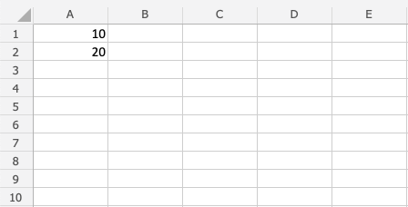

How to do it, step by step:

1. Type B1(=)
2. Select A1
3. Type (+)
4. Select A2
5. Hit enter

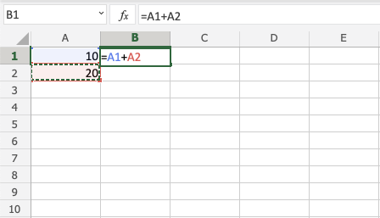

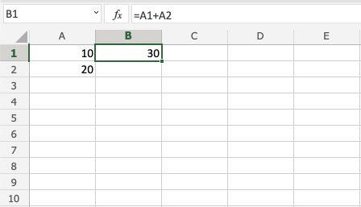

**Great!** 30 is the result by adding A1 and A2.

## **Adding Several Cells**

First let's add some numbers to work with. Type the following values:

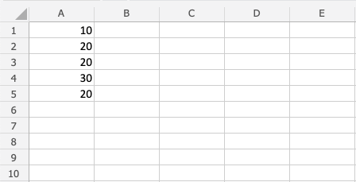

Step by step to add several cells:

1. Type B1(=)
2. Select A1
3. Type (+)
4. Select A2
5. Type (+)
6. Select A3
7. Type (+)
8. Select A4
9. Type (+)
10. Select A5
11. Hit enter

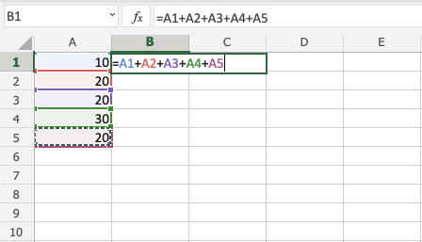

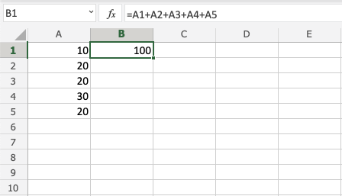

**Good job!** You have successfully added five cells!

## **Adding with SUM**

Let's keep the numbers from the last exercise. If you did last exercise, remove the value in B1.



Step by step to add with SUM:

1. Type B1(=SUM)
2. Double click the SUM command
3. Mark the range A1:A5
4. Hit enter

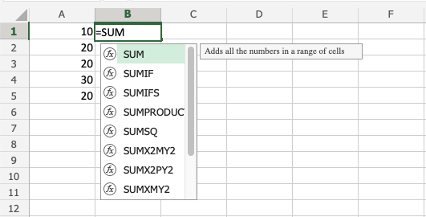

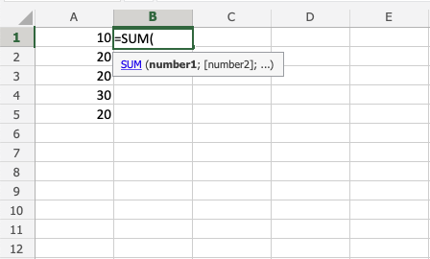

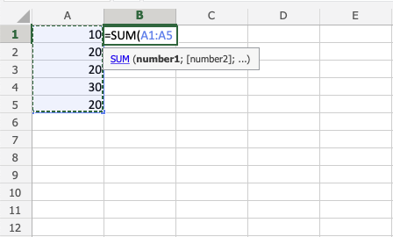

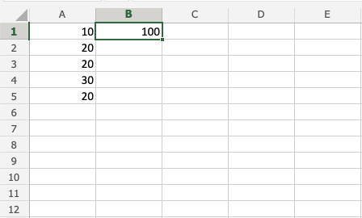

**Note:** SUM saves you time! Keep practicing this function.

## **Adding Using Absolute Reference**

You can also lock a cell and add it to other cells.

How to do it, step by step:

1. Select a cell and type (=)
2. Select the cell you want to lock, add two dollar signs ($) before the column and row
3. Type (+)
4. Fill a range

Let's have a look at an example where we add B(5) to the range A1:A10 using absolute reference and the fill function.

Type the values:

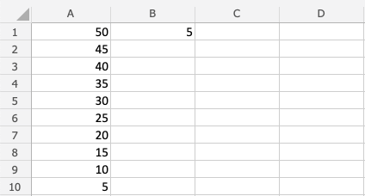

Step by step:

1. Type C1(=)
2. Select B1
3. Type dollar sign before column and row $B$1
4. Type (+)
5. Select A1
6. Hit enter
7. Fill the range C1:C10

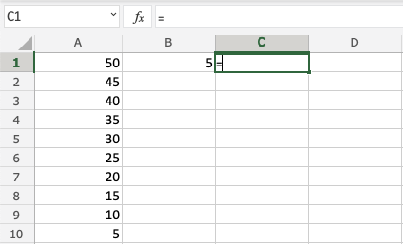

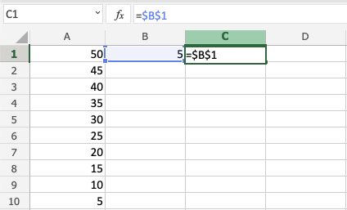

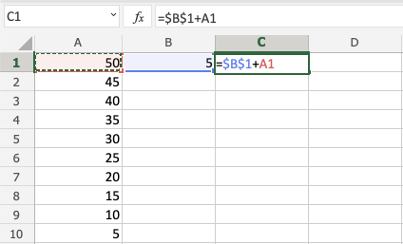

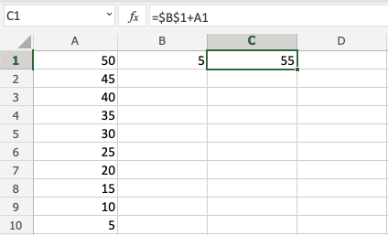

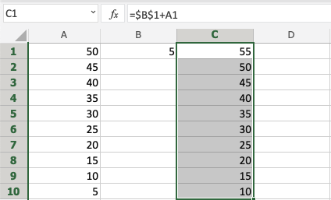

**Great!** You have successfully used absolute reference to add B1(5) with the range A1:A10.

# Excel Subtraction Operator

## **Subtraction Operator**

Subtraction uses the - symbol, and is also known as **minus**.

How to subtract cells:

1. Select a cell and type (=)
2. Select the minuend
3. Type (-)
4. Select the subtrahend
5. Hit enter

Note: The minuend is the number to which the subtrahend subtracts from.

You can add more cells to the formula by typing (-) between the cells.

Let's have a look at some examples.

## **Subtracting Two Manual Entries**

Let's start with adding in a formula. Start with a clean sheet

Step by step:

1. Type A1(=)
2. Type 100-50
3. Hit enter

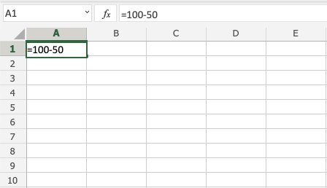

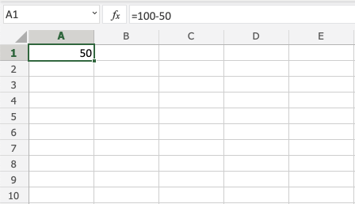

**Tip:** You can add more values into the formula by typing (-) between the cells.

## **Subtracting Using Two Cells**

Let's add some numbers to work with. Type the following values:

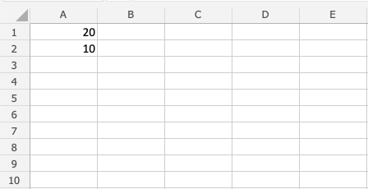

Subtracting using two cells, step by step:

1. Type A3(=)
2. Select A1
3. Type (-)
4. Select A2
5. Hit enter

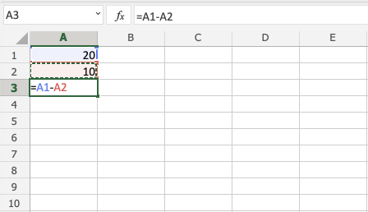

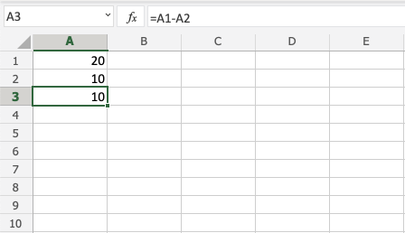

## **Subtracting Using Many Cells**

Let's subtract using many cells. First, type the following values:

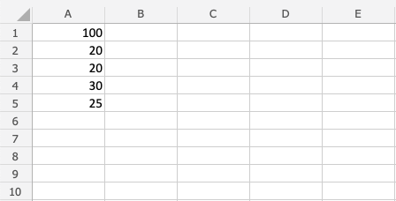

Step by step:

1. Type B1(=)
2. Select A1
3. Type (-)
4. Select A2
5. Type (-)
6. Select A3
7. Type (-)
8. Select A4
9. Type (-)
10. Select A5
11. Hit enter

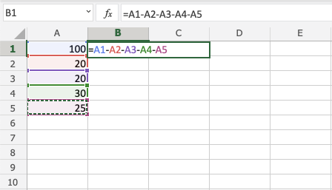

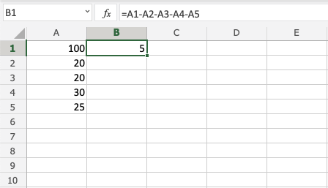

## **Subtracting Using Absolute Reference**

You can lock a cell and subtract it from other cells.

How to do it, step by step:

1. Select a cell and type (=)
2. Select the minuend
3. Type (-)
4. Select the subtrahend and add two dollar signs ($) before the column and row
5. Hit enter
6. Fill the range

**Note:** The minuend is the number to which the subtrahend subtracts from.

Let's have a look at an example where we subtract B(5) from the range A1:A10 using absolute reference and fill function.

Type the values:

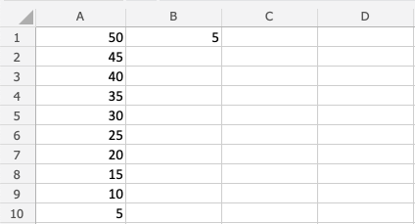

Step by step:

1. Type C1(=)
2. Select A1
3. Type (-)
4. Select B1 and type dollar sign before column and row $B$1
5. Hit enter
6. Fill C1:C10

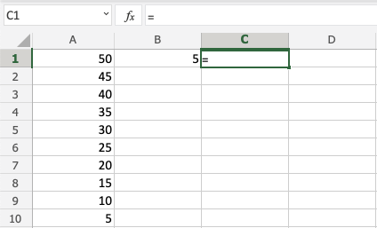

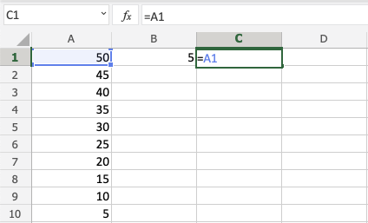

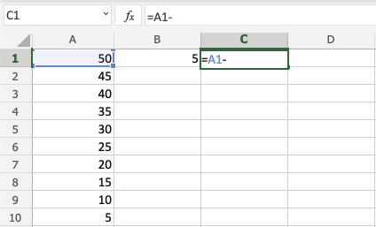

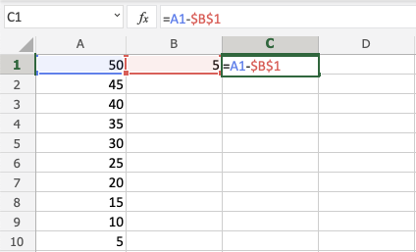

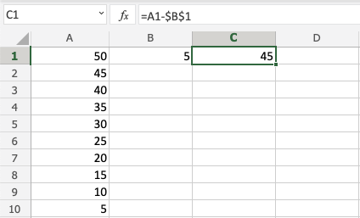

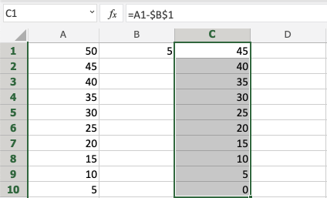

**You got it!** You have successfully used absolute reference to subtract B1(5) from the minuend range A1:A10.

# Excel Multiplication Operator

## **Multiplication Operator**

Multiplication uses the * symbol in Excel.

How to multiply cells:

1. Select a cell and type (=)
2. Select a cell
3. Type (*)
4. Select another cell
5. Hit enter

You can add more cells to formula by typing (*) between the cells.

Let's have a look at some examples.

## **Multiplying Manual Entries**

Let's start with adding in a formula. Start with a clean sheet.

Step by step:

1. Type A1(=)
2. Type 2*2
3. Hit enter

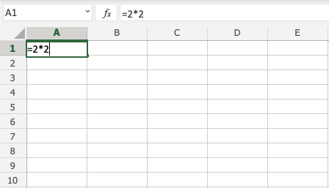

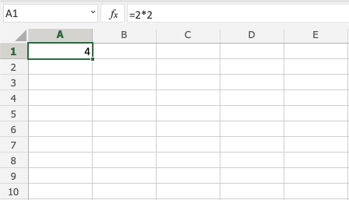

## **Multiplying Two Cells**

Let's add some numbers to work with. Type the following values:



Step by step:

1. Type A3(=)
2. Select A1
3. Type (*)
4. Select A2
5. Hit enter

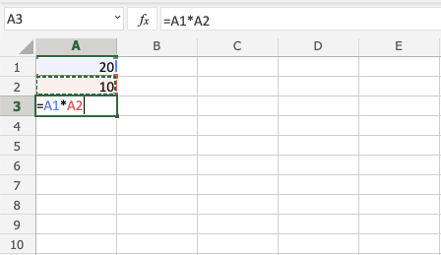

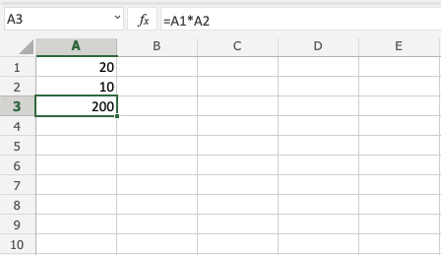

## **Multiplying Using Absolute Reference**

You can lock a cell and multiply it with other cells.

How to do it, step by step:

1. Select a cell and type (=)
2. Select the cell you want to lock and add two dollar signs ($) before the column and row
3. Type (*)
4. Select another cell
5. Hit enter
6. Fill the range

Let's have a look at an example where we multiply B(5) with the range A1:A10 using [absolute reference](https://www.w3schools.com/excel/excel_abs_ref.php) and the [fill function](https://www.w3schools.com/excel/excel_filling.php).

Type the values:



Step by step:

1. Type C1(=)
2. Select B1 type dollar sign before column and row $B$1
3. Type (*)
4. Select A1
5. Hit enter
6. Fill C1:C10

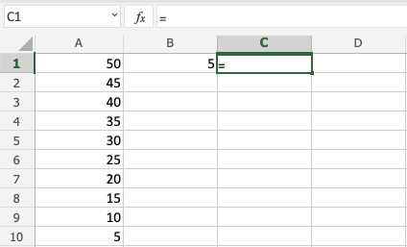

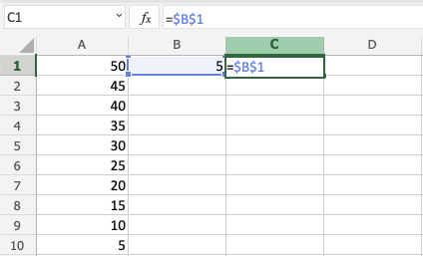

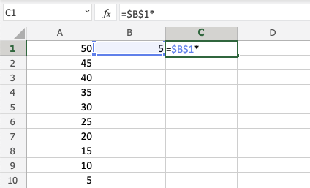

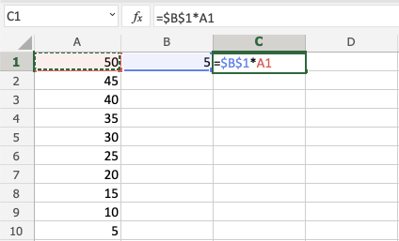

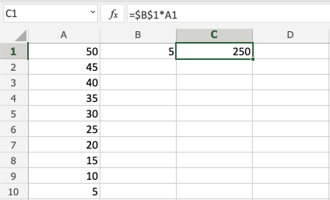

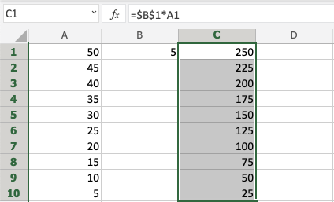

**You got it!** You have successfully used [absolute reference](https://www.w3schools.com/excel/excel_abs_ref.php) to multiply B1(5) with the range A1:A10.

# Excel Division Operator

## **Division Operator**

Division uses the / symbol in Excel.

How to do division cells:

1. Select a cell and type (=)
2. Select a cell
3. Type (/)
4. Select another cell
5. Hit enter

You can add more cells to the formula by typing (/) between the cells.

Let's have a look at some examples.

## **Dividing Manual Entries**

Let's start with adding in a formula. Start with a clean sheet.

Step by step:

1. Type A1(=)
2. Type 4/2
3. Hit enter

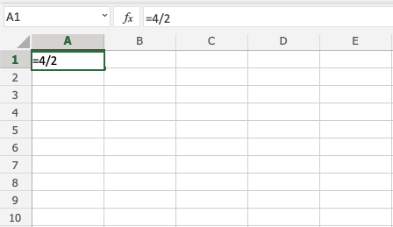

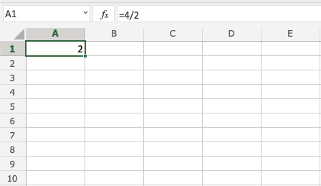

## **Dividing Two Cells**

Let's add some numbers to work with. Type the following values:



Step by step:

1. Type A3(=)
2. Select A1
3. Type (/)
4. Select A2
5. Hit enter

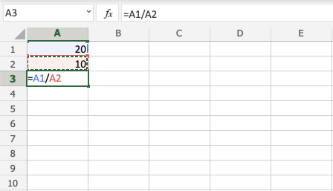

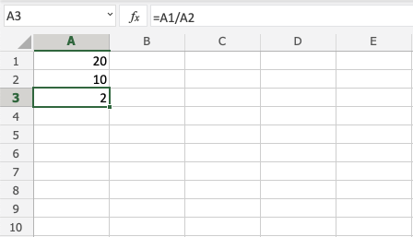

## **Dividing Using Absolute Reference**

You can lock a cell and divide it with other cells.

How to do it, step by step:

1. Select a cell and type (=)
2. Select the dividend
3. Type (/)
4. Select the divisor lock and add two dollar signs ($) before the column and row
5. Hit enter
6. Fill the range

**Note:**Dividend is the number being divided by the divisor.

Let's have a look at an example where we divide B(5) with the range A1:A10 using absolute reference and fill function.

Type the values:



Step by step:

1. Type C1(=)
2. Select A1
3. Type (/)
4. Select B1 type dollar sign before column and row $B$1
5. Hit enter
6. Fill C1:C10



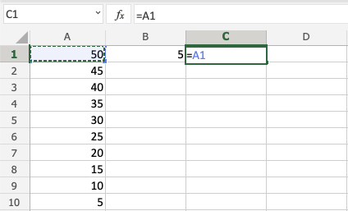

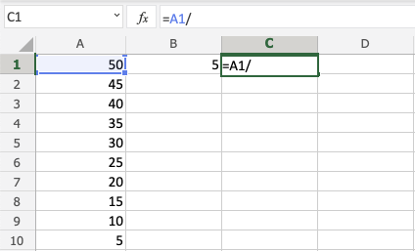

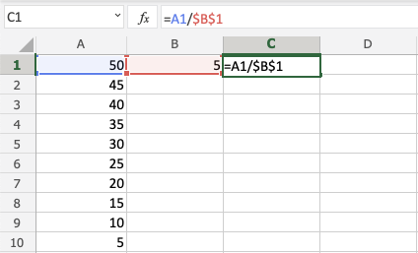

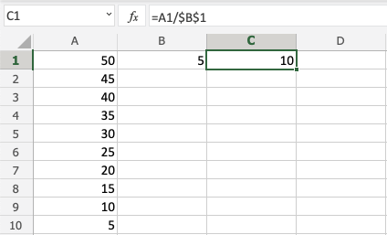

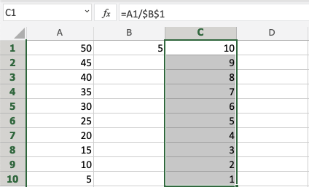

**Goob job!** You have successfully used absolute reference to divide B1(5) with the range A1:A10.

# Excel Parentheses

## **Parentheses**

Parentheses () is used to change the order of an operation.

Using parentheses makes Excel do the calculation for the numbers inside the parentheses first, before calculating the rest of the formula.

Parentheses are added by typing () on both sides of numbers, like (1+2).

### **Examples**

**No parentheses**

=10+5*2

The result is 20 because it calculates (10+10)

**With parentheses**

=(10+5)*2

The result is 30 because it calculates (15)*2

**Formulas can have groups of parentheses.**

=(10+5)+(2*4)+(4/2)

**Note:** Cells can be used as values in the formulas inside parentheses, like =(A1+A2)*B5. We have used manual entries in our examples to keep things simple.

Let's have a look at some real examples in Excel.

## **Without Parentheses**

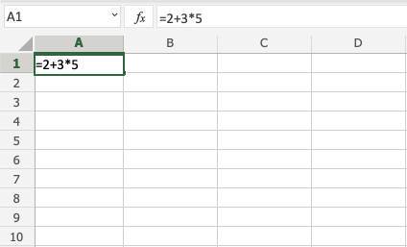

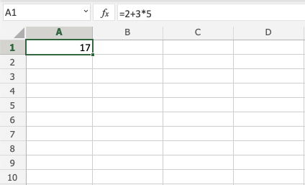

The result is 17, the calculation is 2+15. It uses 15 because 3*5=15.

## **With One Parentheses**

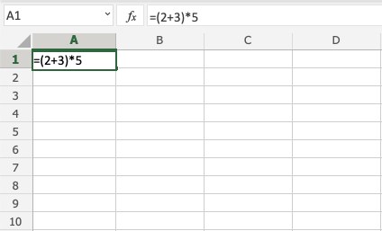

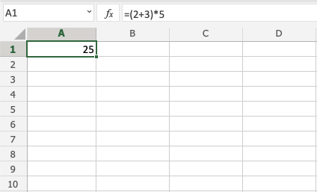

The result is 25, the calculation is 5*5. It uses 5 because it has calculated numbers inside the parentheses (2+3)=5 first.

## **With Many Parentheses**

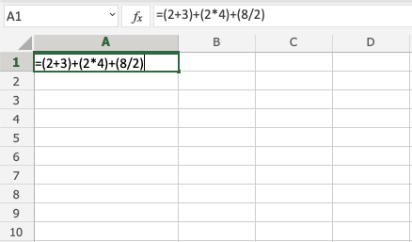

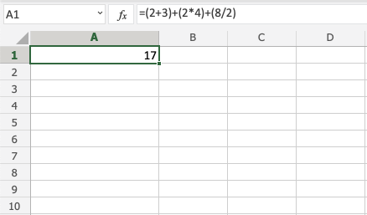

The result is 17, the calculation is 5+8+4. The numbers inside the parentheses are calculated first.

## **Nesting Parentheses**

When using more advanced formulas you may need to nest parentheses. You can look at this like an onion, which has many layers. Excel will calculate the numbers inside the parentheses first, layer by layer, starting with the inner layer.

**Example no nesting**

=2*2+3*4+5*5*2

It calculates the values flat as you would do with a calculator.

**Example nesting**

=((2*2)+(3*4)+(5*5))*2

Let's break it down and explain.

Nesting creates layers like an onion. You can have many layers. This example uses two, the inner and outer layers

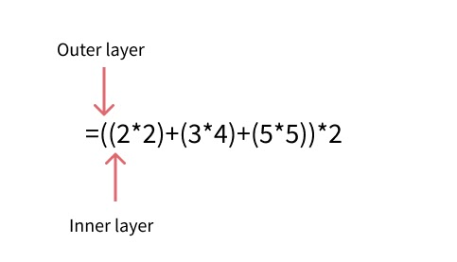

It starts with calculating the numbers in the inner layer:

1. =((2*2)+(3*4)+(5*5))*2
2. =((4)+(12)+25))*2 Calculates the inner layer
3. =(41)*2 Calculates the outer layer
4. 82

## **Chapter Summary**

Parentheses can be used to change the order of an operation. The numbers inside the parentheses gets calculated first. A formula can have sets of parentheses. More advanced formulas can use nesting to create layers of operations, like an onion. It calculates the inner layer first, then the next, and so on.

# Excel Functions

## **Functions**

Excel has many premade formulas, called **functions**.

Functions are typed by = and the functions name.

For example =SUM

Once you have typed the function name you need to apply it to a range.

For example =SUM(A1:A5)

The range is always inside of parentheses.

|  |  |
| --- | --- |
| **Function** | **Description** |
| [=AND](https://www.w3schools.com/excel/excel_and.php) | Returns TRUE or FALSE based on two or more conditions |
| [=AVERAGE](https://www.w3schools.com/excel/excel_average.php) | Calculates the average (arithmetic mean) |
| [=AVERAGEIF](https://www.w3schools.com/excel/excel_averageif.php) | Calculates the average of a range based on a TRUE or FALSE condition |
| [=AVERAGEIFS](https://www.w3schools.com/excel/excel_averageifs.php) | Calculates the average of a range based on one or more TRUE/FALSE conditions |
| [=CONCAT](https://www.w3schools.com/excel/excel_concat.php) | Links together the content of multiple cells |
| [=COUNT](https://www.w3schools.com/excel/excel_count.php) | Counts cells with numbers in a range |
| [=COUNTA](https://www.w3schools.com/excel/excel_counta.php) | Counts all cells in a range that has values, both numbers and letters |
| [=COUNTBLANK](https://www.w3schools.com/excel/excel_countblank.php) | Counts blank cells in a range |
| [=COUNTIF](https://www.w3schools.com/excel/excel_countif.php) | Counts cells as specified |
| [=COUNTIFS](https://www.w3schools.com/excel/excel_countifs.php) | Counts cells in a range based on one or more TRUE or FALSE condition |
| [=IF](https://www.w3schools.com/excel/excel_if.php) | Returns values based on a TRUE or FALSE condition |
| [=IFS](https://www.w3schools.com/excel/excel_ifs.php) | Returns values based on one or more TRUE or FALSE conditions |
| [=LEFT](https://www.w3schools.com/excel/excel_left.php) | Returns values from the left side of a cell |
| [=LOWER](https://www.w3schools.com/excel/excel_lower.php) | Reformats content to lowercase |
| [=MAX](https://www.w3schools.com/excel/excel_max.php) | Returns the highest value in a range |
| [=MEDIAN](https://www.w3schools.com/excel/excel_median.php) | Returns the middle value in the data |
| [=MIN](https://www.w3schools.com/excel/excel_min.php) | Returns the lowest value in a range |
| [=MODE](https://www.w3schools.com/excel/excel_mode.php) | Finds the number seen most times. The function always returns a single number |
| [=NPV](https://www.w3schools.com/excel/excel_npv.php) | The NPV function is used to calculate the Net Present Value (NPV) |
| [=OR](https://www.w3schools.com/excel/excel_or.php) | Returns TRUE or FALSE based on two or more conditions |
| [=RAND](https://www.w3schools.com/excel/excel_rand.php) | Generates a random number |
| [=RIGHT](https://www.w3schools.com/excel/excel_right.php) | Returns values from the right side of a cell |
| [=STDEV.P](https://www.w3schools.com/excel/excel_stdevp.php) | Calculates the Standard Deviation (Std) for the entire population |
| [=STDEV.S](https://www.w3schools.com/excel/excel_stdevs.php) | Calculates the Standard Deviation (Std) for a sample |
| [=SUM](https://www.w3schools.com/excel/excel_sum.php) | Adds together numbers in a range |
| [=SUMIF](https://www.w3schools.com/excel/excel_sumif.php) | Calculates the sum of values in a range based on a TRUE or FALSE condition |
| [=SUMIFS](https://www.w3schools.com/excel/excel_sumifs.php) | Calculates the sum of a range based on one or more TRUE or FALSE condition |
| [=TRIM](https://www.w3schools.com/excel/excel_trim.php) | Removes irregular spacing, leaving one space between each value |
| [=VLOOKUP](https://www.w3schools.com/excel/excel_vlookup.php) | Allows vertical searches for values in a table |
| [=XOR](https://www.w3schools.com/excel/excel_xor.php) | Returns TRUE or FALSE based on two or more conditions |

# Excel Formatting

## **Formatting**

Excel has many ways to format and style a spreadsheet.

Why format and style your spreadsheet?

* Make it easier to read and understand
* Make it more delicate

Styling is about changing the looks of cells, such as changing colors, font, font sizes, borders, number formats, and so on.

The most used styling functions are:

* Colors
* Fonts
* Borders
* Number formats
* Grids

There are two ways to access the styling commands in Excel:

1. The Ribbon
2. Formatting menu, by right clicking cells

## **Styling Commands in Ribbon**



The Ribbon can be expanded by clicking the arrow/caret-down icon on the right side. This gives access to more commands:



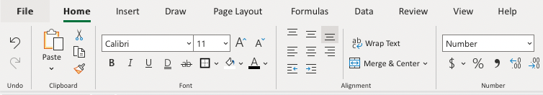

## **Styling Commands, Right Clicking Cells**

You can also right-click on any cell to style it:

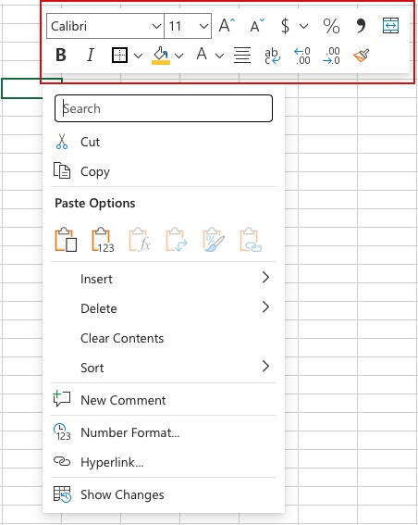

## **Chapter summary**

Formatting is used to make spreadsheets more readable. There are many ways to add styles. The most common ones are; Color, Font, Number format and Grids.

# Excel Format Painter

## **Format Painter**

The format painter is a command which lets you copy formatting from one cell to another.

It is a great tool, which saves you lots of time!

The Format painter can be used to copy to single cells or ranges.

Format Painter is used by clicking on its button in the Ribbon, found in the Clipboard group.

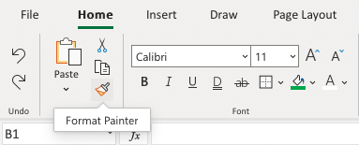

## **How To Use the Format Painter**

1. Select the cell that you want to copy
2. Click the Format Painter button
3. Select a cell or range

Let's try some examples and copy formats with Colors and font Characteristics, such as bold, italic and underline:

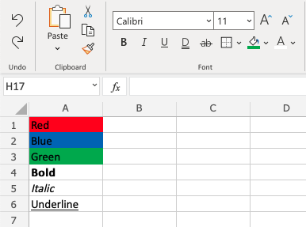

Copy the red color from A1 to B1.

Step by step:

1. Select A1
2. Click the **Format Painter** button
3. Select B1

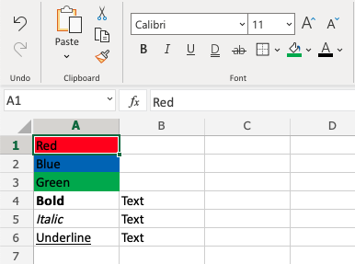

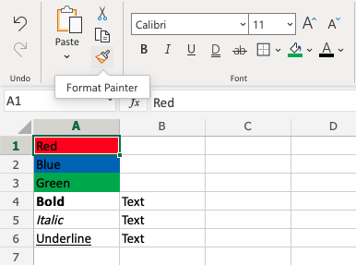

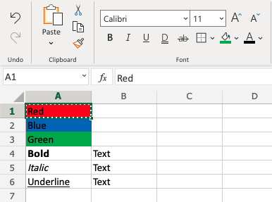

Notice the dotted border around A1. This indicates that the format is copied and ready for pasting. Let's paste it to B1!

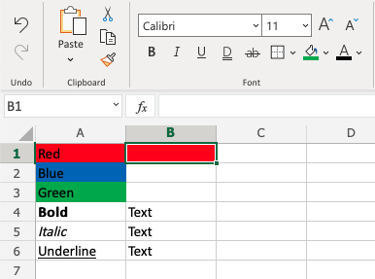

## **Copy and Paste Color to Multiple Cells**

Copy B2 to C2. That is right, let's try to paste to a range of two cells!

1. Select A2
2. Click the **Format Painter** button
3. Select B2 and hold an drag to C2

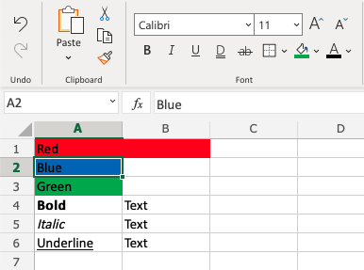

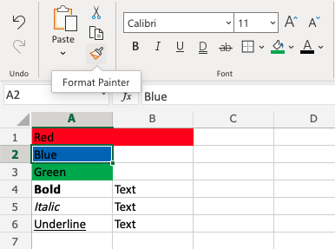

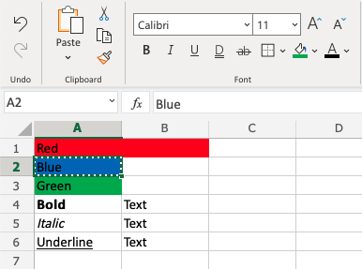

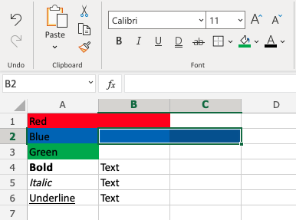

**That's the way!** The format painter can be used for single cells and on ranges.

## **Copy Font Characteristics**

Last example. Copy the Font Characteristics from A4:A6 to B4:B6.

Step by step:

1. Mark A4:A6
2. Click the **Format Painter**button
3. Drag and mark B4:B6

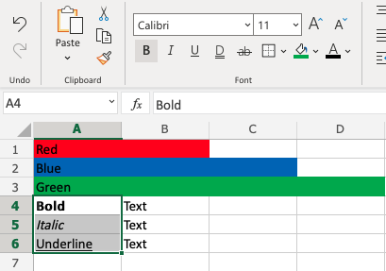

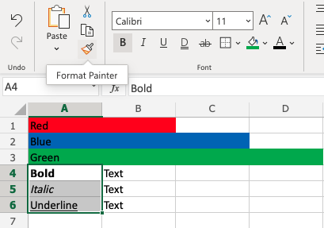

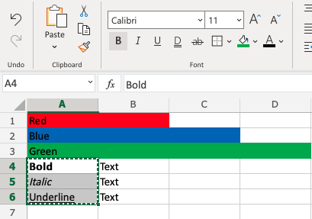

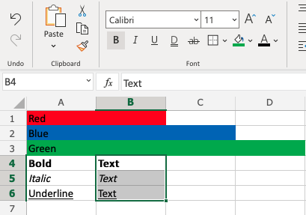

# Excel Format Colors

## **Colors**

Colors are specified by selection or by using Hexadecimal and RGB codes.

## **Theme and Standard Colors**

Excel has a set of themes and standard colors available for use. You select a color by clicking it:

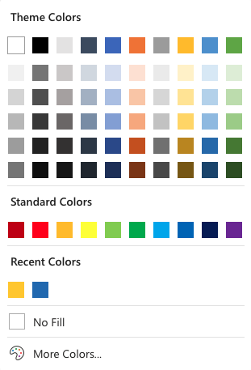

The "**More Colors**" option allows you to select custom colors by entering a RGB or HEX code.

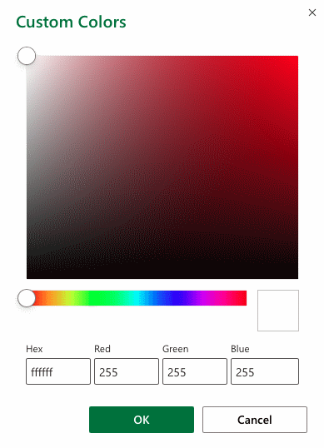

## **Hexadecimal Colors**

Excel supports Hexadecimal color values

A hexadecimal color is specified with: #RRGGBB.

RR (red), GG (green) and BB (blue) are hexadecimal integers between 00 and FF specifying the intensity of the color.

For example, #0000FF is displayed as blue, because the blue component is set to its highest value (FF) and the others are set to 00.

## **RGB Colors**

Excel supports RGB color values.

An RGB color value is specified with: rgb( RED , GREEN , BLUE ).

Each parameter defines the intensity of the color as an integer between 0 and 255.

For example, rgb(0,0,255) is rendered as blue, because the blue parameter is set to its highest value (255) and the others are set to 0.

## **Applying colors**

Colors can be applied to cells, text and borders.

Colors are applied to cells by using the "**Fill color**" function.

How to apply colors to cells:

1. Select color
2. Select range
3. Click the Fill Color button

The "**Fill color**" button remembers the color you used the last time.

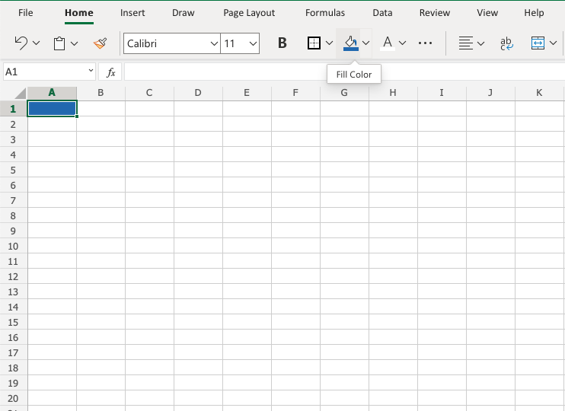

Color options are explored by clicking on the arrow-down icon (), next to the Fill color command:

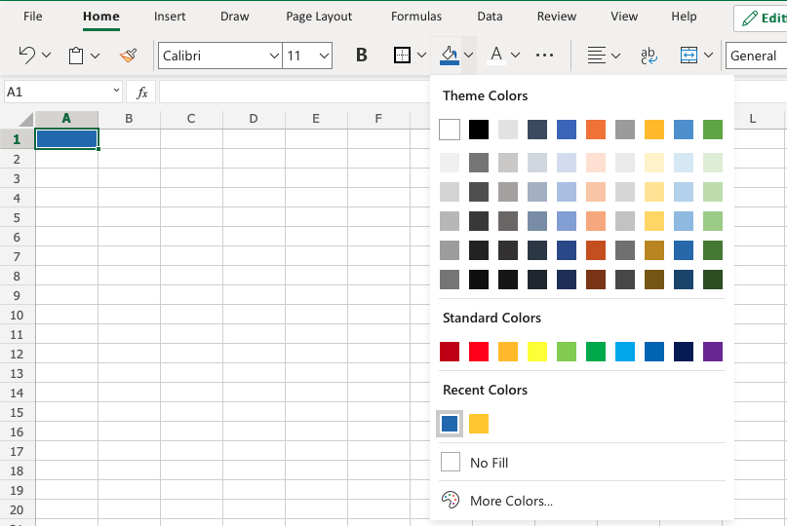

The option allows selection of theme colors, standard colors or use of HEX or RGB codes by clicking on the More Colors option:

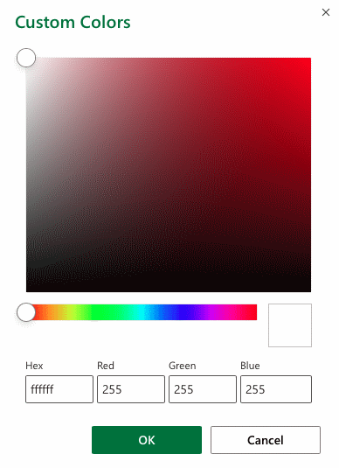

Colors are made from red, green, blue and are universal. Entering a color in one way will give you the code in the other. For example if you enter a HEX code, it will give you the RGB code for the same color.

**Let's try some examples.**

Starting with **theme**and **standard**colors:

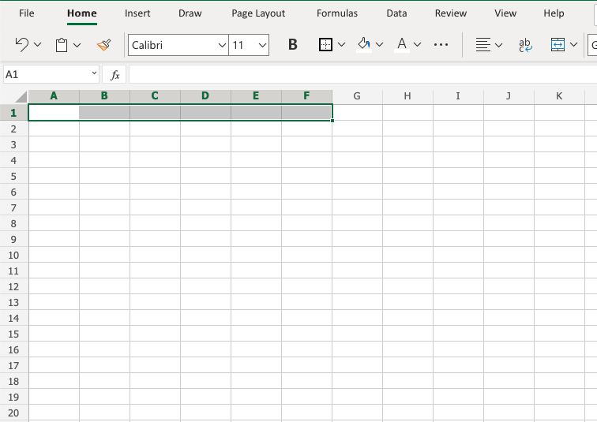

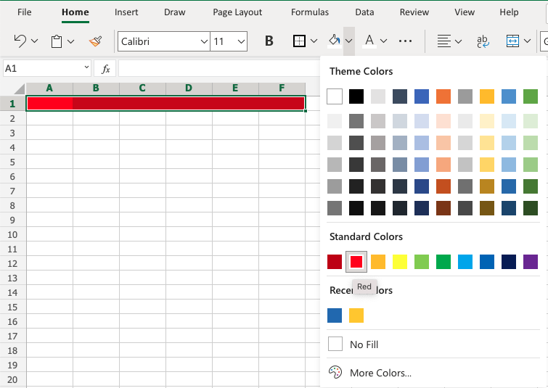

**Great!**

Try to apply the following colors:

* Theme color blue (accent 5) to A3:F3.
* Theme color green (accent 6) and A5:F5.

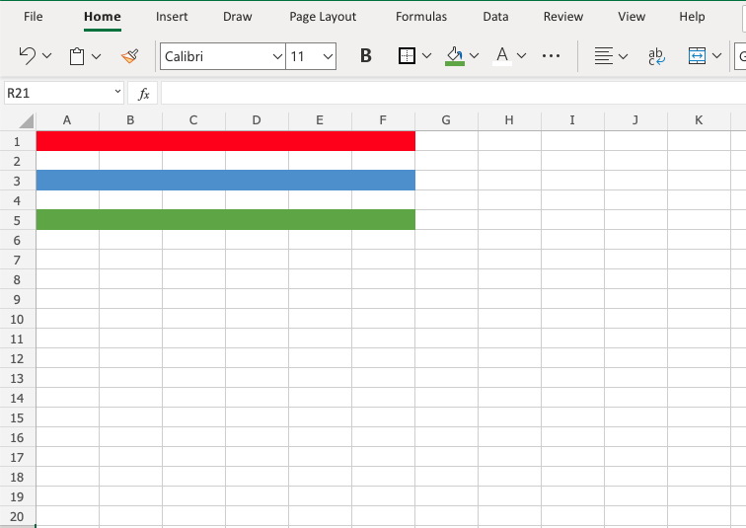

Did you make it?

Let's apply colors using HEX and RGB codes.

Apply HEX code #ffcb05 to A7:F7:

Step by step:

1. Select A7:F7
2. Open color options
3. Click **More colors**
4. Insert #ffcb05 in the **HEX** input field
5. Hit enter

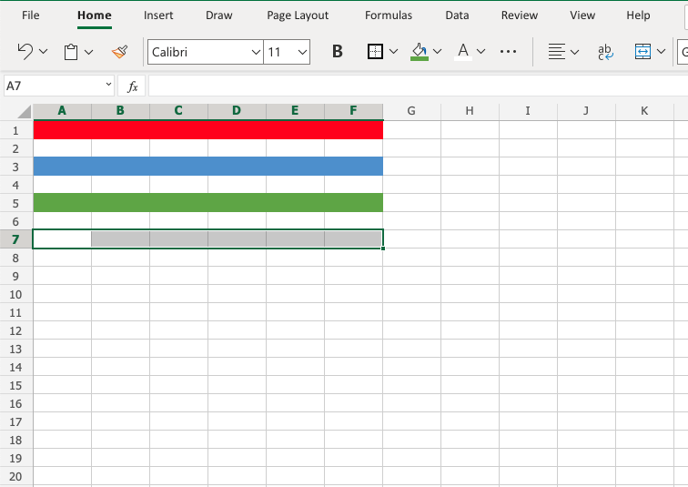

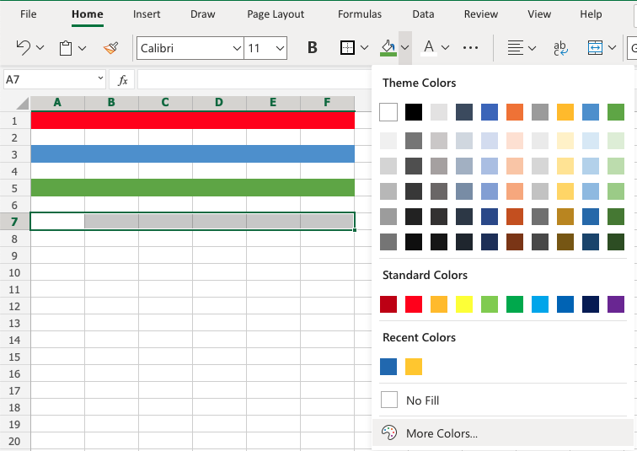

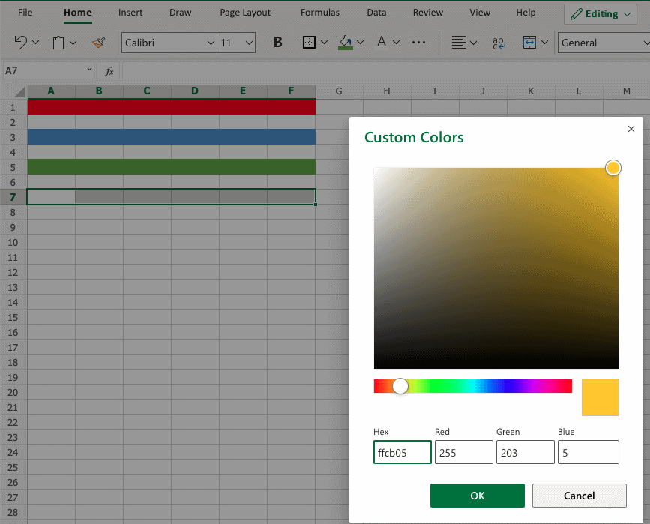

Notice that applying the HEX code gives the RGB code for the same color, and shows where that color is positioned on the color map.

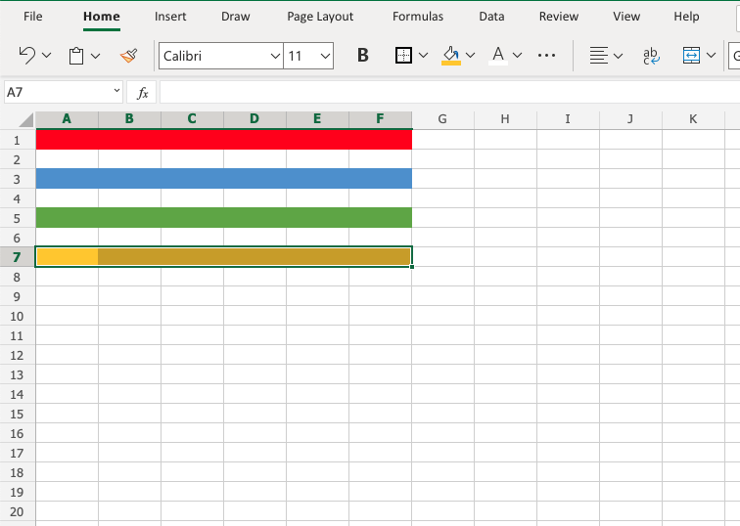

Apply RGB code 60, 90, 166 to A9:F9

Step by step:

* Select A9:F9
* Open color options
* Click More colors
* Insert 60, 90, 166 in the **RGB** input field
* Hit enter

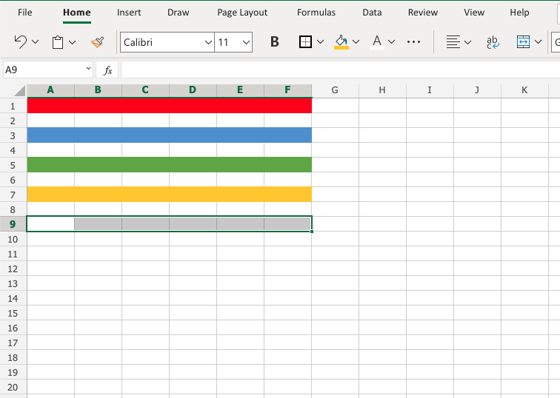

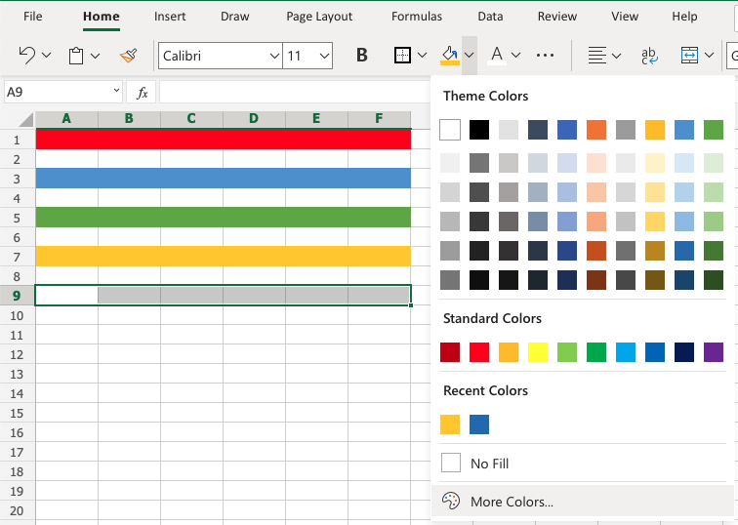

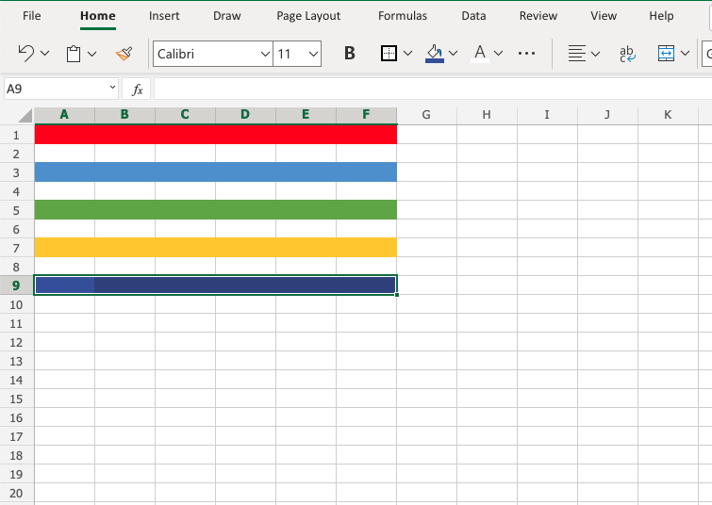

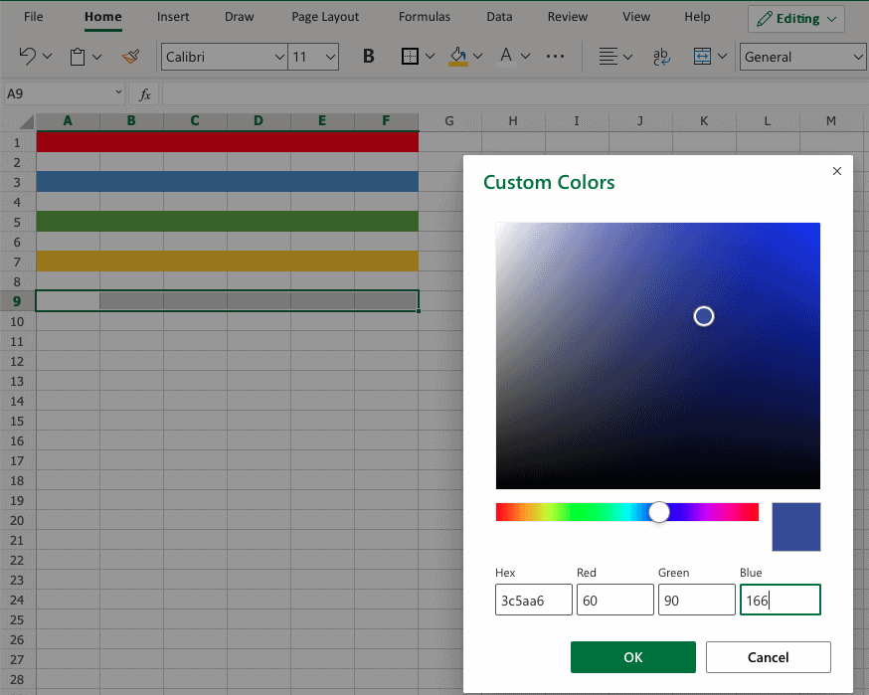

Notice that entering the RGB code also gives the HEX code and shows you where the color is positioned on the color map.

**Well done!** You have successfully applied colors using the standard, theme, HEX and RGB codes.

# Excel Format Fonts

## **Format Fonts**

You can format fonts in four different ways: color, font name, size and other characteristics.

## **Font Color**

The default color for fonts is black.

Colors are applied to fonts by using the "**Font color**" function.

How to apply colors to fonts

1. Select cell
2. Select font color
3. Type text

The font color goes for both numbers and text.

The **Font color** command remembers the color used last time.

Lets try an example, step by step:

1. Select standard font color Red
2. Type A1(Hello)
3. Hit enter
4. Select standard font color Green
5. Type B1(World!)
6. Hit enter

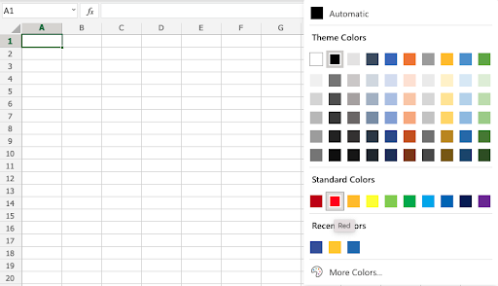

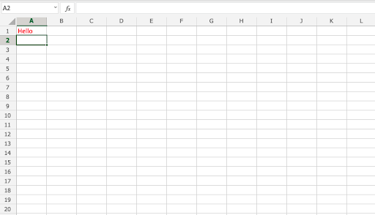

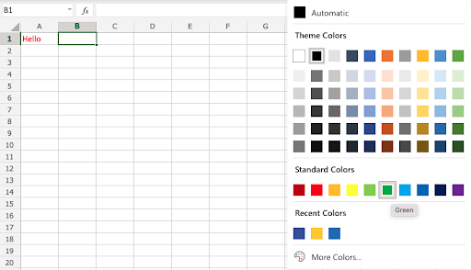

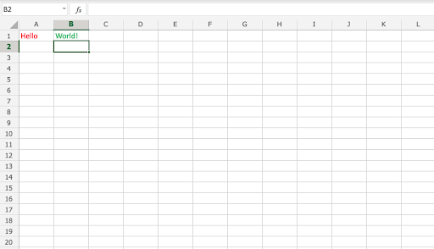

## **Font Name**

The default font in Excel is **Calibri**.

The font name can be changed for both numbers and text.

Why change the font name in Excel?

* Make the data easier to read
* Make the presentation more appealing

How to change the font name:

1. Select a range
2. Click the font name drop down menu
3. Select a font

Let's have a look at an example.

1. Select A1:C4
2. Click the font name drop down menu
3. Select **Arial**

The example has both text (A1:B1) and numbers (A4:C4)

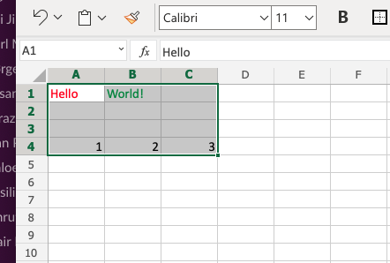

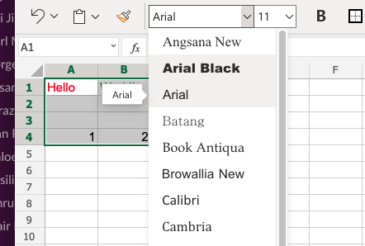

**Good job!** You have successfully changed the fonts from **Calibri**to **Arial**for the range A1:C4.

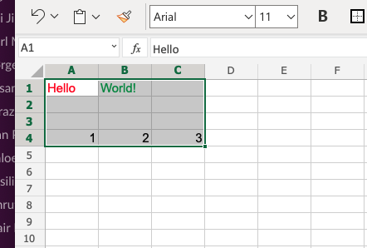

## **Font Size**

To change the **font size** of the font, just click on the font size drop down menu:

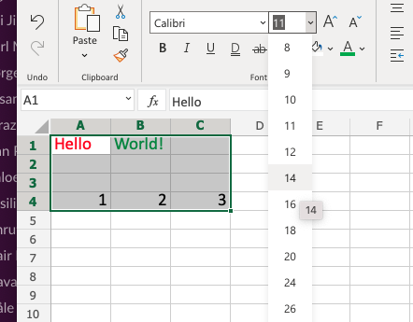

## **Font Characteristics**

You can apply different characteristics to fonts such as:

* **Bold**
* *Italic*
* Underlined
* ~~Strike though~~

The commands can be found below the font name drop down menu:

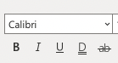

**Bold**is applied by either clicking the Bold (B) icon in the Ribbon or using the keyboard shortcut CTRL + B or Command + B

*Italic*is applied by either clicking the Italic (I) icon or using the keyboard shortcut CTRL + I or Command + I

Underline is applied by either clicking the Underline (U) icon or using the keyboard shortcut CTRL + U or Command + U

~~Strikethrough~~ is applied by either clicking the Strikethrough (ab) icon or using the keyboard shortcut CTRL + 5(five) or Command + Shift + X

## **Chapter Summary**

Fonts can be changed in four different ways: color, font name, size and other characteristics. The fonts are changed to make the spreadsheet more readable and delicate.

# Excel Format Borders

## **Format Borders**

Borders can be added and removed. Colors and style can be changed.

Why format borders?

* Make the document more readable and understandable
* Emphasizing key points

The Borders menu is accessed in the Ribbon, in the Font group.

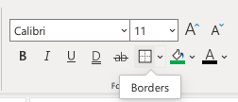

The button remembers the border you used last time.

## **Adding Borders**

Borders are added by clicking the **Borders**button.

The default border is black underline.

Changing the border type, style or color is a choice you make.

The option button next to the Border command gives options for more types of borders.

Clicking the option button gives an overview of the different border options.

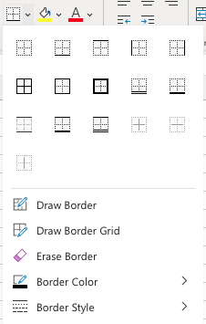

**Example:**

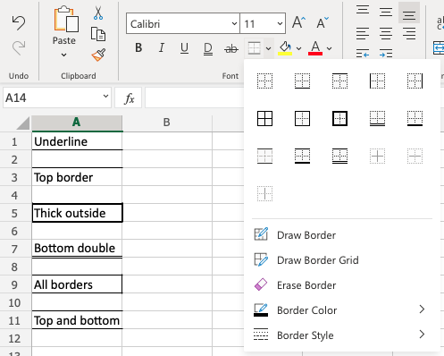

## **Border Colors**

Colored borders are added by selecting a color before adding the border.

The color can be changed in the Border Color menu:

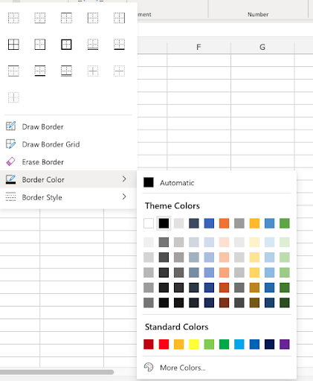

**Example:**

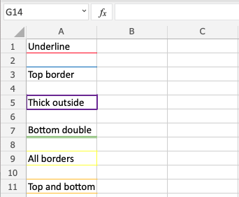

## **Border Style**

Borders styles can be changed.

The menu is accessed in the Border Style menu.

Excel offers 6 different border styles:

* Solid line
* Dashed line
* Dotted line
* Medium line
* Thick line
* Double line

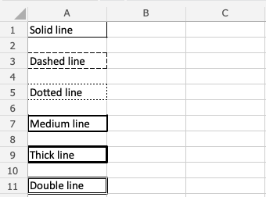

## **Chapter Summary**

Borders can be added with different colors and styles. The border button remembers the border settings used the last time. The options are accessed from the border options button, next to the border button.

In the next chapter you will learn about Number formats.

# Excel Number Formats

## **Number Formats**

The default Number format is **General**.

Why change number formats?

* Make data explainable
* Prepare data for functions, so that Excel understands what kind of data you are working with.

Examples of number formats:

* General
* Number
* Currency
* Time

Number formats can be changed by clicking the Number format dropdown, accessed in the Ribbon, found in the Numbers group.

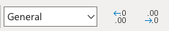

**Note:** You can switch the Ribbon view to access more Number format options.

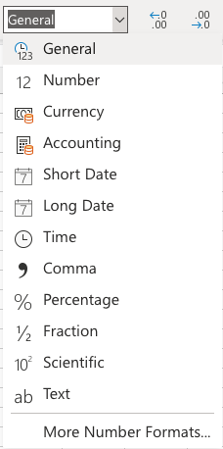

**Example**

In the example we have cells that represent prices, which can be formatted as Currency.

Let's try to change the format of the prices to the Currency Number format.

Step by step:

1. Mark the range B2:C8
2. Click the Number format dropdown menu
3. Click the **Currency**format

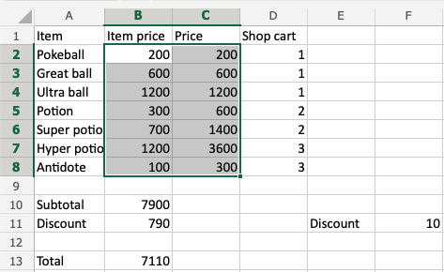

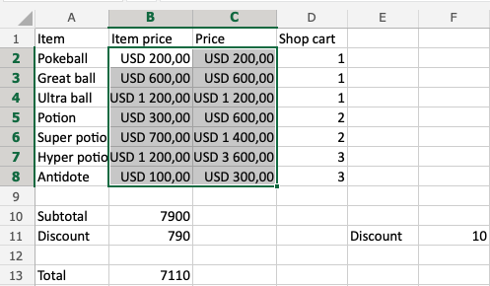

**That's it!** The Number format was changed from **General**to **Currency**.

**Note:**It will use your local currency by default.

Now, do the same for B10, B11 and B13:

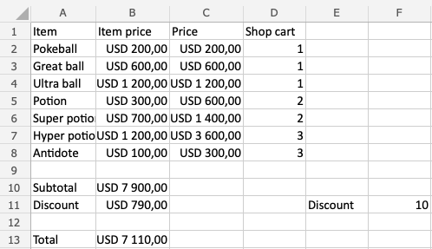

**Note:**The currency can be changed. For example instead of using **USD**like in the example you can decide for **$** or **EUR**. It is changed in the dropdrop menu, clicking the **More Number Formats** in the bottom of the menu. Then, clicking on **Currency**.

Notice that the numbers look like a mess. Let's solve that by decreasing the decimals. This helps to make the presentation more neat.

## **Decimals**

The number of decimals can be increased and decreased.

There are two commands:

* Increase Decimal
* Decrease Decimal

Clicking them reduces or increases the number of decimals.

The commands can be found next to the Number format dropdown menu.

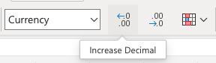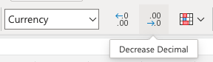

**Note:** Decreasing Decimals can make Excel round up or down numbers as more decimals get removed. This may be confusing if you are working on advanced calculations which require accurate numbers.

Let's clean this up, step by step:

1. Mark the range B2:C8
2. Click the **Decrease Decimal**button two times

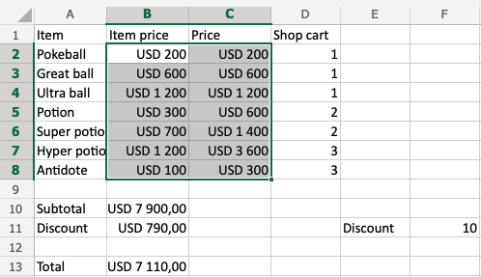

**Great!**

Do the same for B10, B11 and B13:

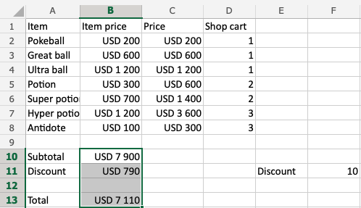

**That looks a lot better!**

**Pro tip:** The arrow in the angle in the top left corner by **row 1** and **column A** can be clicked to mark all cells in the sheet. This can be useful if you want to change the Number format or change Decimals for all cells.

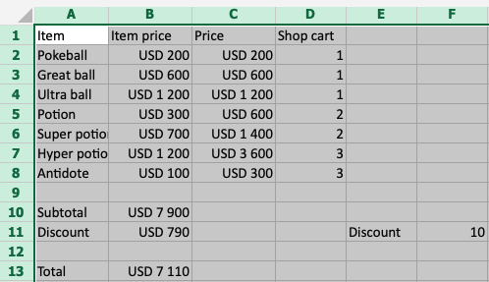

## **Chapter summary**

Number formats can be changed to make the spreadsheet more understandable or to prepare cells for functions. You can increase and decrease decimals to make the presentation neat.

# Excel Format Grids

## **Grids**

By default, gridlines are displayed in Excel.

However, grids can be removed.

Why remove grids?

* Make the spreadsheet more readable
* Make the spreadsheet more delicate

How to remove grids

1. Click view in the Ribbon navigation bar
2. Uncheck gridlines



**Example before removing gridlines:**

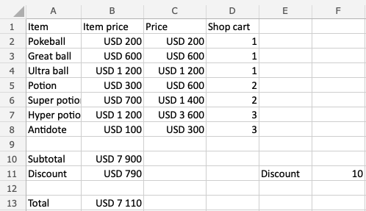

**Example after:**

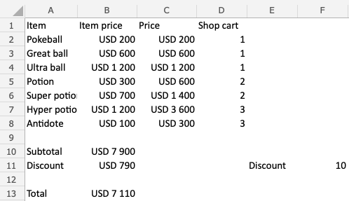

**Note:** Removing gridlines, removes gridlines for all cells in the spreadsheet.

# Excel Regional Format Settings

## **Regional Format Settings**

Excel provides regional formatting settings for different languages and styles of presenting information.

Regional settings affects a number of things, like:

* Calendar date formatting
* Decimal numbers
* Default currency formatting
* Formula delimiters

**Formula delimiters** are the symbols used to separate arguments in a function.

The most common symbols are comma , and semicolon ;

For example, the **English** regional language setting uses commas:

=AND(**[logical1]**, **[logical2]**, ...)

While **German** regional language settings uses semicolons:

=AND(**[logical1]**; **[logical2]**; ...)

## **Example Regional Format Settings**

Here are the date, decimal number, and formula delimiters shown with **English (US)** settings:

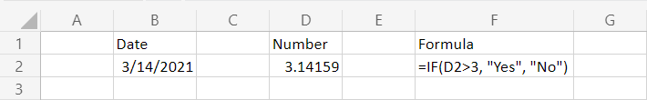

Here are the date, decimal number, and formula delimiters shown with **German** settings:

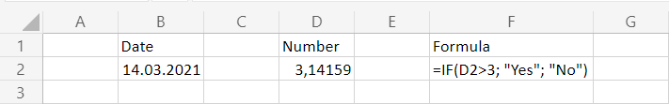

Notice that the English (US) formatting uses month/day/year and the German formatting uses day.month.year for calendar dates.

The English (US) formatting also uses a period (.) for the decimal symbol and the German formatting uses a comma (,).

**Note:** Changing the regional format settings will **automatically** convert any existing values and formulas in your spreadsheet.

## **Changing Regional Format Settings**

Changing Regional Format Settings is accessed in the options part of the **File** menu:

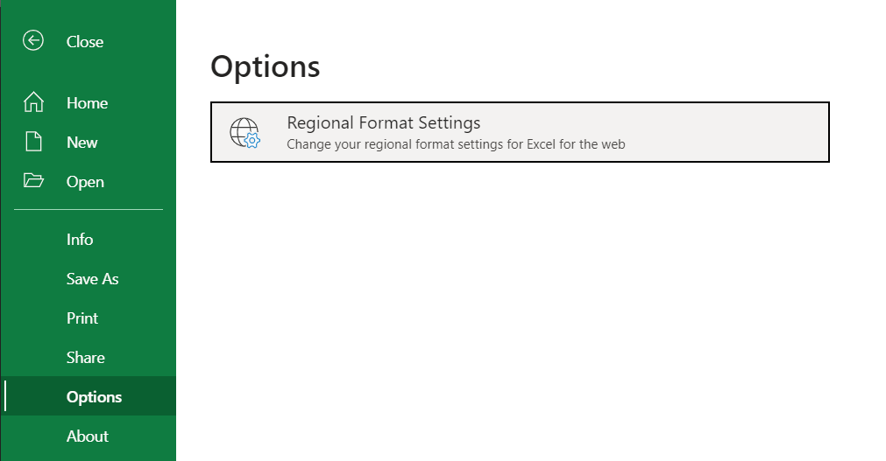

Selecting this option will open a dialog box where you can choose your preferred regional language settings:

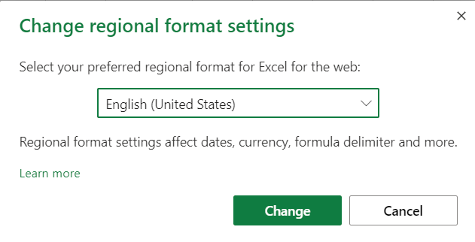

# Excel Sort

## **Excel Sorting**

Ranges can be sorted using the **Sort Ascending** and **Sort Descending** commands.

**Sort Ascending**: from smallest to largest.

**Sort Descending**: from largest to smallest.

The sort commands work for text too, using A-Z order.

**Note:** To sort a range that has more than one column, the whole range has to be selected. Sorting just one can breaks the relationship between columns.

The commands are found in the Ribbon under the **Sort & Filter** menu ()

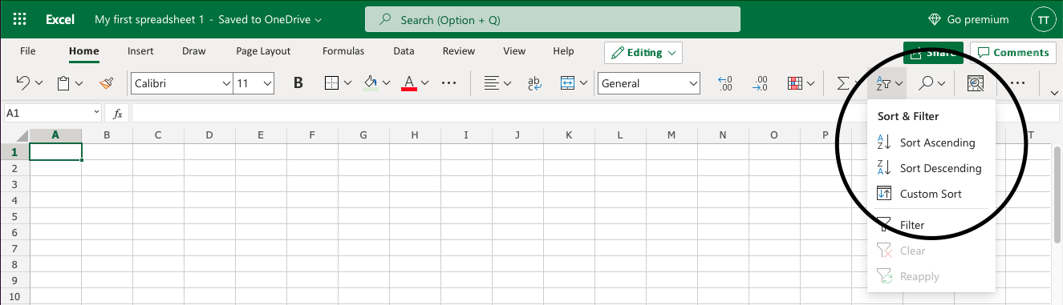

## **Example Sort (text)**

Sort the Pokemons in the range **A2:A21** by their **Name**, ascending from smallest to largest (A-Z).

1. Select **A2:A21**
2. Open the **Sort & Filter** menu
3. Click **Sort Ascending**

**Note:** **A1** is not included as it is the header for the column. This is the row that is dedicated to the filter. Including it will blend it with the rest.

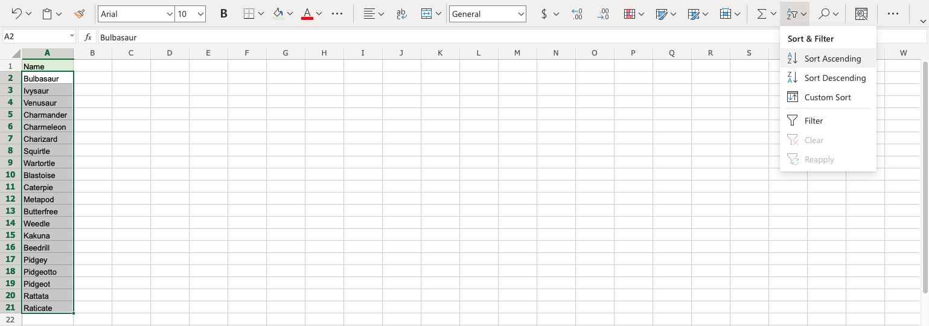

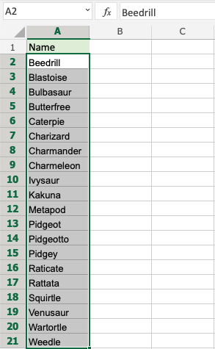

The **Sort Ascending** function successfully sorted the Pokemons by their **Name** ascending from A-Z.

Try again, this time with **Sort Descending** to see what that looks like!

## **Example Sort (numbers)**

Sort the Pokemons ascending by their **Total stats** from smallest to largest.

1. Select **A2:A21**

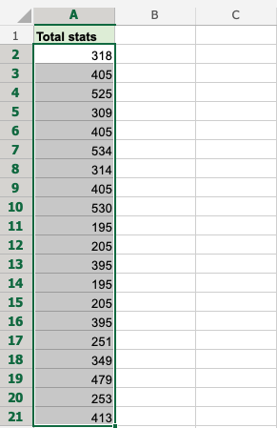

1. Open the **Sort & Filter** menu

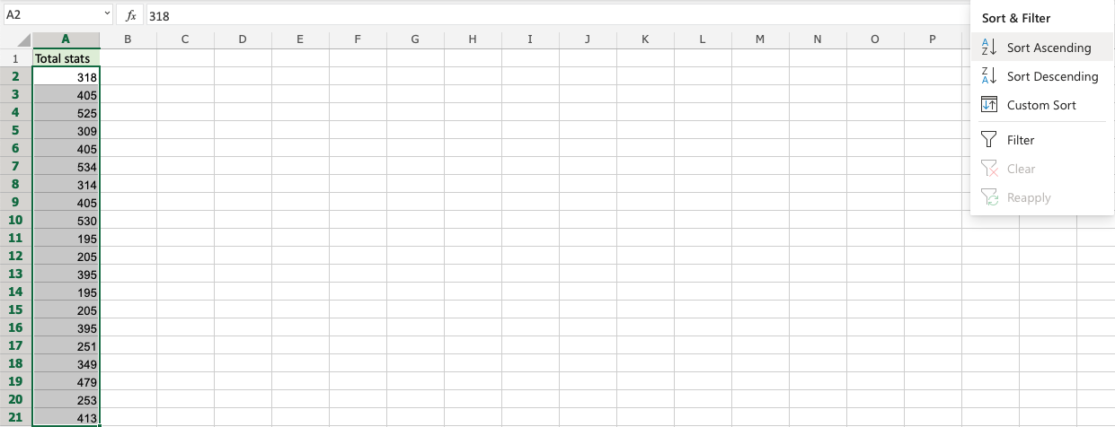

1. Click **Sort Ascending**

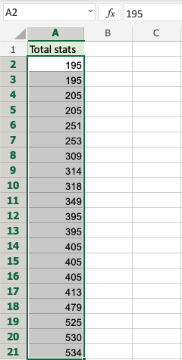

**Great!** The Pokemons were successfully sorted by their **Total stats** from smallest to largest. The sort commands work for both text and numbers.

## **A Non-Working Example (sorting one column in a range)**

In this example we have two columns with related data. Column **A** is the Pokemons **Names** and Column **B** is their **Total stats**. Try sorting just one of the columns (**A2:A21**) ascending by their **Names**

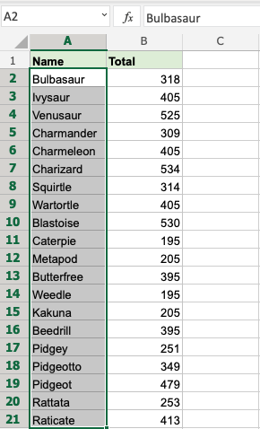

The attempt to sort results in a warning.

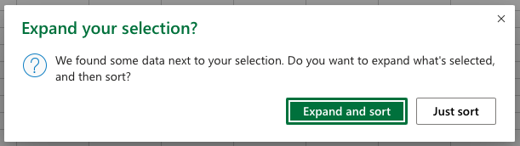

It is not recommended to sort the names alone because it will break the relationship between the Pokemons **Names** and their **Total stats**.

**Click "Just sort" to see what happens.**

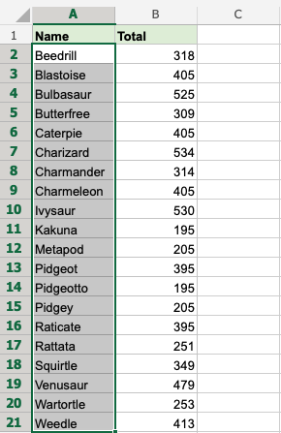

This breaks the relationship with Column **A** and **B**. The Pokemons now have wrong Total stats.

Clicking the other option in the warning "Expand and Sort" makes the sort function include Column **B** and sorts them in relation to each other.

## **Sorting More Than One Column**

Select the whole range when sorting ranges with more than one column.

**Note:** When sorting multiple columns, it will always sort by the first column (leftmost).

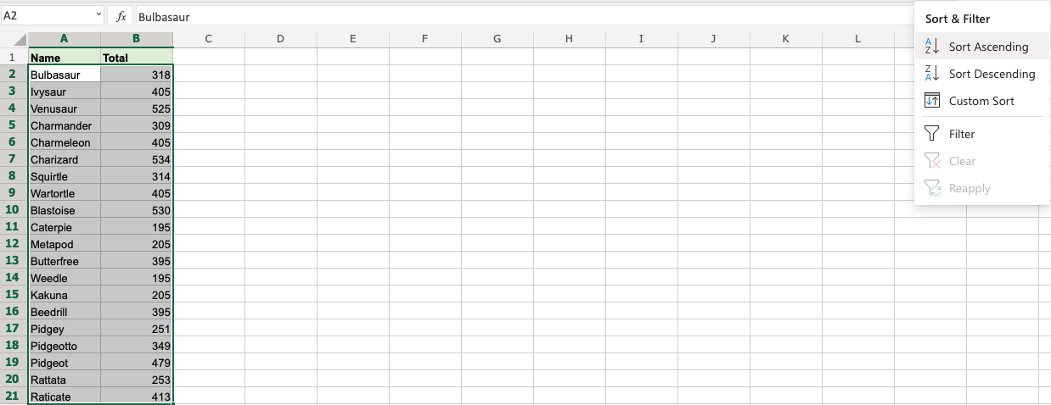

Select **A2:B21** and sort the range ascending.

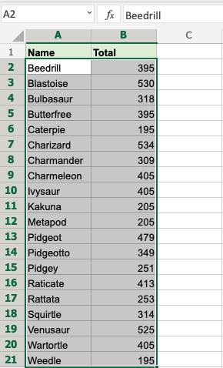

By selecting range **A2:B21** it sorts correctly, keeping the relationship between the data (Column **A** and **B**).

In the next chapter you will learn about **Filter**.

# Excel Filter

## **Excel Filter**

Filters can be applied to sort and hide data. It makes data analysis easier.

**Note:** Filter is similar to formatting a table, but it can be applied and deactivated.

The menu is accessed in the default Ribbon view or in the **Data** section in the navigation bar.

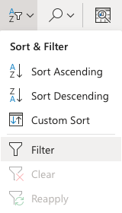

## **Applying Filter**

Filters are applied by selecting a range and clicking the **Filter** command.

It is important to have a row of headers when applying filters. Having headers is useful to make the data understandable.

**Note:** Filters are applied to the top row in a range.

Like in the example below, the dedicated row is row **1**.

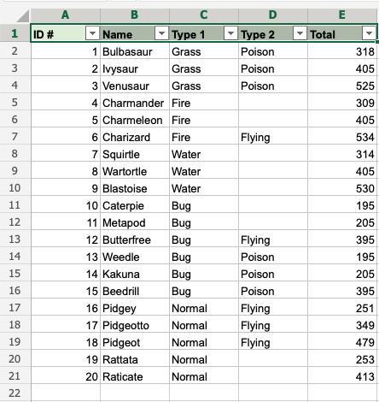

Let's apply filters to the data set, step by step.

1. Select range **A1:E1**



1. Click the **Sort & Filter** menu
2. Click the **Filter** command

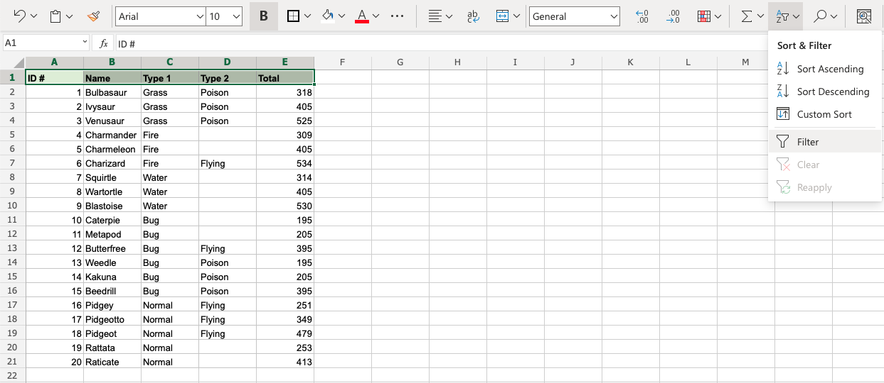

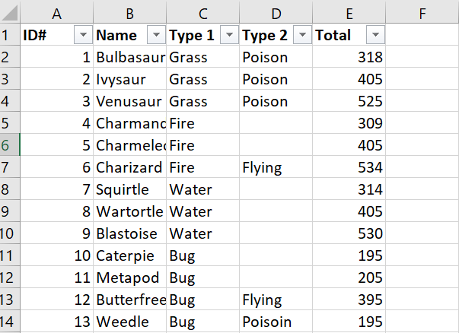

New buttons have been added to the cells in the top row. This indicates that the **Filter** was successfully applied. The buttons can be clicked to access the different **Sort & Filter** options.

## **A Non-Working Example**

Lets delete row **1** (the header row) and apply filters to the new row **1**, to see what happens.

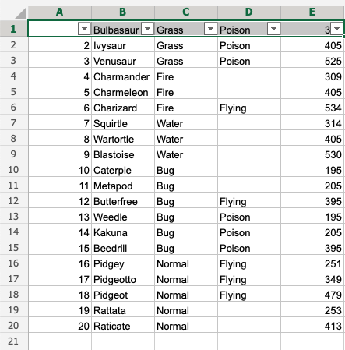

The filter is applied and has replaced the header row. It is important to dedicate a header row for the filter.

## **Filter options**

The filter options allow for sorting and filtering.

Applying filter keeps the relationship between the columns while sorting and filtering.

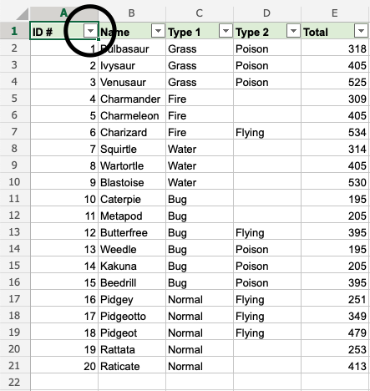

Clicking the options button opens the menu.

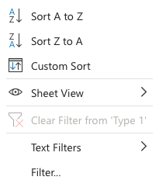

## **Sorting**

Ranges can be sorted and the relationship between the columns is kept.

**Sort Ascending (A-Z)** sorted from smallest to largest.

**Sort Descending (Z-A)** sorts from largest to smallest.

## **Filtering**

Filters can be applied to hide and sort data.

This is helpful for analysis, to select the data that you want to see or not.

### **Example Filter**

Use the filter option to filter on Pokemon that is **Type 1, Bug**.

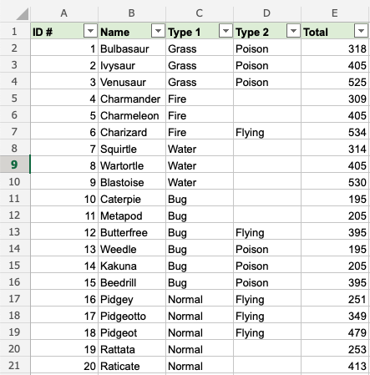

Step by step

1. Click the drop down menu on **C1** () and choose the **Filter** option. This is the Column which holds the **Type 1** data.

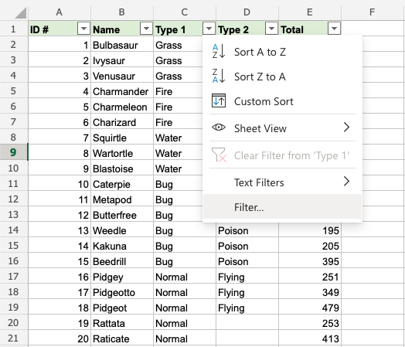

**Note:** "Items" are the different categories in that column; Grass, Fire, Water and so on.

All items are checked by default. The checked items are the ones that are shown. Uncheck to hide.

1. Uncheck all items, except **Bug**, which is the type that we want to show.

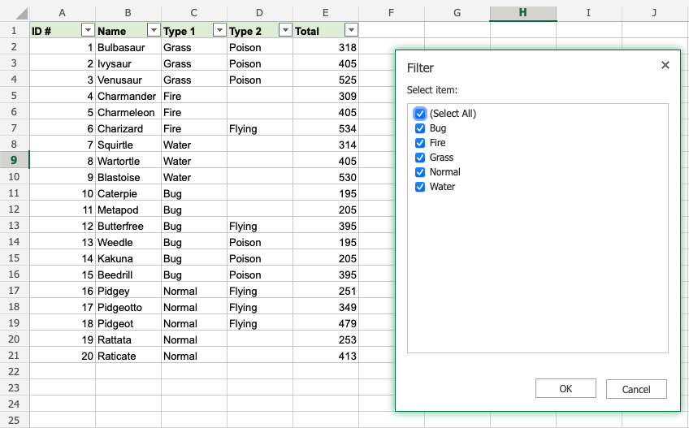

1. Click OK

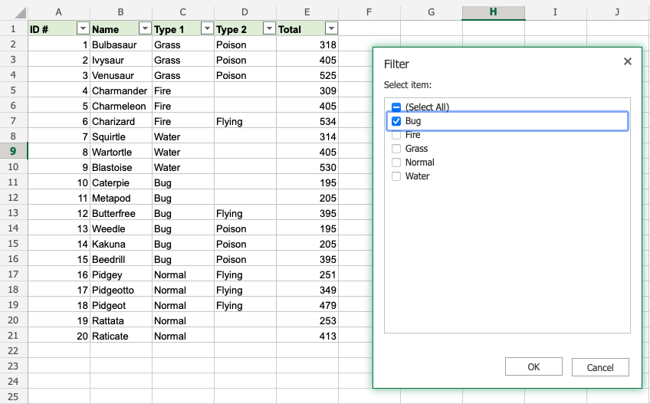

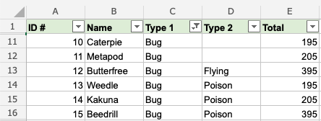

**Good job!** The range was successfully sorted by **Type 1, Bug**. All shown Pokemons are **Bug** type

**Note:** The unchecked rows are hidden, not deleted.

This is explained by looking at the row numbers. The numbers are jumping from 1 to 11 and 16 to 22. The rows in between are hidden.

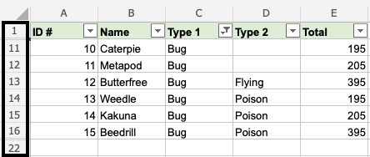

**Note:** Checking the items will have the rows shown again.

## **Another Example**

Use the filter option to filter the Pokemons which have **Type 1**, **Bug** and **Type 2**, **Poison**.

1. Click the filter option in **D1**
2. Uncheck all items except **Poison**
3. click **OK**

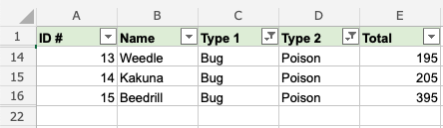

**That is on point!** We have sorted the range based on **Type 1**, **Bug** and **Type 2**, **Poison**. The filter option is helpful to make ranges easier to analyse.

# Excel Tables

## **Table**

Ranges can be converted into tables.

Tables make it easier to structure and organize data.

**Note:** The filter function is similar to a table. The filter can be better used if the only function needed is to sort and filter data.

Tables connect cells in a range and put it into a fixed structure.

The cells in the table range share the same formatting.

**Note:** Tables can be used to prepare data for charts and pivot tables.

Tables allow for options such as:

* Sort & Filter
* Formatting
* AutoFilling

**Note:** Tables can be [converted back to range](https://www.w3schools.com/excel/excel_convert_table_to_range.php).

### **Example**

Formatting a range into a table will give it a new form with a fixed structure. Tables open access to new functionality such as: filtering, automations and styling.

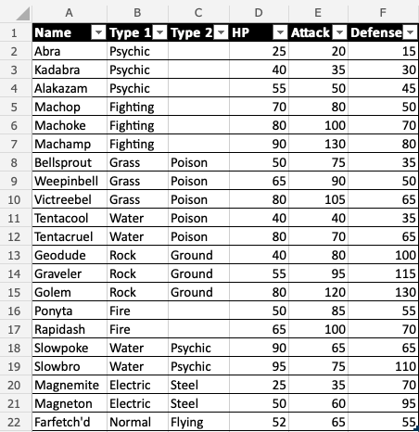

### **Example (Converting a Range to Table)**

How to convert range to table, step by step.

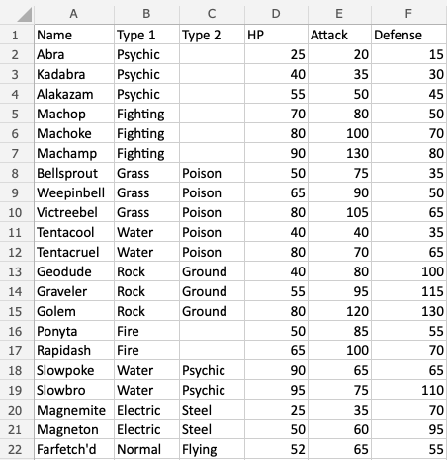

1. Select range A1:F22

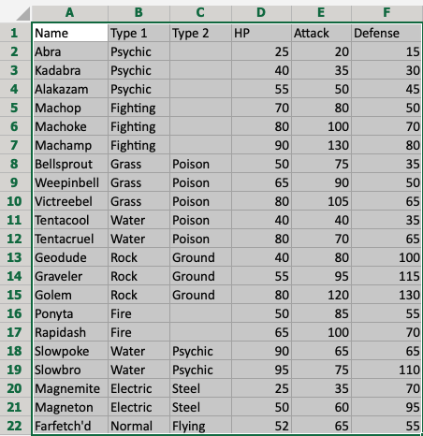

1. Click **Insert**, then Table (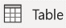), in the Ribbon.

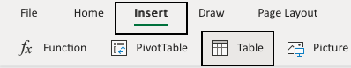

1. Click OK

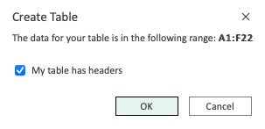

**Note:** The range (A1:F22) already has headers in row 1. Unchecking the "My table has headers" option allows you to create a dedicated header if you do not already have it.

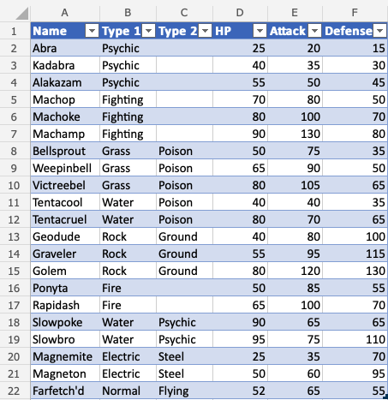

**Good job!** The range A1:F22 was successfully converted from range to table.

The range is now a fixed table structure and new options such as sorting and filtering are now enabled.

Applying the filter keeps the relationship between the columns while sorting and filtering.

## **Table Design**

Tables can be customized and styled in a few clicks.

Converting a range into a table gives access to a menu called "Table Design".



The menu appears when selecting a cell in the table's range.

This menu has options and commands such as:

* Resize
* Remove duplicates
* Convert to range
* Style options (Total row, Header row, Banded row etc..)
* Formatting

## **Table Name**

Excel gives tables default names such as: Table 1, Table 2, Table 3 and so on.

**Note:** Tables cannot be renamed in the Excel online version.

The name of the table can be found in the Table Design tab

1. Select the table
2. Click the Table design menu
3. See the name input field



**Note:** It is useful to know the table names when you have many tables in a workbook and are referring to them in formulas.

## **Table Resizing**

The size of a table can be changed.

Resizing is to increase or decrease the range of the table.

There are three ways to resize a table

* Resize table command
* Drag to resize
* Adding headers

**Note:** Resizing will continue formatting and formulas. This will be covered in a later chapter.

## **Resize Table Command**

The resize table command allows you to change the size of the table by entering a range.

For example by entering A1:D10.

The command is found in the Ribbon under the Table Design tab.



### **Example - Resizing a Table**

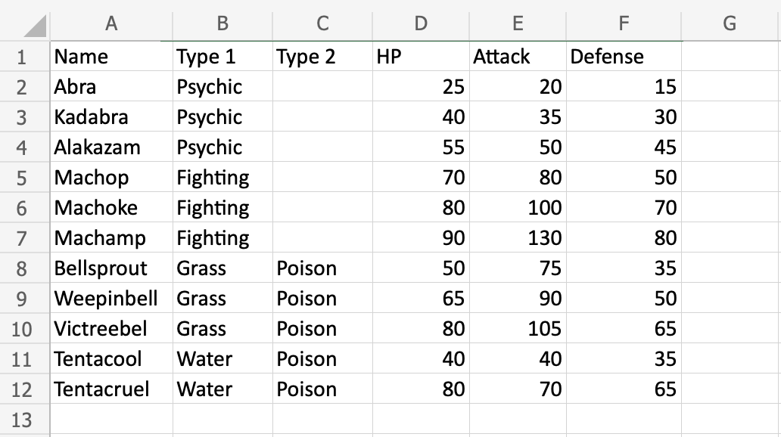

Convert the range into a table.

Lets resize the table from range A1:F12 to A1:F20

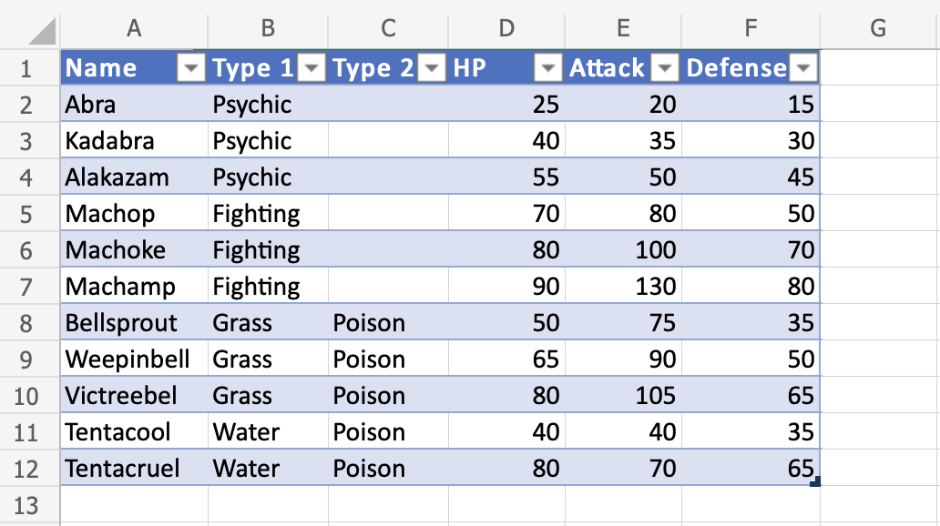

1. Select the table
2. Click the Table Design menu



1. Click the Resize Table command (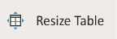)

Clicking the Resize Table command allows you to set a new range for the table.

1. Click the range input field
2. Type the new range, A1:F20

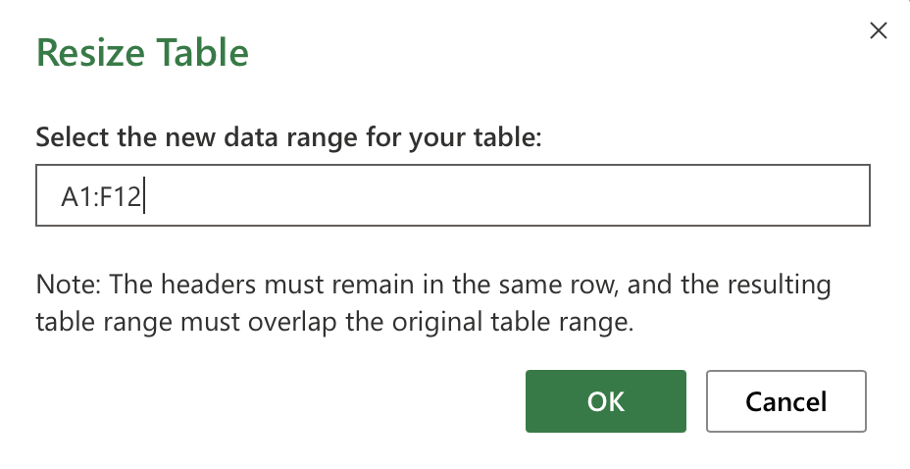

1. Click OK

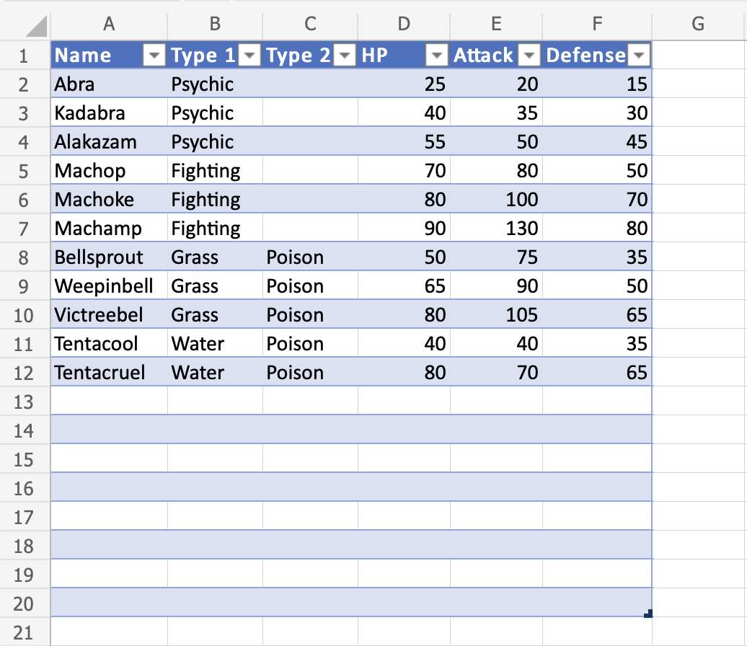

**Great!** The table has been resized to from A1:F12 to A1:F20.

## **Drag to Resize**

The table can be resized by dragging its corner.

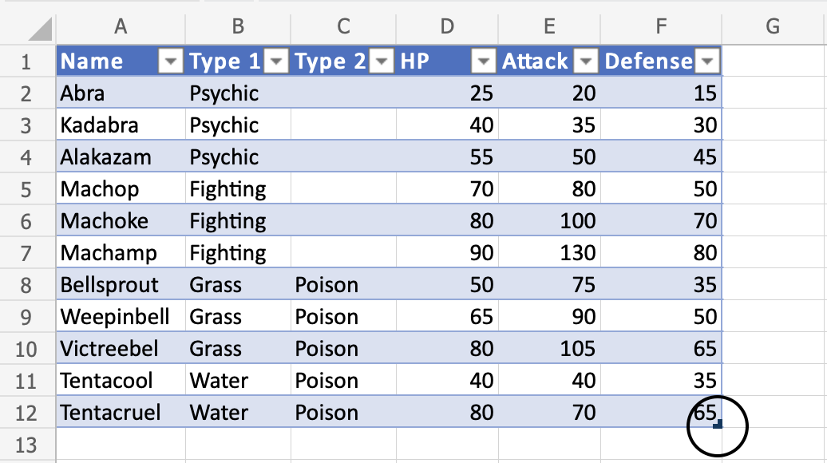

### **Example - Dragging to Resize, Smaller**

Change the tables size from A1:F12 to A1:D5

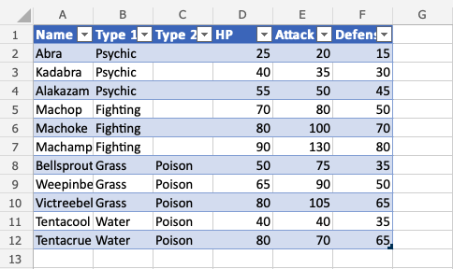

1. Press and hold the bottom right corner of the table ()
2. Move the pointer, marking the range A1:D5

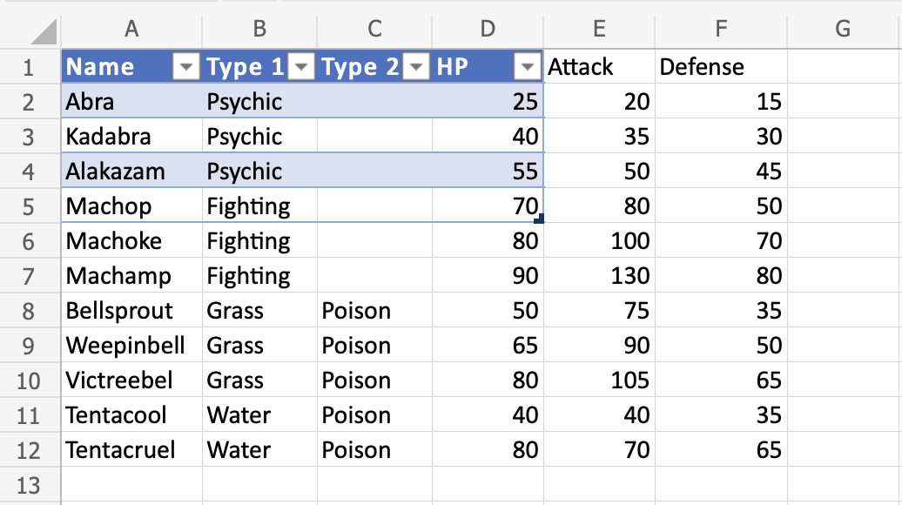

The table range has been changed from A1:F12 to A1:D5.

**Note:** Cells outside of the table range are no longer included in the table. The connection between the cells created by the table is broken and they no longer have the table formatting.

Let's try to sort the Pokemon by their names to see what happens.

1. Click the filter option in A1
2. Sort by Ascending (A-Z)

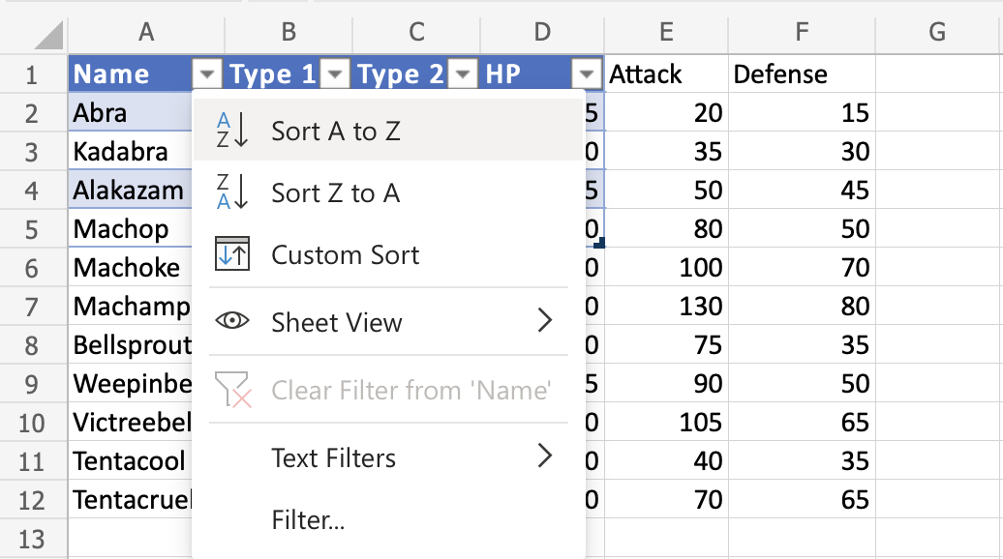

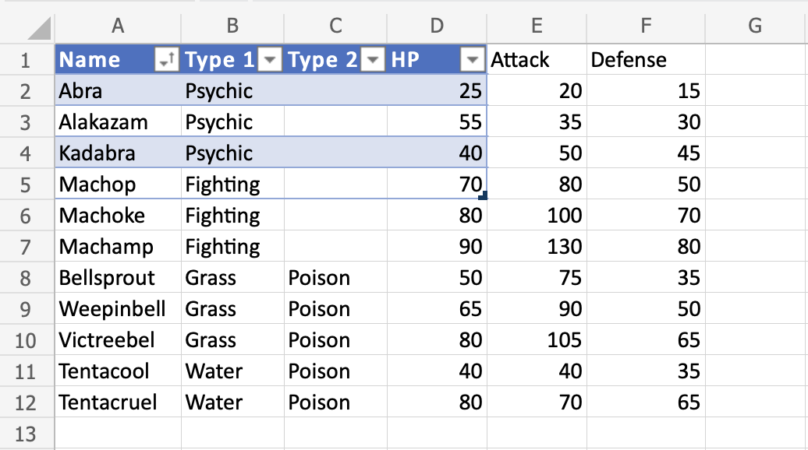

The filter option only includes the Pokemon in the tables range (A1:A5). The connection to the cells outside of the table is broken.

Lets resize again, this time bigger.

### **Example - Dragging to Resize, Bigger**

Change the tables size from A1:D5 to A1:G13

1. Press and hold the bottom right corner of the table ()
2. Move the pointer to mark A1:G13

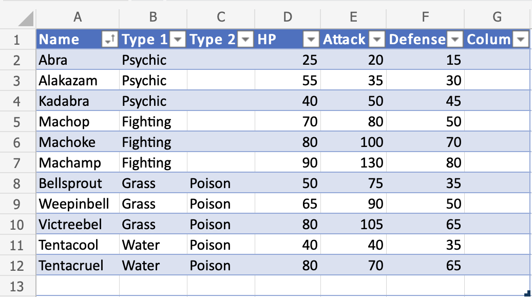

The table range has been changed from A1:D5 to A1:G13.

The rest of the cells are now included again, and the connection between the cells is back.

Let's try to filter the Pokemon by their names to see what happens.

1. Click the filter option in A1
2. Sort by Ascending (A-Z)



**Nice!** The table has successfully sorted the Pokemon in the range A1:A12 by their names.

**Oh wait. Something has changed. A new column (G) has appeared...**

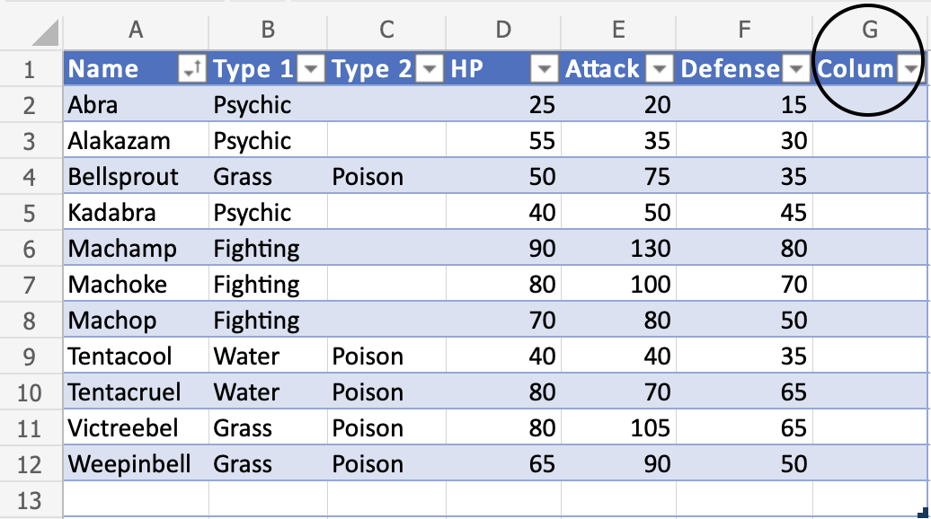

Increasing the table size will continue the formatting, formulas and add new columns.

**Note:** It will not overwrite the name for existing headers. It will use the value that is typed in the header cell.

The header name can be changed.

1. Double click G1
2. Delete the text
3. Type "Mighty" to G1

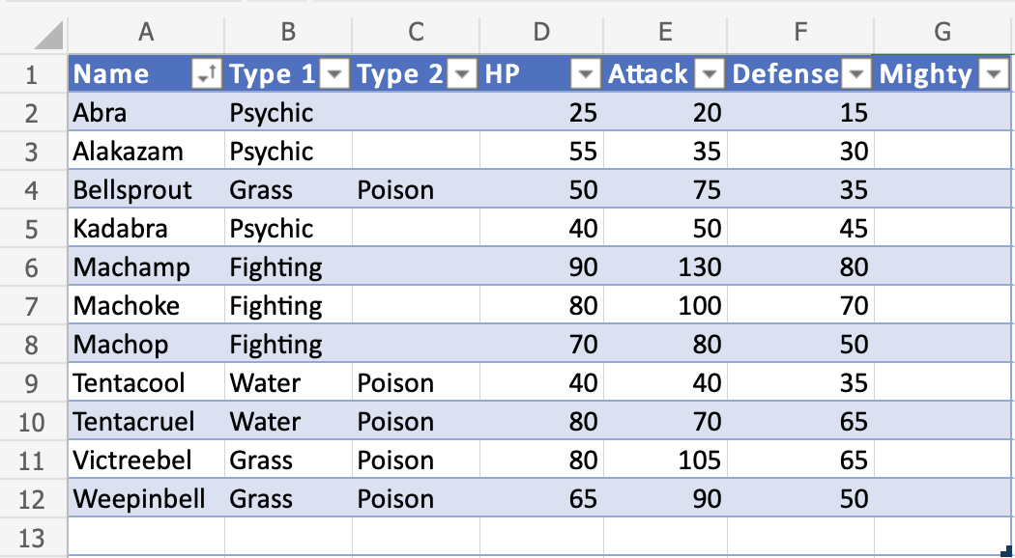

### **Another Example - Resize By Adding Columns**

The table is automatically increased when new headers next to the table are added.

1. Type "Mew" to H1
2. Hit enter
3. Type "Two" to I1
4. Hit enter

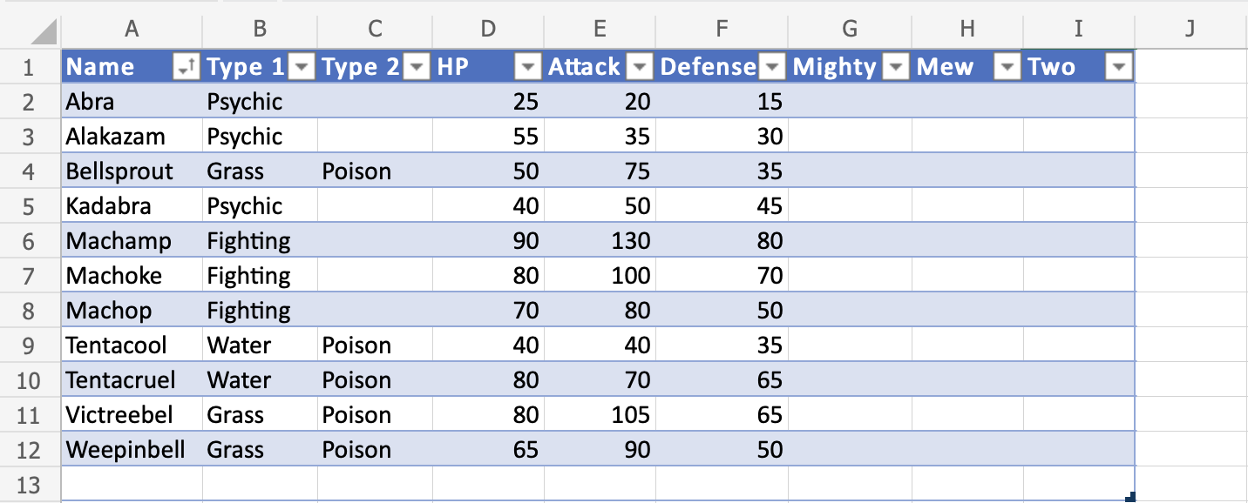

New columns with appropriate rows are automatically added when new headers are typed.

## **Removing Duplicates**

Excel has a command to remove duplicates in tables.

Removing duplicates are helpful when cleaning a dataset and you do not want to include copies.

The Remove Duplicate function is found in the Ribbon under the Table Design tab.

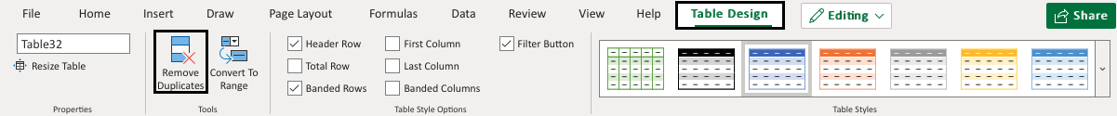

The command allows you to specify the column where you want to find and remove duplicates.

Once applied it will return the number of deleted values and how many unique ones that remains.

**Note:** The remove duplicate command will not ask for which duplicates to delete. Make sure that it does not delete useful data.

### **Examples - Remove Duplicates command**

Lets try an example removing the duplicate Pokemon in the range A1:E13

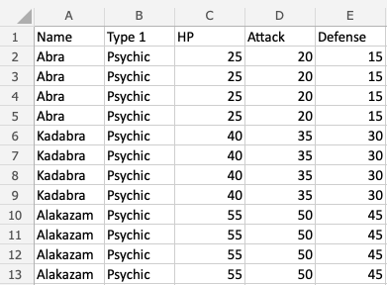

Convert the range into a table.

1. Select the table

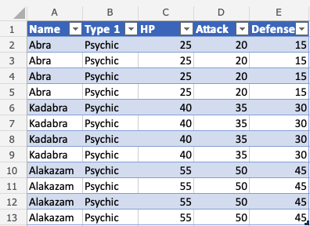

1. Click the Table Design tab
2. Click the Remove Duplicates command
3. Leave all columns checked
4. Click OK

**Note:** Unchecking a column means that it will not remove duplicates for that column.

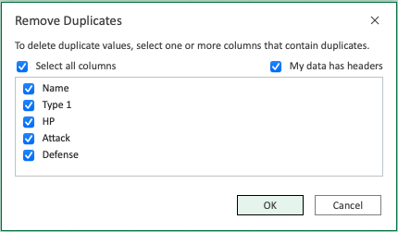

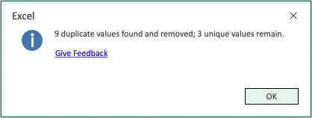

The command returns the number of found and removed duplicates and how many unique ones that remain.

1. Click OK

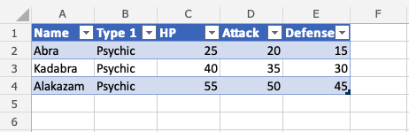

The remove duplicates command has successfully removed the 9 duplicate Pokemon from the range and the table has been resized accordingly. The remaining 3 values are unique.

## **Excel Converting a Table to Range**

Tables can be reversed and converted back to range.

Tables can be converted to ranges by selecting a cell in the table range and clicking on the Convert to Range command.

The command to convert to range is found in the Table Design tab, in the Tools group.

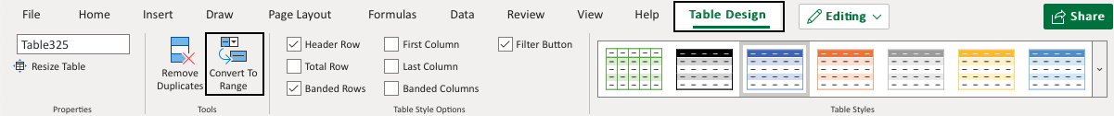

### **Example - Convert Table to Range**

Type or copy the values to follow the example.

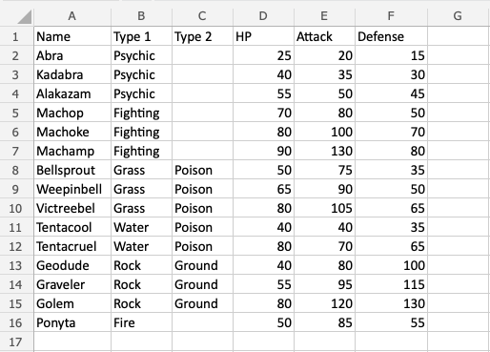

Convert the range into a table.

1. Select a cell in the table range (A1:F16)

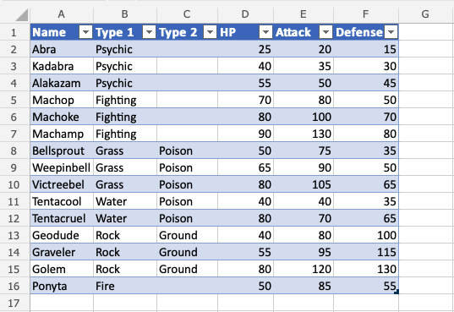

1. Click the Design Table tab
2. Click the Convert to Range command (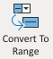)

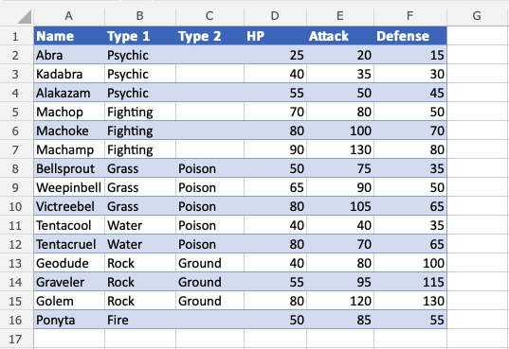

The table is now converted into a range and it no longer has the table options available.

**Note:** The cell forma

tting is kept for the range after the conversion.

## **Table Style**

Excel has many ready to use styles which can be applied for tables.

Table styles is to change the appearance of the table.

It can be changed to:

* Make it easier to read and understand
* Make it look better

The table style is **Blue, Table Style Medium 2** by default.

Example: **Blue, Table Style Medium 2**, which is how the default looks like.



Excel has three main categories for Table styles:

* Light; Light colors, more white space
* Medium; Medium colors, medium white space
* Dark; Dark colors, less white space

The table style can be applied in a few steps.

### **Example - Applying Light Style**



Convert the range into a table.

1. Select a cell in the table range
2. Click the Design Table tab
3. Click on the Table Styles option button

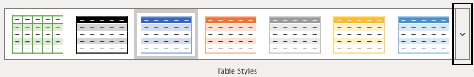

**Note:** The Table Style that is already applied has a green rectangle around it. In this case Blue, Table Style Medium 2.

Clicking the Table Style option button opens a menu with different style options.

Here the three categories are presented; Light, Medium and Dark.

1. Click on the **Light**, **Green**, **Table Style Light 21**. Found in the Light category.

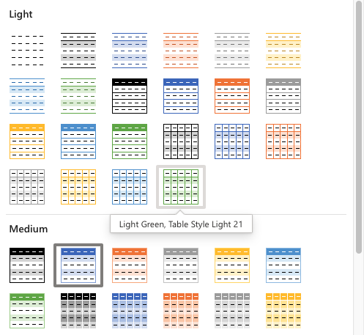

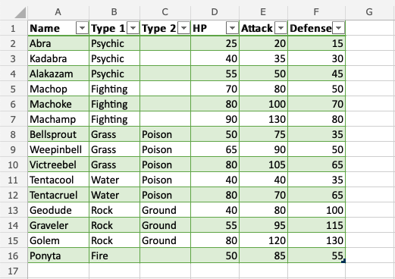

**Well done!** The formatting of the table has changed to the light green style.

Apply **Gray, Table Style Dark 4**. Found in the Dark category.

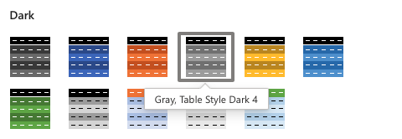

**Did you make it?**

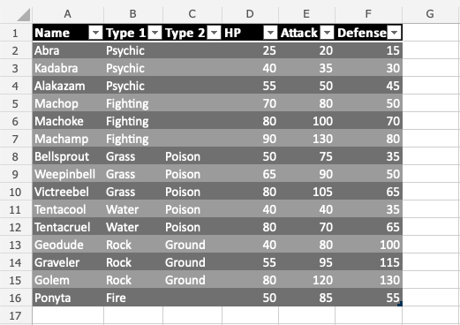

# Excel Conditional Formatting

## **Conditional Formatting**

Conditional formatting is used to change the appearance of cells in a range based on your specified **conditions**.

The conditions are rules based on specified numerical values or matching text.

Changing the appearance of cells can visually highlight interesting data points for analysis.

The browser version of Excel provides a number of built-in conditions and appearances:

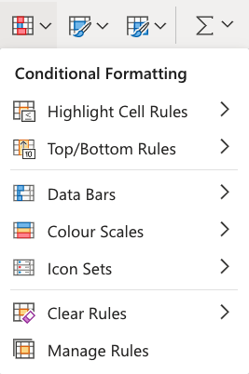

**Note:** The web browser version of Excel only offers a selection of built-in conditional formatting options.

The Excel application has the option of creating fully customized conditional formatting rules.

## **Conditional Formatting Example**

Here, the Speed values of each pokemon is formatted with a **Color Scale**:

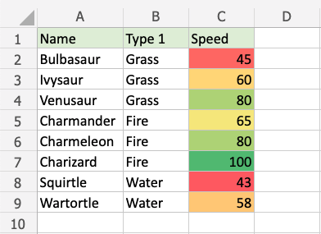

**Note:** Excel has several different color scales to pick from.

## **Color Scale Formatting Example**

Highlight the Speed values of each Pokemon with **Color scale** conditional formatting.

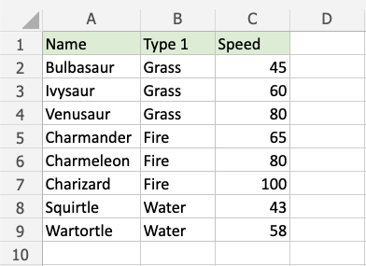

Conditional formatting, step by step:

1. Select the range of Speed values C2:C9

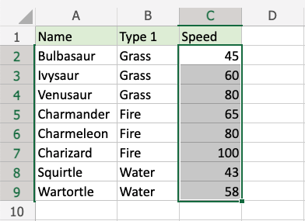

1. Click on the Conditional Formatting icon 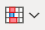 in the ribbon, from the **Home** menu
2. Select **Color Scales** from the drop-down menu

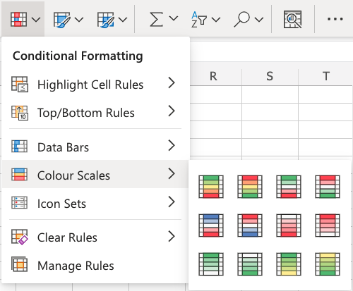

There are 12 Color Scale options with different color variations.

The color on the top of the icon  will apply to the highest values.

1. Click on the "Green - Yellow - Red Colour Scale" icon

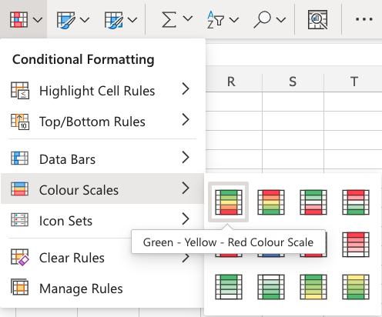

Now, the Speed value cells will have a colored background highlighting:



Dark green is used for the highest values, and dark red for the lowest values.

Charizard has the highest Speed value (100) and Squirtle has the lowest Speed value (43).

All the cells in the range gradually change color from green, yellow, orange, then red.

# Excel Highlight Cell Rules

## **Highlight Cell Rules**

Highlight Cell Rules is a premade type of conditional formatting in Excel used to change the appearance of cells in a range based on your specified **conditions**.

The conditions are rules based on specified numerical values, matching text, calendar dates, or duplicated and unique values.

Here is the Highlight Cell Rules part of the conditional formatting menu:

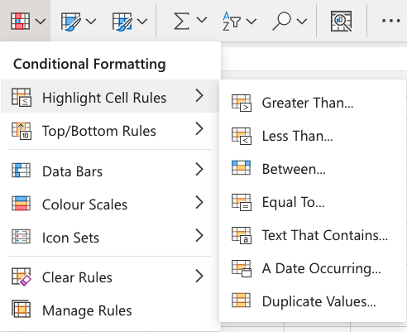

## **Appearance Options**

The web browser version of Excel offers the following appearance options for conditionally formatted cells:

* Light Red Fill with Dark Red Text
* Yellow Fill with Dark Yellow Text
* Green Fill with Dark Green Text
* Light Red Fill
* Red Text
* Red Border

Here is how the options look in a spreadsheet:

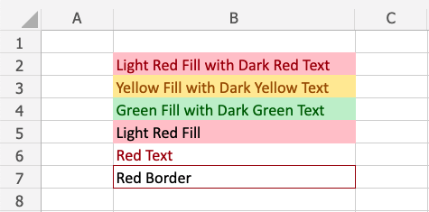

## **Cell Rule Types**

Excel offers the following cell rule types:

* [Greater Than...](https://www.w3schools.com/excel/excel_cf_greater_than.php)
* [Less Than...](https://www.w3schools.com/excel/excel_cf_less_than.php)
* [Between...](https://www.w3schools.com/excel/excel_cf_between.php)
* [Equal To...](https://www.w3schools.com/excel/excel_cf_equal_to.php)
* [Text That Contains...](https://www.w3schools.com/excel/exceL_cf_text_that_contains.php)
* [A Date Occurring...](https://www.w3schools.com/excel/excel_cf_date_occurring.php)
* [Duplicate/Unique Values](https://www.w3schools.com/excel/excel_cf_duplicate_unique.php)

## **Highlight Cell Rule Example**

The "Equal To..." Highlight Cell Rule will highlight a cell with one of the appearance options based on the cell value being **equal** to your specified value.

The specified value could be a particular number or particular text.

In this example, the specified value will be "48".

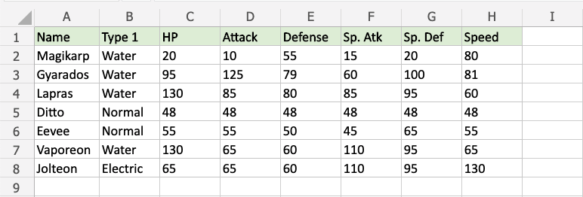

You can [choose any range](https://www.w3schools.com/excel/excel_ranges.php) for where the Highlight Cell Rule should apply. It can be a few cells, a single column, a single row, or a combination of multiple cells, rows and columns.

Let's apply the rule to all of the different stat values.

"Equal To..." Highlight Cell Rule, step by step:

1. Select the range C2:H8 for all of the stat values

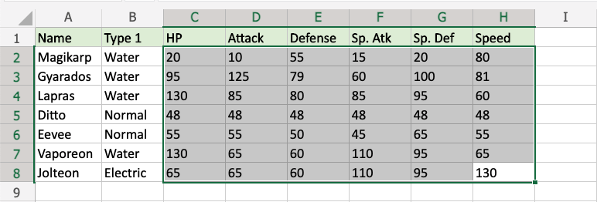

1. Click on the Conditional Formatting icon  in the ribbon, from **Home** menu
2. Select **Highlight Cell Rules** from the drop-down menu
3. Select **Equal To...** from the menu

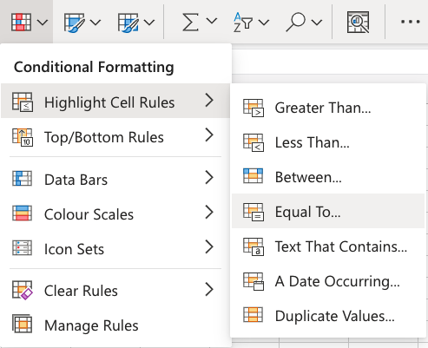

This will open a dialog box where you can specify the value and the appearance option.

1. Enter 48 into the input field
2. Select the appearance option "Yellow Fill with Dark Yellow Text" from the dropdown menu

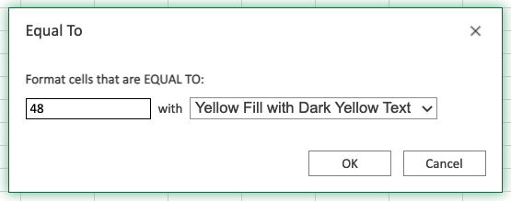

Now, the cells with values equal to "48" will be highlighted in yellow: 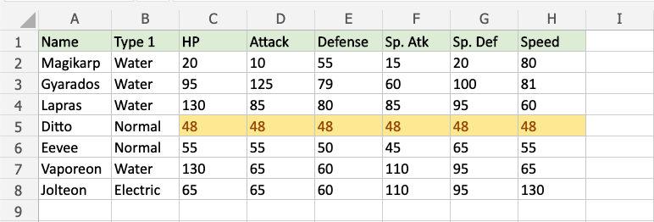

All of Ditto's stat values are 48, so they are highlighted.

**Note:** You can remove the Highlight Cell Rules with [Manage Rules](https://www.w3schools.com/excel/excel_cf_manage_rules.php).

# Excel HCR - Greater Than

## **Highlight Cell Rule - Greater Than Example**

The "Greater Than..." Highlight Cell Rule will highlight a cell with one of the appearance options based on the cell value being **greater than** to your specified value.

The specified value is typically a number, but it also works with a text value.

In this example, the specified value will be "65".



You can [choose any range](https://www.w3schools.com/excel/excel_ranges.php) for where the Highlight Cell Rule should apply. It can be a few cells, a single column, a single row, or a combination of multiple cells, rows and columns.

Let's apply the rule to the HP values.

"Greater Than..." Highlight Cell Rule, step by step:

1. Select the range C2:C8 for HP values

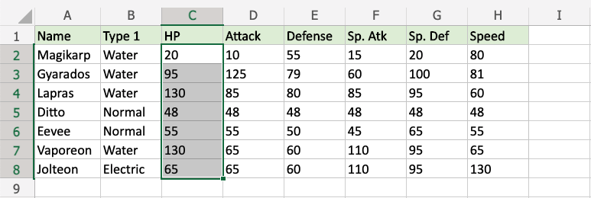

1. Click on the Conditional Formatting icon  in the ribbon, from **Home** menu
2. Select **Highlight Cell Rules** from the drop-down menu
3. Select **Greater Than...** from the menu

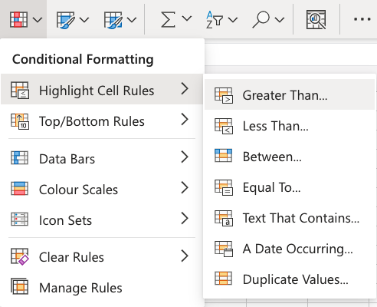

This will open a dialog box where you can specify the value and the appearance option.

1. Enter 65 into the input field
2. Select the appearance option "Green Fill with Dark Green Text" from the dropdown menu

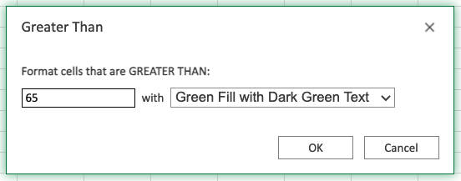

Now, the cells with values greater than "65" will be highlighted in green:

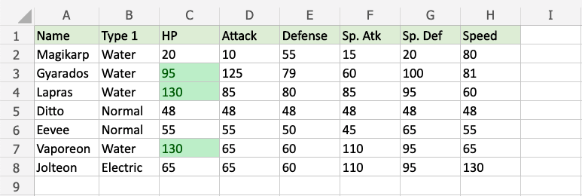

Gyarados, Lapras and Vaporeon have HP values greater than 65, so they are highlighted.

**Note:** Jolteon's HP value is 65, but is not highlighted, since the rule does not include the specified value itself.

The "Greater Than..." Highlight Cell Rule also works with text values.

Excel will use alphabetical order (A-Z) to highlight the text values that start with a letter that is **later** in the alphabet than the specified value.

In this example, the specified text value will be "Gyarados".



Let's apply the rule to the Name values.

"Greater Than..." Highlight Cell Rule, step by step:

1. Select the range A2:A8 for Name values

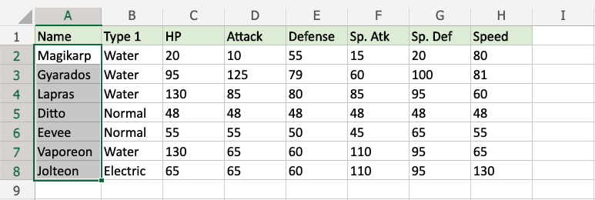

1. Click on the Conditional Formatting icon  in the ribbon, from **Home** menu
2. Select **Highlight Cell Rules** from the drop-down menu
3. Select **Greater Than...** from the menu



This will open a dialog box where you can specify the value and the appearance option.

1. Enter Gyarados into the input field
2. Select the appearance option "Yellow Fill with Dark Yellow Text" from the dropdown menu

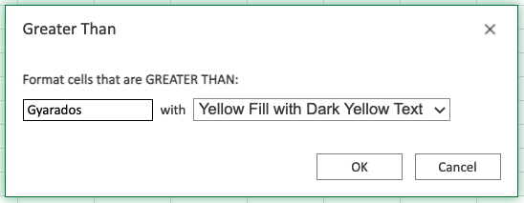

Now, the cells with text values **later** in the alphabet than "Gyarados" will be highlighted in yellow:

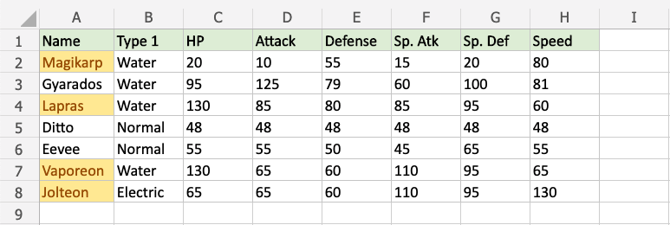

Magikarp starts with "M", Lapras with "L", Vaporeon with "V", and Jolteon with "J".

"M", "L", "V", and "J" are all **later** in the alphabet than "G", which Gyarados starts with, so these all are highlighted.

**But, what about the rest of the letters in the text value?**

Let's see what happens if we add a fictional pokemon with a new name:

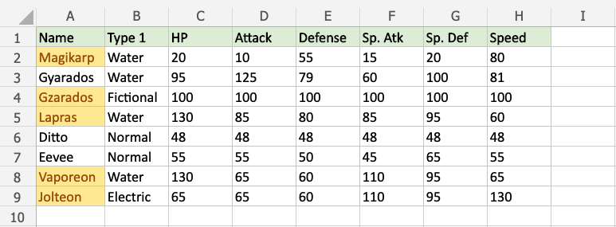

Notice that the fictional "Gzarados" is highlighted.

The Excel condition checks each letter in the specified text value from left to right.

Because the "z" in "G**z**arados" comes **later** in the alphabet than the "y" in "G**y**arados", this is considered **Greater Than** and is highlighted.

# Excel HCR - Less Than

## **Highlight Cell Rule - Less Than Example**

The "Less Than..." Highlight Cell Rule will highlight a cell with one of the appearance options based on the cell value being **less than** to your specified value.

The specified value is typically a number, but it also works with a text value.

In this example, the specified value will be "55".



Let's apply the rule to the Attack values.

"Less Than..." Highlight Cell Rule, step by step:

1. Select the range D2:D8 for Attack values

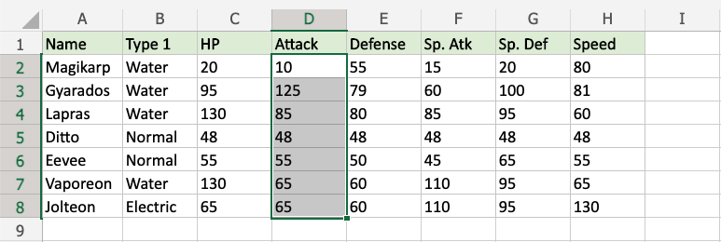

1. Click on the Conditional Formatting icon  in the ribbon, from **Home** menu
2. Select **Highlight Cell Rules** from the drop-down menu
3. Select **Less Than...** from the menu

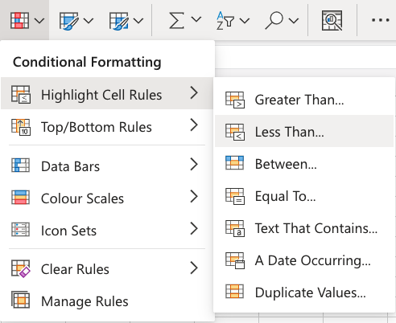

This will open a dialog box where you can specify the value and the appearance option.

1. Enter 55 into the input field
2. Select the appearance option "Light Red Fill with Dark Red Text" from the dropdown menu

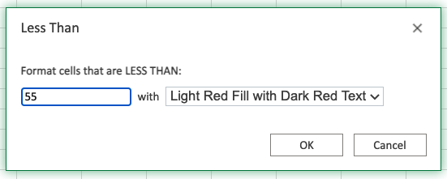

Now, the cells with values less than "55" will be highlighted in red:

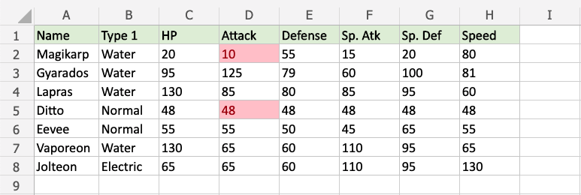

Only Magikarp and Ditto have Attack values less than 55, so these values are highlighted.

**Note:** Eevees's Attack value is 55, but is not highlighted, since the rule does not include the specified value itself.

## **Highlight Cell Rule - Less Than Example (with Text)**

The "Less Than..." Highlight Cell Rule also works with text values.

Excel will use alphabetical order (A-Z) to highlight the text values that start with a letter that is **earlier** in the alphabet than the specified value

In this example, the specified text value will be "Electric".



Let's apply the rule to the Type 1 values.

"Less Than..." Highlight Cell Rule, step by step:

1. Select the range B2:B8 for Type 1 values

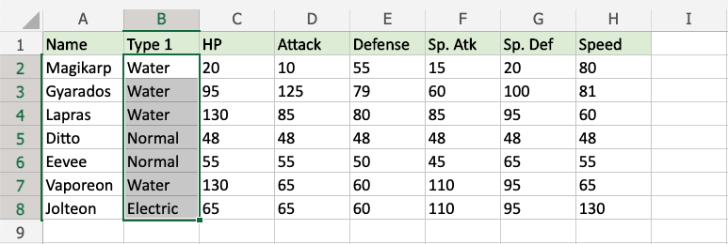

1. Click on the Conditional Formatting icon  in the ribbon, from **Home** menu
2. Select **Highlight Cell Rules** from the drop-down menu
3. Select **Less Than...** from the menu



This will open a dialog box where you can specify the value and the appearance option.

1. Enter Electric into the input field
2. Select the appearance option "Yellow Fill with Dark Yellow Text" from the dropdown menu

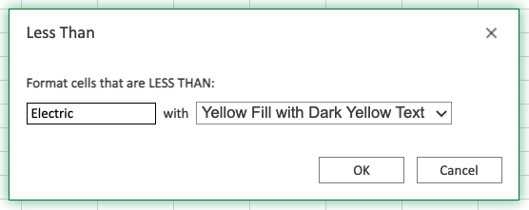

Now, the cells with text values earlier in the alphabet than "Electric" will be highlighted in yellow:



**Nothing seems to have changed!**

Water starts with "W" and Normal starts with "N".

"W"and "N" are all **later** in the alphabet than "E", which Electric starts with, so **none** of these are highlighted.

**Note:** The specified value "Electric" itself is also **not highlighted**, because the rule only highlights text values that are earlier in the alphabet.

**So, what about the rest of the letters in the text value?**

Let's see what happens if we add a fictional pokemon with a new Name and Type:

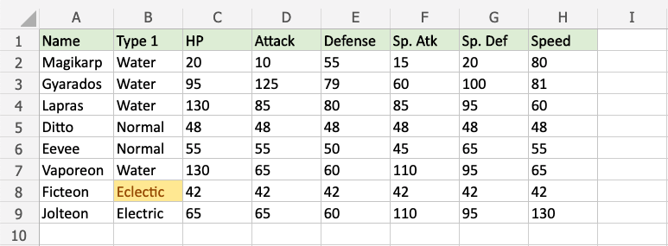

Notice that the fictional "Ficteon" has the type "Eclectic", which is highlighted.

The Excel condition checks each letter in the specified text value from left to right.

Because the "c" in "E**c**lectic" comes **earlier** in the alphabet than the "l" in "E**l**ectric", this is considered **Less Than** and is highlighted.

# Excel Highlight Cell Rules - Between

## **Highlight Cell Rules - Between**

**Between...** is one of the options for the condition.

Here is the Highlight Cell Rules part of the conditional formatting menu:



## **Highlight Cell Rule - Between Example**

The "Between..." Highlight Cell Rule will highlight a cell with one of the appearance options based on the cell value being **between** two specified values.

The specified values are typically numbers, but can also be text values.

In this example, the specified values will be "79" and "100".



"Between..." Highlight Cell Rule, step by step:

1. Select the range C2:H8 for all of the stat values
2. Click on the Conditional Formatting icon  in the ribbon, from **Home** menu
3. Select **Highlight Cell Rules** from the drop-down menu
4. Select **Between...** from the menu

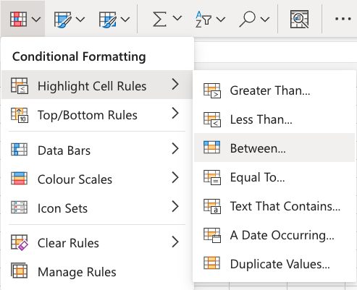

This will open a dialog box where you can specify the value and the appearance option.

1. Enter 79 and 100 into the input fields
2. Select the appearance option "Yellow Fill with Dark Yellow Text" from the dropdown menu

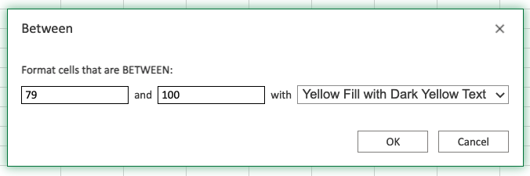

Now, the cells with values between "79" and "100" will be highlighted in yellow:

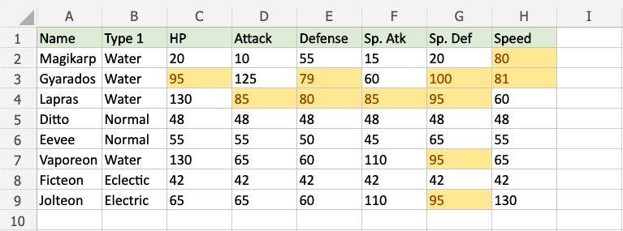

Notice that Gyarados' Defense and Special Defense, which are 79 and 100, are highlighted.

The **Between...** condition **includes** the specified values. This is different from the [Greater Than...](https://www.w3schools.com/excel/excel_cf_greater_than.php) and [Less Than...](https://www.w3schools.com/excel/excel_cf_less_than.php) conditions, which do **not** include the specified values.

# Excel HCR - Equal To

## **Highlight Cell Rules - Equal To**

**Equal To...** is one of the options for the condition.

Here is the Highlight Cell Rules part of the conditional formatting menu:



## **Highlight Cell Rule - Equal To Example (with Numbers)**

The "Equal To..." Highlight Cell Rule will highlight a cell with one of the appearance options based on the cell value being **equal** to your specified value.

The specified value could be a particular number or particular text.

In this example, the specified value will be "48".



"Equal To..." Highlight Cell Rule, step by step:

1. Select the range C2:H8 for all of the stat values



1. Click on the Conditional Formatting icon  in the ribbon, from **Home** menu
2. Select **Highlight Cell Rules** from the drop-down menu
3. Select **Equal To...** from the menu



This will open a dialog box where you can specify the value and the appearance option.

1. Enter 48 into the input field
2. Select the appearance option "Yellow Fill with Dark Yellow Text" from the dropdown menu



Now, the cells with values equal to "48" will be highlighted in yellow:



All of Ditto's stat values are 48, so they are highlighted.

## **Highlight Cell Rule - Equal To Example (with Text)**

The "Equal To..." Highlight Cell Rule also works with text values.

In this example, the specified text value will be "Magikarp".

"Equal To..." Highlight Cell Rule, step by step:

1. Select the range A2:A8 for Name values



1. Click on the Conditional Formatting icon  in the ribbon, from **Home** menu
2. Select **Highlight Cell Rules** from the drop-down menu
3. Select **Equal To...** from the menu



This will open a dialog box where you can specify the value and the appearance option.

1. Enter Magikarp into the input field
2. Select the appearance option "Yellow Fill with Dark Yellow Text" from the dropdown menu

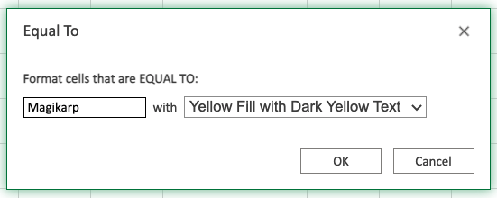

Now, the cells with text values equal to "Magikarp" will be highlighted in yellow:

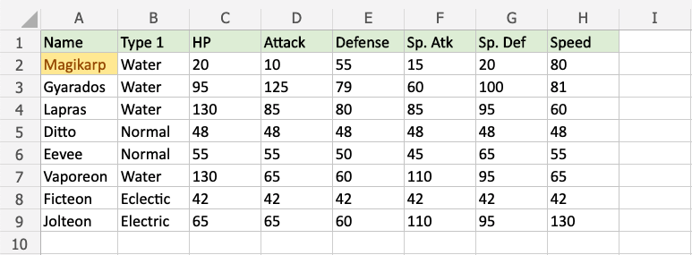

**Note:** The **Equal To...** Highlight Cell Rule will highlight cells that **exactly** match the specified value.

You can use the [Text That Contains](https://www.w3schools.com/excel/excel_cf_text_that_contains.php) rule for highlighting cells that have values with **any part** matching the specified value.

# Excel HCR - Text That Contains

## **Highlight Cell Rules - Text That Contains**

**Text That Contains...** is one of the options for the condition.

Here is the Highlight Cell Rules part of the conditional formatting menu:



## **Highlight Cell Rule - Text That Contains Example (with Text)**

The "Text That Contains..." Highlight Cell Rule will highlight a cell with one of the appearance options based on **a part of the cell value** containing your specified value.

The specified value is typically text, but also works with a numerical value.

In this example, the specified value will be "Pidge".

"Text That Contains..." Highlight Cell Rule, step by step:

1. Select the range A2:A8 for the Name values

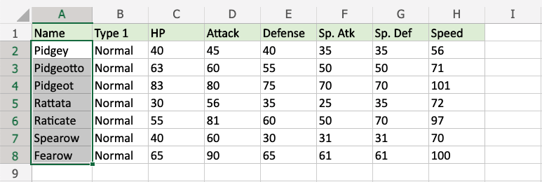

1. Click on the Conditional Formatting icon  in the ribbon, from **Home** menu
2. Select **Highlight Cell Rules** from the drop-down menu
3. Select **Text That Contains...** from the menu

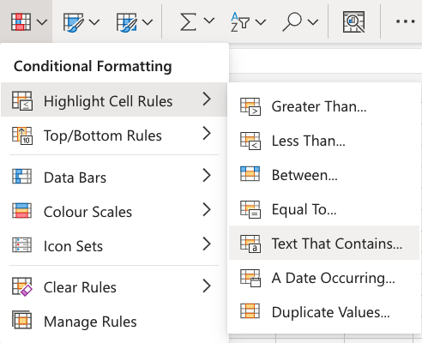

This will open a dialog box where you can specify the value and the appearance option.

1. Enter Pidge into the input field
2. Select the appearance option "Yellow Fill with Dark Yellow Text" from the dropdown menu

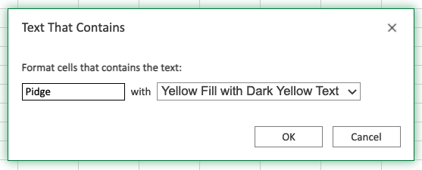

Now, the cells with values Text That Contains "Pidge" will be highlighted in yellow:

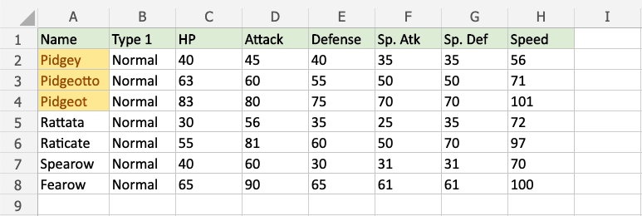

The names "Pidgey", "Pidgeot", and "Pidgeotto" all start with "Pidge", so all these cells are highlighted.

## **Highlight Cell Rule - Text That Contains Example (with Numbers)**

The "Text That Contains..." Highlight Cell Rule also works with numbers.

In this example, the specified text value will be "7".

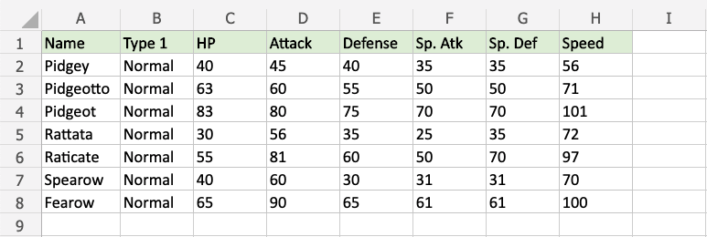

"Text That Contains..." Highlight Cell Rule, step by step:

1. Select the range C2:H8 for all the stat values

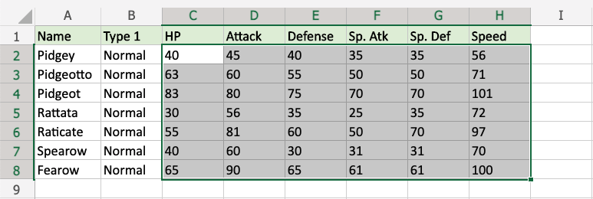

1. Click on the Conditional Formatting icon  in the ribbon, from **Home** menu
2. Select **Highlight Cell Rules** from the drop-down menu
3. Select **Text That Contains...** from the menu



This will open a dialog box where you can specify the value and the appearance option.

1. Enter 7 into the input field
2. Select the appearance option "Green Fill with Dark Green Text" from the dropdown menu

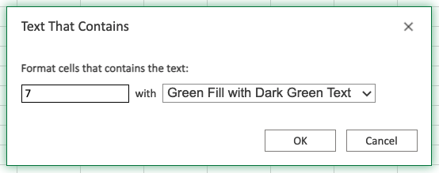

Now, the cells with values That Contains "7" anywhere will be highlighted in green:

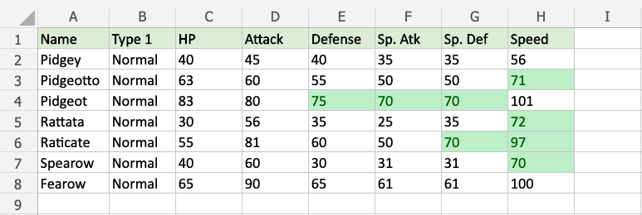

**Note:** The **Text That Contains...** Highlight Cell Rule will highlight cells that have values with **any part** matching the specified value.

You can use the [Equal To...](https://www.w3schools.com/excel/excel_cf_equal_to.php) rule for highlighting cells that **exactly** match the specified value.

# Excel HCR - A Date Occurring

## **Highlight Cell Rules - A Date Occurring**

**A Date Occurring...** is one of the options for the condition.

Here is the Highlight Cell Rules part of the conditional formatting menu:



## **Highlight Cell Rule - A Date Occurring Example**

The "A Date Occurring..." Highlight Cell Rule will highlight a cell with one of the appearance options based on the cell value relative to a specified time frame.

The time frame can be:

* Yesterday
* Today
* Tomorrow
* In the last 7 days
* Last Week
* This Week
* Next Week
* Last Month
* This Month
* Next Month

In this example, the specified time frame will be "next month".

"A Date Occurring..." Highlight Cell Rule, step by step:

1. Select the range C2:C19 for the Birthday values

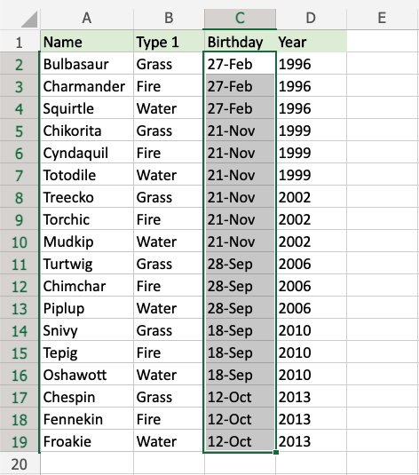

1. Click on the Conditional Formatting icon  in the ribbon, from **Home** menu
2. Select **Highlight Cell Rules** from the drop-down menu
3. Select **A Date Occurring...** from the menu

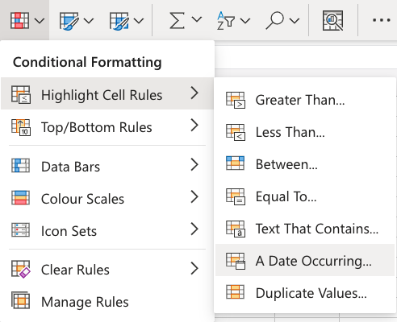

This will open a dialog box where you can specify the value and the appearance option.

1. Select "Next Month" from the dropdown menu
2. Select the appearance option "Yellow Fill with Dark Yellow Text" from the dropdown menu

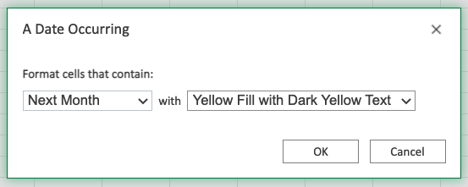

Now, the cells with values A Date Occurring next month will be highlighted in yellow:

**Note:** In this example, the next month happens to be **September**.

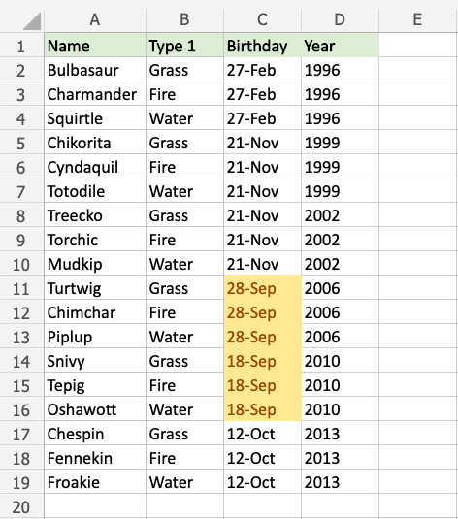

Turtwig, Chimchar, Piplup, Snivy, Tepig, and Oshawott all have birthdays in September, so their cells are highlighted.

# Excel HCR - Duplicate and Unique Values

## **Highlight Cell Rules - Duplicate and Unique Values**

**Duplicate Values..** is one of the options for the condition, and can check for both **duplicate** and **unique** values.

Here is the Highlight Cell Rules part of the conditional formatting menu:



## **Highlight Cell Rule - Duplicate Value Example**

The "Duplicate Values..." Highlight Cell Rule will highlight a cell with one of the appearance options based on the cell value being the **same** as other cells in the range.

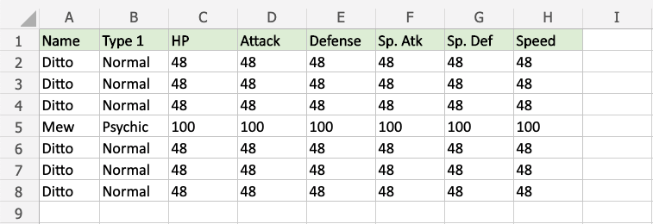

"Duplicate Values..." Highlight Cell Rule, step by step:

1. Select the range A2:H8

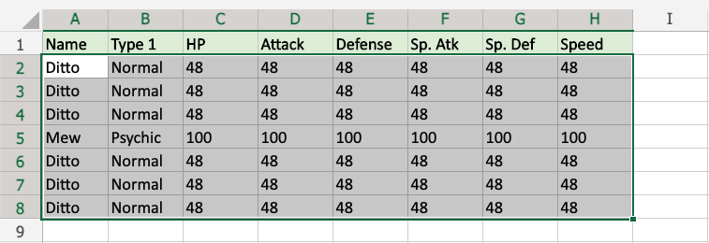

1. Click on the Conditional Formatting icon  in the ribbon, from **Home** menu
2. Select **Highlight Cell Rules** from the drop-down menu
3. Select **Duplicate Values...** from the menu

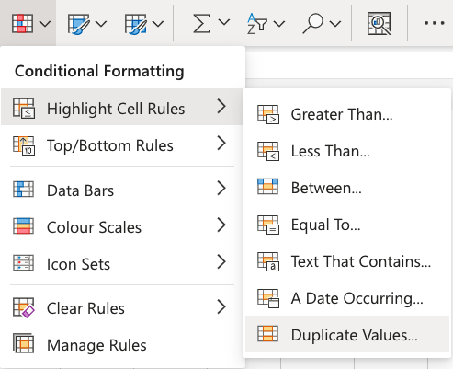

This will open a dialog box where you can specify the value and the appearance option.

1. Select **Duplicate**
2. Select the appearance option "Yellow Fill with Dark Yellow Text" from the dropdown menu

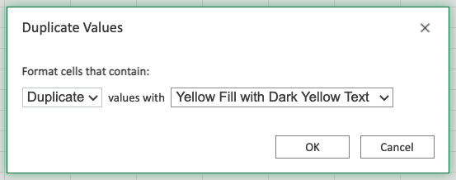

Now, all the cells in the range that have the **same** value as another cell are highlighted in yellow:

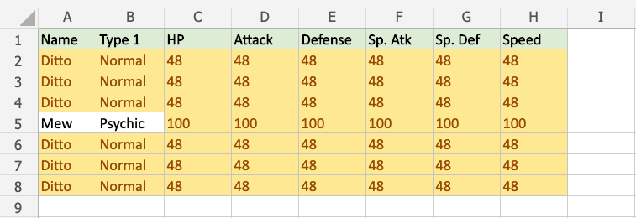

All of Ditto's stat values are 48 and all of Mew's stat values are 100, so they are all highlighted.

All of the Dittos and all of the Normal Type values are also highlighted.

## **Highlight Cell Rule - Unique Value Example**

The "Duplicate Values..." Highlight Cell Rule can also find and highlight **Unique Values**.

Let's apply this to the same set of data:



"Duplicate Values..." Highlight Cell Rule, step by step:

1. Select the range A2:H8



1. Click on the Conditional Formatting icon  in the ribbon, from **Home** menu
2. Select **Highlight Cell Rules** from the drop-down menu
3. Select **Duplicate Values...** from the menu



This will open a dialog box where you can specify the value and the appearance option.

1. Select **Unique** from the dropdown menu
2. Select the appearance option "Green Fill with Dark Green Text" from the dropdown menu

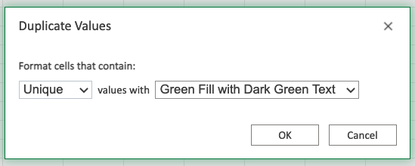

Now, the cells with **unique** values will be highlighted in green:

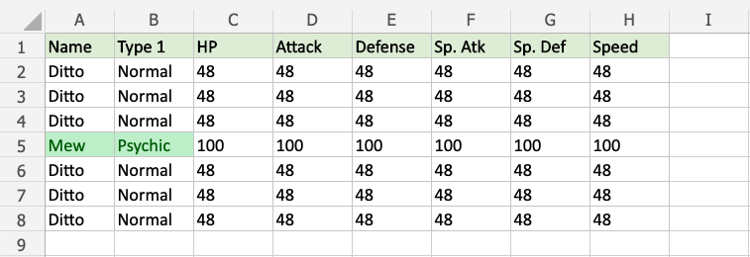

Mew and Psychic only appears once in the range, so these values are highlighted.

# Excel Top/Bottom Rules

## **Top/Bottom Rules**

Top/Bottom Rules are premade types of conditional formatting in Excel used to change the appearance of cells in a range based on your specified **conditions**.

Here is the Top/Bottom Rules part of the conditional formatting menu:

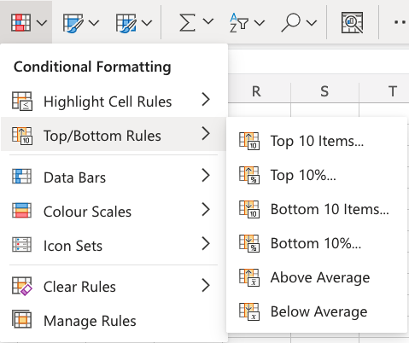

## **Appearance Options**

The web browser version of Excel offers the following appearance options for conditionally formatted cells:

* Light Red Fill with Dark Red Text
* Yellow Fill with Dark Yellow Text
* Green Fill with Dark Green Text
* Light Red Fill
* Red Text
* Red Border

Here is how the options look in a spreadsheet:



## **Top/Bottom 10 Items Example**

The "Top 10 Items..." and "Bottom 10 Items..." rules will highlight cells with one of the appearance options based on the cell value being the top or bottom values in a range.

**Note:** The default number of items is 10, but you can specify any whole number up to 1000 for Top/Bottom Items to be highlighted.

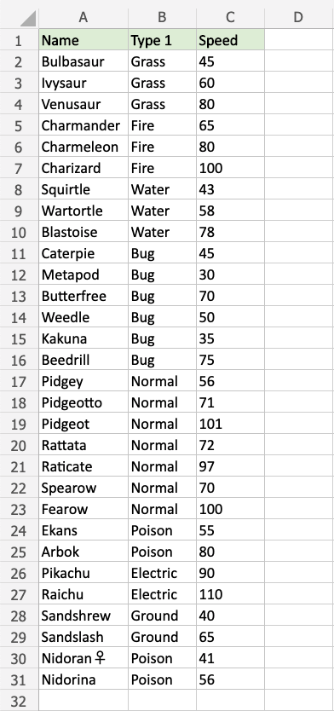

Let's first apply the **Top 10 Items...** rule to the Speed values.

"Top 10 Items..." Rule, step by step:

1. Select the range C2:C31 for Speed values

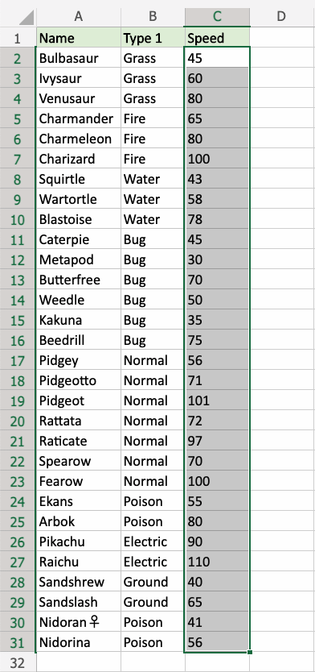

1. Click on the Conditional Formatting icon  in the ribbon, from **Home** menu
2. Select **Top/Bottom Rules** from the drop-down menu
3. Select **Top 10 Items...** from the menu

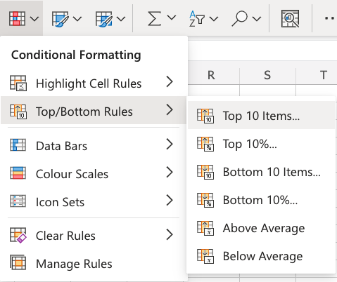

This will open a dialog box where you can specify the value and the appearance option.

1. Leave the default value 10 in the input field
2. Select the appearance option "Green Fill with Dark Green Text" from the dropdown menu

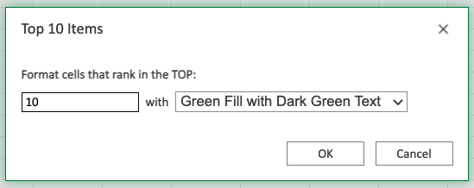

Now, the 10 cells with the top values will be highlighted in green:

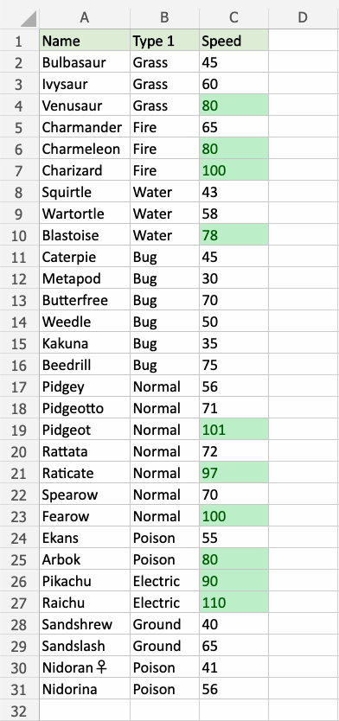

**Great! Now, the top 10 Speed values are easily identified.**

Let's try the same with the bottom 10 Speed values.

**Note:** Multiple rules can be applied to the same range.

Repeat the steps, but instead choose **Bottom 10 Items...** in the menu and select the "Light Red Fill with Dark Red Text" appearance option.

Now, the slowest values are also highlighted:

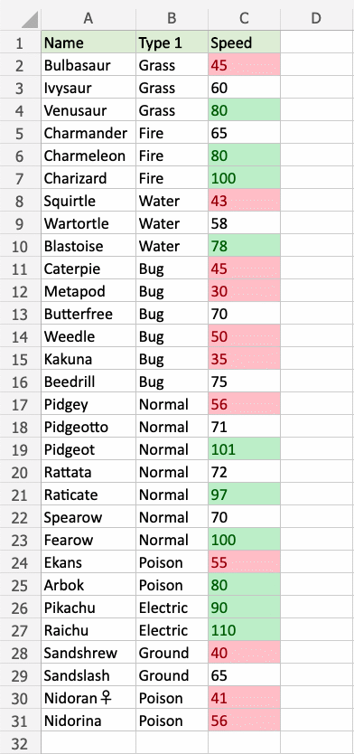

Notice that there are actually 11 items highlighted in red. Why could this be?

Let's [sort the table](https://www.w3schools.com/excel/excel_sort.php) with descending Speed values for a clue:

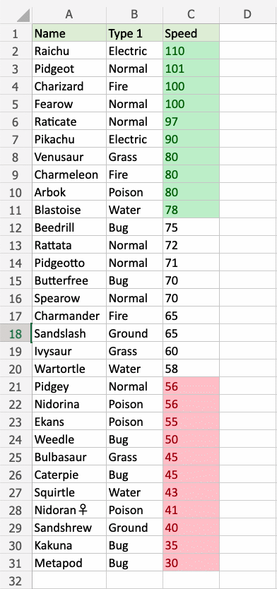

We can see that both Pidgey and Nidorina have a Speed of 56. So, they are tied for the 10th bottom value.

**Note:** When using the **Top/Bottom 10...** conditional formatting, values that tie will **all** be highlighted.

## **Top/Bottom 10% Example**

The "Top 10%..." and "Bottom 10%..." rules will highlight cells with one of the appearance options based on the cell value being the top or bottom **percent of values** in a range.

**Note:** The default percent of items is 10, but you can specify any whole number up to 100 for Top/Bottom Percent to be highlighted.

Let's apply Top and Bottom 10% rules to the same dataset with sorted Speed values:

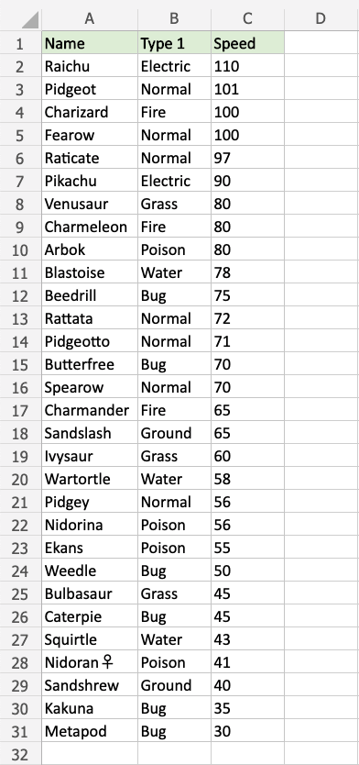

Let's first apply the **Bottom 10%...** rule to the Speed values.

"Bottom 10%..." Rule, step by step:

1. Select the range C2:C31 for Speed values

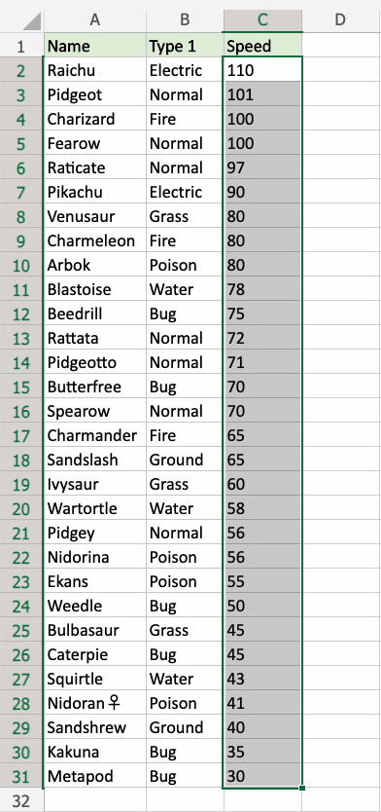

1. Click on the Conditional Formatting icon  in the ribbon, from **Home** menu
2. Select **Top/Bottom Rules** from the drop-down menu
3. Select **Bottom 10%...** from the menu

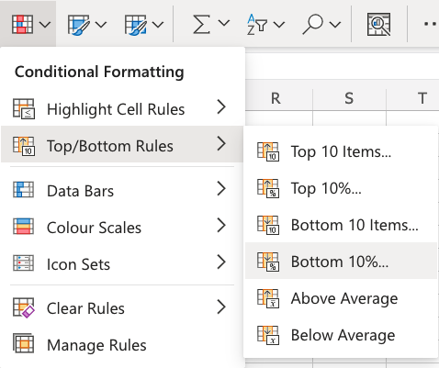

This will open a dialog box where you can specify the value and the appearance option.

1. Leave the default value 10 in the input field
2. Select the appearance option "Light Red Fill with Dark Red Text" from the dropdown menu

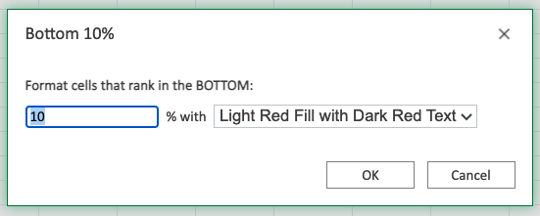

Now, the bottom 10% of cells will be highlighted in red:

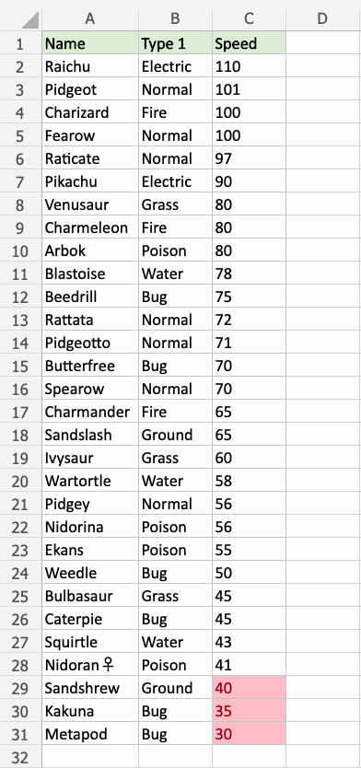

**Notice that there are 3 highlighted cells.**

There are 30 cells in the range, so 10% of that is 3 cells.

**Note:** The number of cells will be rounded **down** to the closest whole number based on the percent.

For example:

* 6% of 30 is 1.8, which will be rounded **down** to 1 cell
* 7% of 30 is 2.1, which will be rounded **down** to 2 cells

Let's try the same with the top 10% Speed values.

Repeat the steps, but instead choose **Top 10%...** in the menu and select the "Green Fill with Dark Green Text" appearance option.

Now, the fastest values are also highlighted:

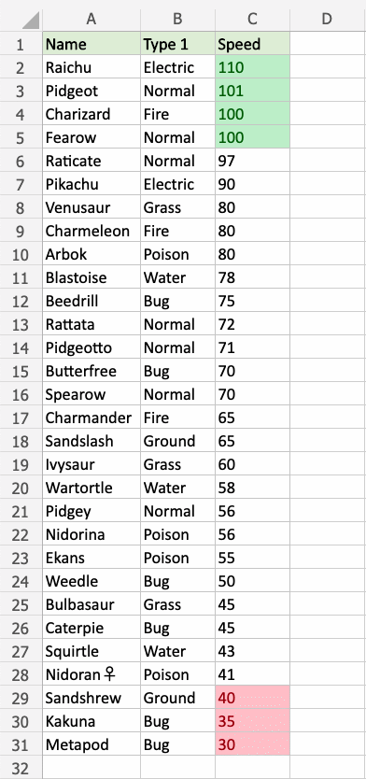

Notice that there are actually 4 items highlighted in green.

We can see that both Charizard and Fearow have a Speed of 100. So, they are tied for the 3rd top value.

Both are included in the top 10% and are highlighted.

# Excel Above and Below Average Rules

Above and Below Average Rules are found in the **Top/Bottom Rules** part of the conditional formatting menu:



## **Above and Below Average Example**

The "Above Average" rule will highlight cells with one of the appearance options based on the cell value being the above the average value in a range.

**Note:** You can use Excel to calcluate the [the average value](https://www.w3schools.com/excel/excel_average.php) of a range, like in the example data below:

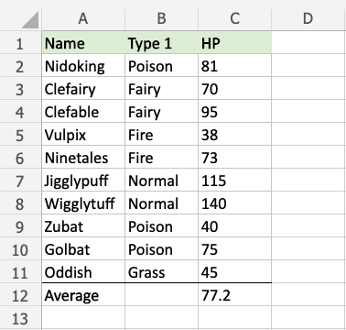

**Note:** The Average value row is separated from the data with a visual border. Check out how to add this in the [format borders chapter](https://www.w3schools.com/excel/excel_format_borders.php).

You can [choose any range](https://www.w3schools.com/excel/excel_ranges.php) for where the Highlight Cell Rule should apply. It can be a few cells, a single column, a single row, or a combination of multiple cells, rows and columns.

Let's first apply the **Above Average** rule to the HP values.

"Above Average" Rule, step by step:

1. Select the range C2:C11 for HP values

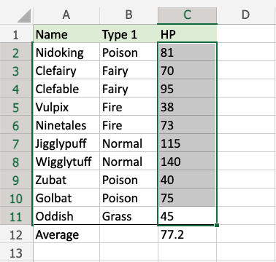

1. Click on the Conditional Formatting icon  in the ribbon, from **Home** menu
2. Select **Top/Bottom Rules** from the drop-down menu
3. Select **Above Average** from the menu

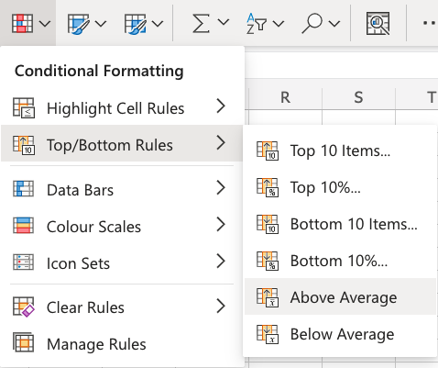

This will open a dialog box where you can specify the value and the appearance option.

1. Select the appearance option "Green Fill with Dark Green Text" from the dropdown menu

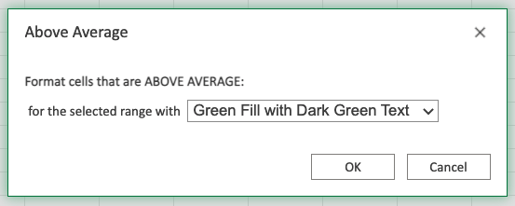

Now, the cells with above average HP values (more than 77.2) will be highlighted in green:

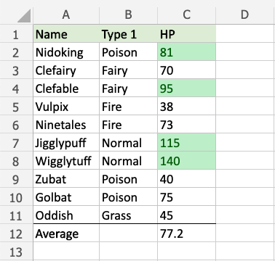

**Note:** Multiple rules can be applied to the same range.

Repeat the steps, but instead choose **Below Average** in the menu and select the "Light Red Fill with Dark Red Text" appearance option.

Now, the below average values are also highlighted:

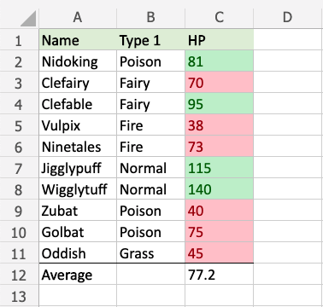

**Note:** You can remove the Highlight Cell Rules with [Manage Rules](https://www.w3schools.com/excel/excel_cf_manage_rules.php).

Notice that there are more below average values than above average values. Why could this be?

The number of above or below average value cells in a range will depend on the actual values in the range.

If some values in the range are extra large this will increase the average by a lot.

Let's add a fictional Pokemon with a very high HP stat value to illustrate this:

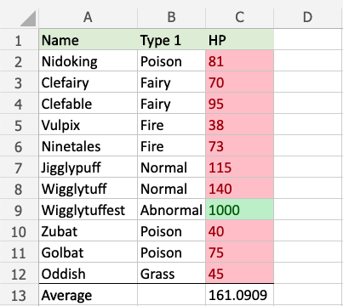

The fictional Wigglytuffest has 1000 HP, which increases the average value all the way up to more than 161.

Now, only Wigglytuffest has an above average HP stat value, and every other Pokemon has below average HP stat values.

**Note:** This kind of average value is referred to as **the mean**.

You can learn more about different kinds of average values are calculated in the [Statistics - Average chapter](https://www.w3schools.com/statistics/statistics_mean.php)

# Excel Data Bars

## **Data Bars**

Data Bars are premade types of conditional formatting in Excel used to add colored bars to cells in a range to indicate how large the cell values are compared to the other values.

Here is the Data Bars part of the conditional formatting menu:

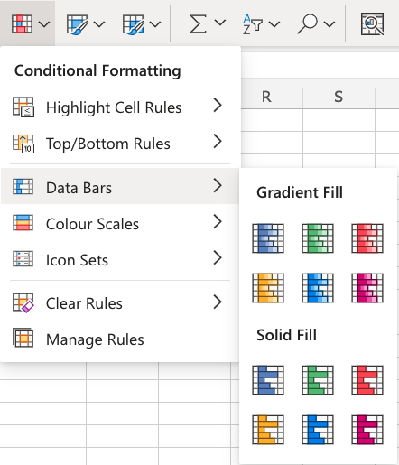

## **Data Bars Example**

**Note:** The size of the data bars depends on the **smallest** and **largest** cell value in the range.

Let's apply the **Data Bars** conditional formatting to the Speed values.

"Data Bars", step by step:

1. Select the range C2:C10 for Speed values

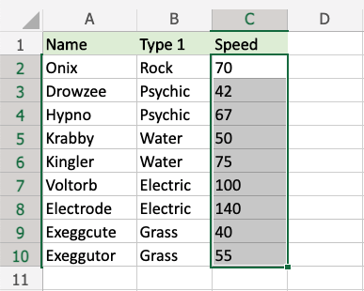

1. Click on the Conditional Formatting icon  in the ribbon, from **Home** menu
2. Select **Data Bars** from the drop-down menu
3. Select the "Green Data Bars" color option from the **Gradient Fill** menu

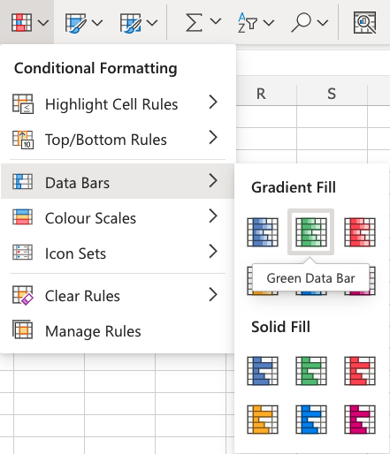

**Note:** Both **Gradient Fill** and **Solid Fill** work the same way. The only difference between those, and the color options are aesthetic.

Now, all of the Speed value cells have a green bar showing how big the value is compared to the other values in the range:

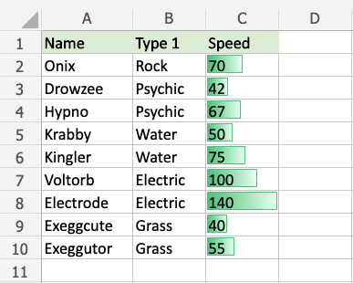

Electrode has the highest value, 140, so the bar fills the entire cell.

The other bars are scaled relative to the highest value and 0 by default.

Exeggcute has the lowest value, 40, so this is the shortest bar. Though, it is larger than 0, so there is still a small bar.

Let's see what happens if we add a fictional Pokemon with a 0 Speed value:

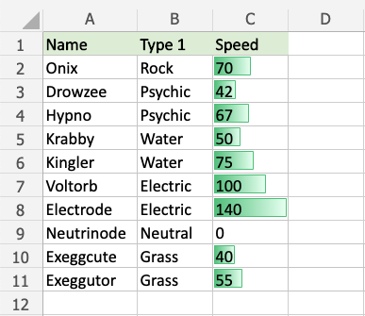

The fictional Neutrinode has a Speed value of 0, so this becomes an invisible "minimum" bar.

Let's see what happens if we add another fictional Pokemon with a negative Speed value:

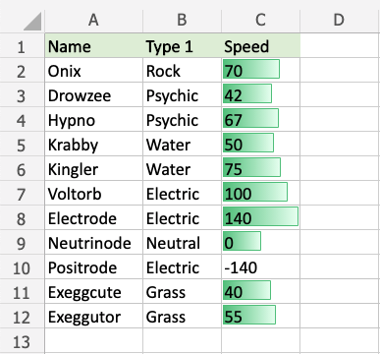

Now, the fictional Positrode has the lowest Speed value, -140, so this becomes an invisible "minimum" bar.

**Notice that all the other bars have now been scaled relative to the new minimum (-140).**

Neutrinode's Speed value of 0 is now in the middle between -140 and 140, so the cell has a bar filling half the cell.

Electrode still has the highest Speed value, 140, so this bar still fills the entire cell.

**Note:** You can remove the Highlight Cell Rules with [Manage Rules](https://www.w3schools.com/excel/excel_cf_manage_rules.php).